**DIGITAL AND HANDMADE ARTWORK ONLINE AUCTION SYSTEM FOR ARTIST STUDENTS**

A **Capstone Project**

Presented to the faculty of the

College of Communication and Information Technology

University of Northern Philippines

Vigan City, Ilocos Sur

In partial Fulfillment of the Requirements for the Degree

**Bachelor of Science in Information Technology**

**CAIN P. RUALIZO**

**JAN PAOLO P. ARRUEJO**

**KOBE BYEIN D. BELARDE**

**SHERLYN G. DULDULAO**

**2023**

**CERTIFICATION**

This thesis entitled “Digital and Handmade Online Auction System for Artist Students”, prepared and submitted by, **Cain P. Rualizo**, **Jan Paolo P. Arruejo**, **Kobe Byein D. Belarde**, and **Sherlyn G. Duldulao**, in partial fulfillment of the requirements for the degree **Bachelor of Science in Information Technology**, has been examined and is recommended for **Oral Defense**.

**RICHARD C. ARRUEJO, DIT**

Adviser

**APPROVAL SHEET**

Approved by the Panel of Examiners on Oral Examination with a Grade of

____________.

**MARIANO T. ROMANO JR., MIT**

Chair

**MARIBEL T. TACLA, MBA, MIT**  **CHLOE REOTUTAR, BSInfoTech**

Member Member

In partial fulfillment of the requirements for the degree **Bachelor of Science in Information Technology**.

**ROSANNE S. AGUP, MIS**

Dean, College of Communication and Information Technology

Date: ________________2023

**ACKNOWLEDGMENT**

The researchers would like to extend their grateful acknowledgment to all those who contributed and give assistance in the success of this study, without whom this work could not be achieved.

**Prof. Rosanne S. Agup,** Dean of the College of Communication and Information Technology, for her encouragement, guidance, support, and motivation.

**Dr. Richard C. Arruejo,** their thesis adviser, for sharing generously her time to guide, advice, and monitor us through the completion of this work. The researchers gratefully thank her for imparting her knowledge and expertise for us to be able to come up with this manuscript.

**Dr. Mariano Romano**, Chairman of the Defense Panel, for his great suggestions to improve this study;

**Mrs. Maribel T. Tacla and Ms. Chloe Reotutar**. Panel members, for their valuable comments and ideas for the enrichment of this study;

**Dr. Ashley S. Martinez,** for allowing them to gather relevant data necessary for this undertaking.

To all the Faculty members of the College of Communication and Information Technology, for sharing their knowledge and expertise;

To all our **classmates**, for the four years of laughter, sorrow, and endless support;

To all our **friends, barkadas, and families,** for the help, happiness, and laughter they had shared in order for the researchers to have a peaceful, relaxe,d and productive mind.

Thank to these persons who guide us and succeed in our daily life. We can’t thank enough for the support and advice that they gave us through our struggles and triumphs.

**C.P.R**

**J.P.P.A**

**K.B.D.B**

**S.G.D**

This Thesis is dedicated to:

our parents who have never failed to give us financial and moral support, for giving all our needs during the time we developed our system, and for teaching us that even the largest task can be accomplished if it is done one step as a time.

We dedicate this Project to all the people who have worked hard to help us complete this Thesis.

**-CAIN**

I dedicate my work to:

my family and friends. A special feeling of gratitude for my parents, **Mr. and Mrs. Arruejo** whose encourage me to become a better person.

To my friends thank you for always there and for your support. To my teachers, thank you for your guidance, support, and patience throughout this study, and thank you also for the comments and questions you shared that is beneficial in the completion of this study.

I also dedicate this research to the **Almighty God**, for his guidance, power of mind and protection for giving us a healthy life to be able to carry out this thesis. All of these, we offer to you.

**-PAOLO**

I dedicate my work to:

my family that has been supporting me from the very beginning. Specially to my father and mother who are very hard working and it keeps me motivated to work.

I also dedicate this thesis to my friends, for their unending advice and giving the support to reach my goals. To my teachers thank you for contributed in many ways to the success of this study and made it unforgettable experience.

And to the father all mighty for being always there when I needed you. Thank you for guiding and giving me the strength in everyday life. Thank you for making all of these happened and ended it with a good outcome. Lord god, Amen.

**-KOBE**

This thesis is dedicated to:

my family, friends and teachers. A special deepest gratitude to my loving mother, **Emelyn Duldulao** who have been source of inspiration, gave me strength, encouragement and continually provide my moral, spiritual, emotional, and financial support. To my cousin, **Joshua Tapugay** thank you for never left my side and supported me throughout the process.

I also dedicated this thesis to my friends and teachers, who played such important roles along this journey. And as mutually engaged in making sense of the various challenges we faced and improving encouragement.

And lastly, I dedicated this thesis to the **Almighty god,** thank you for the guidance, strength, power of mind, protection and skills and for giving us a healthy life. All of these, I offer to you.

**-CHIT**

**TABLE OF CONTENTS**

**PRELIMINARIES Page**

Certification…………………………………………………………………......... ii

Approval Sheet……………………………………………………………............. iii

Acknowledgement……………………………………………………………….... iv

Dedication…………………………………………………………………………. vi

Table of Contents………………………………….………………….…................ x

List of Figures…….……………………………………………………................. xii

List of Tables…………….……………………………………………………….... xiii

Abstract……………………………………………………………………………. xiv

**CHAPTER**

1. **THE PROBLEM**

Introduction…………………………………………………………... 1

History of Auction………..……………………………………..... 5

Research Locale……………………………………………….……... 6

Statement of Objectives……………………………….……………... 7

Significance of the Study…………………………………………….. 8

Scope and Delimitation………………………………………………. 9

1. **REVIEW OF RELATED LITERATURE AND METHODOLOGY**

Review of Related Literature…………………………………. 10 Operational Definitions of Terms………………………………….. 17

Methodology……………………………………….………………. 20

1. **RESULTS AND DISCUSSION**

Problems Encountered in the Online Auction System……...………. 29

Functional Requirements of the Developed System ………………… 30

The Developed System …………………………………………........ 32

1. **FINDINGS, CONCLUSIONS, AND RECOMMENDATIONS**

Findings ................................................................................................ 63

Conclusions .......................................................................................... 65

Recommendations ................................................................................ 66

1. **REFERENCES** ....................................................................................... 68

**APPENDICES**

* 1. Letter of Request …………………………………………………. 70
  2. Interview Guide …………………………………………………... 71
  3. Evaluation Sheet ………………………………………………….. 72
  4. User’s Manual ............................................................................... 75

**CURRICULUMVITAE**...................................................................................... 125

**LIST OF FIGURES**

**Figure No. Title Page**

* 1. Research Locale ………….………………………….….…………. 6
  2. RAD Model ……………………………………………...………... 25
  3. Use Case Diagram …………………………….…………………... 34
  4. Activity Diagram for Log In ..……………………….…………… 36
  5. Entity Relationship Diagram ………………………….……….…. 39
  6. Input Output Process ……………………………………………… 55
  7. HIPO Hierarchical Input Process Output for Patient ......................... 56
  8. HIPO Hierarchical Input Process Output for Dentist ......................... 57
  9. HIPO Hierarchical Input Process Output for Staff ............................ 58

**Lists of Tables**

**Table No. Title Page**

* 1. Scale for the Interpretation of the Evaluation of the System ……. 27
  2. Functional and Non Requirements of the Developed System…… 30
  3. Data Structure for User.. ................................................................. 39
  4. Sample Record of User………….................................................... 40
  5. Data Structure of Category.............................................................. 44
  6. Sample Record of Category ............................................................ 45
  7. Data Structure of Service ................................................................ 45
  8. Sample Record of Service ............................................................... 42
  9. Data Structure of Product ................................................................ 45
  10. Sample Record of Product .............................................................. 46
  11. Data Structure of Bidding ............................................................... 47
  12. Sample Record of Bidding .............................................................. 48
  13. Data Structure of Bidding winner ................................................... 47
  14. Sample Record of Bidding winner .................................................. 48
  15. Data and Sample Record of Customization .................................... 51
  16. Evaluation of the System in terms of Functional Suitability ............ 59
  17. Evaluation of the System in terms of Performance Efficiency ........ 60
  18. Evaluation of the System in terms of Reliability ............................. 61
  19. Evaluation of the System in terms of Security …….......................... 62

**ABSTRACT**

**RUALIZO, CAIN P., ARRUEJO, JAN PAOLO P., BELARDE, KOBE BYEIN D., DULDULAO, SHERLYN G., (2023) Digital and Handmade Online Auction System for Artist Students** (Undergraduate Thesis). Bachelor of Science in Information Technology. University of Northern Philippines, College of Communication and Information Technology, Vigan City, Ilocos Sur.

Adviser: **Richard C. Arruejo, DIT**

*This study aimed to develop a Digital and Handmade Online Auction System for Artist Students within the College of Fine Arts and Design at University of Northern Philippines. An online auction is an auction which is held over the internet. It is a popular method for buying and selling products and services. The proposed system helps the customer to sell and buy products in best price.*

*The researcher used Agile Methodology for faster development of the proposed system. We conducted interviews with the students of College of Fine Arts and Design to gather information about the processes involve with the current system. This led us in identifying, analyzing and understanding the process involved in the system. The researcher used MySQL as their database, as well as HTML and Visual code studio in designing and coding their proposed system.*

*It is developed with the objective of making the system reliable, easier, and faster. This Web-based system is to sell the products of Digital and Handmade artworks of students in the College of Fine Arts and Design. It developed with the objective of making the system reliable, easier and faster. The application is made like a surfing website.*

*It was found out that the developed Digital and Handmade Online Auction is functional, efficient, reliable, and secured as supported by the result of evaluation of 4.44.*

**Keywords:** Digital and Handmade Artwork, Online Auction System, web-based

**Chapter I**

**THE PROBLEM**

**Introduction**

A world that loves to participate in real time activities would certainly appreciate the idea of an online auction system that opens 24/7. Unlike the traditional auctioning method, this modern system brings together buyers and seller from across the globe to a single location. Since the item are listed for few days, bidders can think and study the deal before bidding. Since there is no geographical or time restrictions, the number of bids received will be more. The cost for conducting an auction online is less when compared to physical auction sales and the price of the items are also low. This way both parties the buyer and the seller are benefited retailers, distributors and liquidators can test new products, quickly sell off excess inventory and get new customers. Auctions taking place between customers, companies and business have gained popularity.

Online auctions are very useful for businesses, regardless of its type and size. Founded in 1995, eBay takes the credit of being the major online auction host. Many businesses have taken off because of the auction space offered by eBay. Bidders go through the product descriptions, shipping information and images of the item before bidding. Advancement of the technologies and implementation of new features have made online auctioning than ever. From the initial development process to the integration of the online auction system, developers and software engineers encounters many challenges and difficulties. They think, plan, analyze, design, redesign, test and correct errors to set-up the most up to date online auction system for their clients.

Basic processes involved in online auction system are registration for both seller and buyer, identifying the auction type, auction rules, names, product information, prices, etc. Scheduling times for auction sessions including starting and closing time, bidding includes collecting bids and validating the collected bids, closing the auction and finally trade settlement.

The online auction system is a model where we participate in a bid for products and services. This auction is made easier by using online software which can regulate process involved. Online Auction System has several other names such as e-Auction, electronics auction and etc. The requirement for online auction or online bidding can be more accurately specified by the client. It should be a healthy and a good practice when it is made more transparent as a matter of fact. Online Bidding has become more wide spread in all sort of industrial usage. It not only includes the products or goods to be sold, it also has services which can be provided. Due to their low cost this expansion made the system to grow. Online bidding has become a standard method for procurement process. Bidders can be maintained in a single database according to the preference, and they can be monitored. User’s data can be maintained a confidential way of validity. Multiple bidders can be communicated with great ease. Online Auction allows multiple bids by single users.

The global reach of online auction market places allows for the buyers and sellers to overcome geographical constraints and purchase products anytime from anywhere over the internet. The online auction provides the consumers with great advantages of low prices, greater product selection and greater efficiency compared to the usual traditional online markets (Ghose et al, 2017). The use of online auction system makes use of decision-making assistance tool that results in greater buyer certainty towards their choice of the sellers and product that they make. Decision making of assistance tool consists of three parts that is the product information signals, sellers rating scores and sellers shilling activities.

Decision making assistance tool also provides for seller ratings by making use of the feedback scores. These feedbacks are given by previous winning bidders and they evaluate the online auction product sellers. These bidders give detailed seller ratings of all aspects of the seller and giving scores for example, giving scores of how accurate was the items description, how satisfied they were with the seller communication and how quickly were the products transported to them by the seller.

Online auctions present great opportunities to entrepreneurs and shoppers alike. They offer a common platform where buyers and sellers can bid or sell just about anything. Bidding on the auction websites is convenient and highly cost effective. Most of the auction portals present automated bidding with a multitude of listing categories and subcategories. This will enable buyers and sellers to make transactions in real time.

The other important aspect of this decision-making tool involves the process of coming up with seller’s shill ratings. Shilling is the act of introducing fake bids into an auction on the behalf of the seller to artificially inflate the price of an item (Weinberg, 2017). To come up with shill rating the system monitors the shill activity characteristics which include those bidders who make a lot of repeated failed bids on the same seller. Shills usually have higher number of failed bids per seller ratio. The auction house maintains records of the number of bids a bidder has placed for every seller that the bidder has interacted with. This information is used to come up with a shill score. Detailed evaluation of the product and seller and the use of the decision-making assistance tool ensures consumers certainty on the choice of the sellers and the products that they make.

**Background of the study**

Today, the artwork is popular and there are fascinating backstories, such as Leonardo da Vinci’s Monalisa, a well-known and expensive painting. Other beautiful paintings are sold through the bidding or auction system to anyone interested. We create a system so that artists can sell their work and earn enough money to meet their daily needs. It allows customers to get the desired artwork products and buy them anytime through the internet.

This system shall handle this issue by creating an online platform where a user will be able to post items for auction. The item will accompany name, selling price and a picture presentation for the bidder. If the costumer will like or interested in the item, will auction for the product and will be able to inspect the item physically to approve the product then complete the business with the seller. Online auction provides the opportunity to get the item you want by raising the price until nothing can match the late bidder

The auctioneer will have a provision to chat with the seller and consult with him/her about the details of the product. There chat will be confidentially only between the buyer and seller, ensuring the buyers confidentiality. The customers will be assured of getting the right products, since they will take their time to analyses and compare a range of listed items and choose appropriately according to their need or desire. This will save time that buyers take in search of items and therefore they will save themselves from worsening of conditions which may lead to wastage of time conditions, at the end of the day the bidders will have a reason to smile with this online system.

The system will run on the internet since of the dynamic nature of the internet, and anybody can access it from smartphones, computers, personal digital assistance and many more digitals.

**History of Auction**

The history of auction returns back to 500 B.C as stated by Herodotus. In Babylon where annually women were sold based on auction and being married to the person who has bought her. Women with less pretty were sold with returning money back to the bidder. The bids of these auctions were not mentioned whether they were ascending or descending.

The Roman Empire used auctions to dispose of debt. One example is selling the own home ‘s furniture by Marcus Aurelius to pay off debts.

The important historical auction happened in the year 193 A.D when the whole of Roman Empire was placed on auction block after being dismissed. In China also auction was used by Buddhist friars to put up money for temple creation. After that it became usual to auction of the possessions of deceased friars for this purpose.

**Figure 1**

**Research Locale**

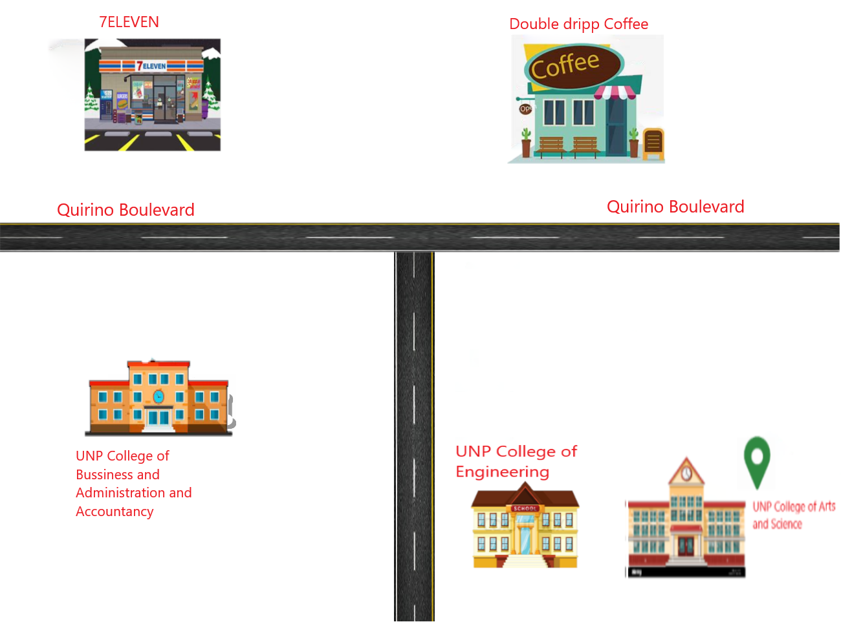

**Statement of Objectives**

This study aims to develop a Digital and Handmade Artwork Online Auction System for Artist Students where student who has talents on making Art like painting, drawing, editing and etc. Can post their works on the page and waits until someone will get interested in their work.

Specifically, it seeks to answers the following Objectives:

1. Determine the problems encountered in online auction.
2. Failure to Deliver; and,
3. Misrepresentation;
4. Develop the Digital and Handmade Artwork Auction for Artist Students of College of Fine Arts and Design in the University of Northern Philippines.
5. Develop the Digital and Handmade Artwork Auction for Artist Students using Agile model.
6. Determine the level of usability of the proposed online auction system using the ISO 25010 software quality evaluation toll along;
7. Functional Sustainability;
8. Performance Efficiency;
9. Reliability; and,
10. Security;

**Significance of the Study**

This study aimed to develop a **Digital and Handmade Artwork Online Auction System for Artist Students** that will provide a forum to interact with the buyers and sell their items to interested bidders.

**Online Auction.** The proposed systemis an auction held over the internet and accessed by internet connected devices and a service in which auction users or participants sell or bid for products or services via the Internet.

**Bidder.** Through the proposed system,the bidder is someone who offers to pay a certain amount for something that is being sold.

**Auctioneer.** Through the proposed system,this is a person who manage an auction, or a public sale at which people can bid on items and conducts auctions by accepting bids and declaring goods sold.

**Seller.** Through the proposed system, the sellerthe one who post the artworks item that they want to be bid.

**Researcher.** This study helped the researcher to enhance their skills about programming that they can use to their future. Also, they learned how to get their feet together with others and believe themselves.

**Future Researcher.** This study helps future researchers, as it can serve basis in developing system that are related to Online Auction System.

**Scope and Delimitation**

This study aims to develop online auction system of Digital and Handmade Arts. This system only accepts sellers located within the University of Northern Philippines. Registered potential buyers and sellers participate in either auction process. Bidders will be able to get connected to the specific sellers who will offer them necessary information and give hand to sell their items to them. It will help save time and offer quality deliverables to the bidders by quick response and attention service. This system will replace the manual way of seeking items in the market and travelling along journeys just to get an item yet there are available items just in around the school.

The user cannot view the item in person and another reason was lack of time which made limitation of this research.

The system is exclusively for the College of Fine Arts and Design in the University of Northern Philippines. The system does cater online auction system. The system is available online, it can run on window operating system and automatically back-up and restore data. This system will run on the internet since of the dynamic nature of the internet, and anybody can access it from smartphones, computers, personal digital assistants and many more digital gadgets. Also, the system is a forum where the bidders meet their respective product sellers in their locality on the internet to solve the problem of item auctioning. This is a sure promise that the system will serve many students in school.

**Chapter II**

**REVIEW OF RELATED LITERATURE AND METHODOLOGY**

**Related Literatures**

The term Auction extracted from the Latin root auctus which means “I augment”. It is a process of purchasing and selling items through the bid and selling to the bidder who makes the highest offer. Usually, the bidders that participate in the same auction item will increase the price against each other. The increasing prices continues until it reaches the highest price by the bidder. Many types of auctions exist; each of them has their rules and conditions. The auction is a fact which items goes to the highest bidder. By publishing the items to the audience an auction may have a wide range of bids which make the item surprisingly goes to the very high price.

The Auction sales are held in the auction system. The people who wish to sell their items by auctioning take part in auction system and publish their items for sale. Also, the buyers have to exist in the auction system which takes the time to arrive. In the auction sales, the seller has to pay some amount to the auctioneer who is managing the auction by accepting offering price and declaring items sold.

Bidders are able to participate in an online auction from anywhere and at any given time. Auctioneers are not needed to run the auction. All information of each product is in one central space, the catalogue on the website.

These important principles are the foundation of this study: Determine the current problems encountered in online auction.

**Problems encountered in online auction system**

Auction fraud is therefore an increasingly difficult problem in the virtual market. The common types of auction fraud are as follows:

**Failure to deliver**

Buyers pay for an item, which is never received or is not the item listed as purchased, the seller must take the necessary corrections or reimburse you for your purchase, but online retailers may take a different tack if the item you received is not the one that was listed as your purchase. If the buyer did not receive the item, it requires the auctioneer process orders by mail and telephone number ship within 30 days. If auctioneer cannot ship within the promised time, the auctioneer must obtain the buyer’s consent to a delay in shipping or refund payment for the unshipped items. If the auctioneer can’t meet the revised shipping date, it must notify you again by mail, email or telephone and give you a new shipping date or cancel your order and give you a refund

**Misrepresentation**

Items received do not match up to the original description.

Shill bidding: A seller, or an associate, places a fake bid intended to drive up prices.

Selling black- items: The items are typically delivered without authentic merchandize, warranty, or instructions.

According to Jim Renfroe, senior vice president for Halliburton's Fluids Division (2019), said online bidding makes up a small percentage of the projects his company bids on. Most online bidding has been set up around what Renfroe calls "low-risk" products and services. Low risk in this case means that if the product or service fails to deliver, it will not cause major problems for the customer. These are what most companies consider commodity products, where there is little difference between brands.

According to Renfroe (2019), a number of major operators are testing online bidding for higher risk products and services. These include directional drilling, stimulation services, and complex well design work. In a traditional tender offer, a number of factors come into play before a bid is accepted. In the online auction, the sole consideration is price. The operators do pre-qualify bidding companies, Renfroe said, but in several cases the winning bidder had little or no experience in the field for which the bid was won.

According to Renfroe (2019). In earlier bids, there was a certain amount of transparency. All bidding companies could see each other's bids, though the companies were not identified by name. In more recent rounds of online bidding, the only information provided is the status of the individual company's bid. In experience, each bidder is told whether or not his is currently the winning bid, with no idea of where the other bids lie. Obviously, this could lead to a number of problems for service companies.

**Online Auction System**

This chapter basically looks at the current online auction systems that are in use and state their strengths and weaknesses. The purpose of this chapter is to outline the evolution of auction systems, explain their general structure.

Abeille and Calauz (2018) proposed explicit shading strategies for repeated truthful auctions. This paper tells some points about stopping strategies in an auction from stochastic stopping time perspectives which are fundamental building blocks of martingale theories and are widely used in pricing options.

The premier online auction retailer, boasted 167 million global active buyers in 2016 and $84 billion in gross merchandise volume (GMV) (eBay, 2017). This reflects a year over year increase of both active buyers and GMV and underscores the revenue generating power of online auctions and they have significantly changed the way people exchange Information and participate in business transactions.

Luan et al. (2019) discussed consumers’ online review search Behavior on the various types of products reviewed. It shows how the bidder’s Patience until they get the items.

Research has shown that customers’ trust is shaped through their experiences (Gefen et al., 2018). Even if their initial trust of another party is low, experience with this other party brings familiarity, which significantly influences their intended behavior. In an online auction setting, once a buyer understands the social norms of an institution or has enough successful transactions with different sellers. For example, if an eBay bidder has made several purchases and has received the items as promised, that bidder will begin to believe that opportunistic behavior is the exception, not the norm, in the online auction environment.

Vijay et.al (2017) suggests that both internal and external elements have direct influence on website satisfaction. They highlight on why and how satisfaction with website matters in the contribution of online auction values and website atmospheric to behavioral outcomes by presenting its mediating role

Tierwiesch and Tiererova (2018) analyze this online trade using a model of endogenous sorting between heterogeneous sellers in quality and cost and heterogeneous buyers in outside option and willingness-to-pay for quality.

(Wood, and Barkataki, 2018) found that experienced bidders in online Auctions tend to gravitate toward bidding patterns that reduce their bid levels. These findings suggest a conclusion that experienced bidders in both traditional and online auctions change their bidding patterns and behavior to identify and win auctions with lower bids.

Halton, C. (2018). Wang and Hu (2018) tracked new bidders and observed their bidding behavior over time. They showed that novice bidders learned from their experience and followed the conventions of the learning literature and also, they defined experience in their study as the actual number of auctions in which a bidder participated.

Gentry, Komarova and Schiraldi (2020) consider simultaneous auctions with a complementarity or cost synergy as a deterministic function of bidders’ and projects’ characteristics. In addition, their model accounts for the fact that bidders bid simultaneously on several auctions. Bidders have independent standalone costs.

Li and Tan (2017) The use of a secret or random reserve price remains, however, a puzzle for economists, who justify it with bidders’ risk aversion

Schurter (2020) adopts a structural approach and shows that a model with asymmetric independent private values and collusion is not identified if the identities of colluding bidders are unobserved. He shows that an exogenous change in the level of competition can help to achieve identification. In particular, an instrument that is independent of the values, conditional on auction characteristics such as the reserve price, restores identification.

Kang and Miller (2021) note that Federal procurements suffer from low competition/participation. Federal procurement data on Information Technology and Telecommunications products and services show that about 44% of auctions attract a single bid and that competition is low in general.

Chen et Al. 20217 An empirical model that addresses plausible concerns about sample selection bias and endogeneity is constructed to capture a seller’s strategic behavior and examine how auction outcomes are related to this behavior.

Most auctions are open to the public. Whatever you want, you can find. Given the rapid success of the virtual market, the standards exist as to the bidding rules and policies governing the online auction business. Although online auctions have been developing for many years, there are still two major problems: trustworthy transaction and security. Regarding the first problem, trustworthy transactions, many auction sites describe themselves merely as meeting places for buyers and sellers. They simply allow sellers to list merchandise offered for trade and do not verify that the merchandise actually exists or is accurately described. They only use an email address to identify the traders, buyers and sellers. After the auction is over, it is the seller’s responsibility to deal directly with the buyer concerning payment and delivery. Performance Efficiency refers to the performance related to the number of resources used. Security refers to how well a product or system protects information and data from security vulnerabilities.

**Quality Evaluation using the ISO 25010**

ISO 2510 (2011) The quality model is the cornerstone of a product quality evaluation system. The quality model determines which quality characteristics will be taken into account when evaluating the properties of a software product.

As cited by Yadao, Tabag and Cueto (2018), ISO 25010, titled “Systems and software engineering – Systems and software Quality Requirements and Evaluation (SQuaRE) – System and software quality models”, is a software quality standard. It describes the models, consisting of characteristics and sub-characteristics, for both software product quality, and software quality in use together with practical guidance on the use of the quality models.

ISO 25010 is an international standard for software and systems quality evaluation. This standard has gone through three important updates in 2007, 2011 and 2017. This standard is also known as the SQuaRE (Systems and software Quality Requirements and Evaluation) model. It describes software product quality and quality in use as well. According to ISO 25010 was developed from an update of ISO 9126 model. According to them, the previous model (ISO 9126) has six factors and twenty-one sub-factors. By simple comparison of the two models, “security” and “compatibility” were the only two factors introduced together with their sub-factors into the ISO 25010. The quality attributes in this model are presented starting from top factors down to the sub-factors. The top level composes eight factors that are further decomposed into thirty-one subfactors on the down level. ISO 25010 a derivation of ISO 9126 model describes thirty-one attributes that every quality software product must exhibit (Peters, Emmanuel & Aggrey, 2020).

In this study, the researchers only used five (5) characteristics to evaluate the online auction system. These are the Functional Sustainability, Performance Efficiency, Reliability and Security.

The quality of this system is the degree to which the system satisfies the stated and implied needs of its various stakeholders, and thus provides value. Those stakeholders’ needs (functionality, performance, security, maintainability, etc.) are precisely what is represented in the quality model, which categorizes the product quality into characteristics and sub-characteristics. On the other hand, Functional Suitability refers to how well a product or system is able to provide functions that meet the stated and implied needs. Reliability refers to how well a system, product, or component performs specified functions under specified conditions.

Overall software quality reflects how well software conforms to the design but also how it meets non-functional requirements such as security or maintainability as described by the characteristics in ISO 25010.

**OPERATIONAL DEFINITION OF TERMS**

This section defines terms and abbreviations used.

**Admin.** These admin create user accounts and give it to the required customers, must provide rules for the transactions, maintain the website and update the same making necessary changes at times, take care of the security involved in the transactions, inform the users about their transaction status and keep them updated about the progress through emails, receive feedbacks from their customer or any users about their system and act upon the relevant ones, and failures in the system have to be detected and repaired.

**Auctioneers.** These are the people involved in selling their products. They consider this as a virtual market place. They need to be provided with proper advertisement place, and ratings of customers.

**Buyer/Bidder.** These are the genuine customers of the website. They can see the listing, bid for various things, and also buy them to various payment option.

**Casual Visitors.** These people don’t come to the site on specific intensions of auction or bidding. They just visit to see listing and to see the products, they need not have a user account and they can be future potential customers.

**Compatibility.** It is the ability of a system to exist together without trouble or conflict.

**Computer.** An electronic device used for performing high-speed arithmetic and logical operations.

**Data.** Refers to the facts needed by the computer system in order to process and output necessary information. It refers to the details that is from the suppliers, events, and clients. Their information that will be used in auctioning.

**Database.** A structured set of data held in a computer, especially one that is accessible in various ways.

**ER Diagram.** Diagrams that use Entity-Relationship model to design or describe database.

**File.** A collection of records that can be manipulated by people or machine.

**HIPO.** (Hierarchical Input Process Output) is used to present the system's structure in a graphical format, designers and managers may quickly comprehend it.

**HTML.** Hyper Text Markup Language HTML is the lingua franca for publishing hypertext on the World Wide Web. It is a non-proprietary format based upon SGML and can be created and processed by a wide range of tools, from simple plain text editors.

**Information.** Facts or knowledge obtained from investigation, study or instructions.

**Internet.** It is an interconnected system of networks that connects computers around the world via the TCP/IP protocol.

**ISO 25010:2022.**  It is a model composed of five characteristics (some of which are further subdivided into sub characteristics) that relate to the outcome of interaction when a product is used in a particular context of use. This system model is applicable to the complete human-computer system, including both computer systems in use and software products in use.

**Login.**  It refers to a username and password that allows a person to log in to a computer system, network, mobile device, or user account.

**Online.** It is activated and ready for operation, capable of communicating with or being controlled by a computer.

**Online auction.** It is a web-based application which will help users to buy or sell item; they can trade anything they want by posting. The users allow to post product for auction and bidder can register and bid for any available product.

**Online transactions.**  Occur when a process of buying and selling takes place through the internet.

**Payment.** It is a discharge or performance of an obligation, by giving over something that is of satisfactory value to its recipient, such as money.

**PHP.** (An acronym for PHP: Hypertext Preprocessor) a programming language that allows web developers to create dynamic content that interacts with databases.

**Register.** To put information, especially the name, into an official list or record.

**Record.** Group of collected fields of information treated as a unit.

**SQL**. (Structured Query Language) is used to communicate with a database.

**System.** A complete installation including peripherals, such as disk drive, monitor and printer which all the components are designed to work with each other. It refers to a set of principle or procedures according to which something is done; an organized framework or method.

**Technology.**  It refers to machinery and equipment developed from the application of scientific knowledge.

**Usability.** It is how effectively, efficiently, and successfully a product or system may be utilized to achieve specific goals.

**Use Case.** Diagrams that are most common type of system/software requirements for newly produced software programs.

**Website.** It is a group of files that can be accessed via a web address, covering a specific theme or subject, and are controlled by a specific individual or organization.

**METHODOLOGY**

This study discusses the different research methodologies and the software development methodologies that are to be considered for this project and the ones that are to be used in the development of the online auction system. The term methodology refers to a systematic way of carrying out all the activities, by providing a framework of development. This study covers the details of the different methodologies that can be used for this project. The goal of this chapter is to explore the different kind of methodologies and come up with the most suitable methodology for developing online auction system. Software development methodologies help the development team structure work in a timely and effective way.

There are a number of software development models that are in existence. In the development of this system, we have to choose the best suitable approach for the given project to produce a quality end product. This study is a set of outlines of the different possible development approaches and also comparing their advantages and disadvantages. The approach that is finally chosen is the one that appropriately suite the project that is to be developed.

**Determination of the Problems Encountered in the Online Auction System**

In determining the problems encountered in the current system of Online Auction System the researchers used the interview method. According to Tegan George (2022), an interview is a qualitative research method that relies on asking questions in order to collect data. Interviews involve two or more people, one of whom is the interviewer asking the questions. Also sample forms were gathered from the school which served as their basis in the development of the system.

**The Proposed system**

The proposed system is creating online auction system for College of Fine Arts and Design that allows students using it. No matter where they are or when they use it. There is no need to go anywhere to participate in auction process. Alternatively, they can stay at home or in school to join it. At any time, they are wish to participate. The only thing that users have to do to take part in bidding process is registering and confirming their emails. The email verification will be done through a confirmation link that they will receive in their email inbox after registration. Without this verification the users cannot access to the website.

The problem that ordinarily occurs in the online auction systems is the user's unreliability towards each other and uncertainty to the seller’s item, because the buyer is unable to see the item physically. The users must verify their identities to reduce the fraud make by users and producing higher level of confidently. Thus, a person is known who she/he is. By this way the users can trust each other, and providing confidence and willingness to deal with each other. The verification of user’s identities is done by asking user to input his/her national card number at registration time. It is used for identifying each person’s personal information. In proposed system the users require to provide detail descriptions of items which they upload them for auctioning. Giving detail information about items leads to increase the sureness of bidders to seller’s item.

What the proposed system is trying to achieve is to produce a higher level of confidence among users, the type of sellers, and items that they choose for bidding. By making the seller give the efficient information like visible and textual description of items. The outcome of implementing this system successfully will be an online auction system. It provides the evaluation of the item that is far much effective and that come close or equal the physical evaluation of the item

**Development of the System using Agile Scrum Model**

Agile scrum methodology is the combination of the agile philosophy and the scrum framework. Agile means “incremental, allowing teams to develop projects in increments. Scrum is one of the many types of agile methodology, known for breaking projects down into sizable chunks called “sprints”. Agile scrum methodology is good for businesses that need to finish specific projects quickly.

Other project management methods emphasize building an entire product in one operation from start to finish, agile scrum methodology focuses on delivering several iterations of a product to provide stakeholders with the highest business value in the least amount of time.

Agile scrum methodology has several benefits. First, it encourages products to be built faster, since each set of goals must be completed within each sprint’s time frame. It also requires frequent planning and goal setting, which helps the scrum team focuses on the current sprint’s objectives and increase productivity.

One of the most important parts of the business is customer satisfaction. Due to its simplicity and flexibility, Agile projects have made reach this mostly easier. Moreover, In Agile Methodology person and interactions are valued more than processes and tools. Continuous planning, testing, and other types of project growth are all part of this process. The Agile path breaks down business success factors into smaller chunks. Hence, this enables a project to be developed, tested, and deployed in many stages. Also, Agile projects can break down into one or more iterations with the last iteration bringing the entire product.

In this study, the researcher utilized Agile Model it is classical model used in system development life cycle to create a system with a scrum method. Agile scrum methodology is a project system that relies on incremental development. Each iteration consists of two to four work sprint is to build the most important features first and come out with a potentially deliverable product.

Agile scrum methodology is adaptable, fast, flexible, and effective agile framework that is designed to deliver value to the costumer throughout the development of the project. The primary objective of scrum is to satisfy the costumer’s need trough an environment of transparency in communication, collective responsibility and continuous progress. The development starts from a general idea of what needs to be built, elaborating a list of characteristics ordered by priority that the owner of the products want to obtain.

The agile scrum model illustrates the software development for its process for managing a project that involves constant collaboration and working in iterations. Agile project management works off the basis that a project can be continuously improve upon throughout its cycle, with changes being made quickly and responsively.

**Agile Scrum methodology phases**

Scrum is an agile project management framework that is frequently used by agile software development teams. Figure 1. Below shows diagrammatic representation of the agile scrum model. In this project the completion of each stage is accompanied by the delivering of a document. The whole process of software development is divided into separate phases. In agile model, the outcome of one phase acts as the input for the next phases.

**Figure 2. Agile Methodology**

The researcher improves the system backlog as additional information is obtained. This shows that the direction of the system is changing. This continuous planning improves the researcher’s chances of success because it incorporates additional information and experience.

***Planning.*** The requirements and planning phase of Agile project management identifies what the project should do. The researcher tries to understand the project’s requirements based on what the project sponsors need. This phase involves identifying and describing the project’s risks, assumptions, dependencies, quality metrics, costs, and timeline.

***Design****.* The design phase solidifies and documents all the decisions.

In this case, the researcher develops solution that can solve the project’s requirements. The best way to do so is to note all the actions that take to deliver the project scope to execute them.

***Develop****.* The develop phase executes the project plan and design to produce the desired product.

The researcher develops software, it will spend this phase coding the software functionalities.

***Testing.*** Testing verifies that the product developed in the develop phase fulfills the entire project’s requirements.

The researcher must review the project from phase one to identify what went wrong. The testing phase uses various quality metrics and customer satisfaction to measure the project’s success.

***Release.*** The release phase is a product management method where the plan incremental release of the product.

The researcher involves making minor modifications to improve the product developed during develop and performing other routine maintenance tasks. It’s also a phase to identify any errors that might have missed during the testing phase.

***Feedback.*** The feedback phase is a development process to maintain communication throughout the development process.

The researcher will gather good or bad feedback on the system and will identify areas for improvement.

This Methodology had been a significant help for the researcher. Agile model enabled the researcher to allows for departmentalization and control. A schedule can be set with deadlines for each stage of development and a product can proceed through the development process model phases one by one and works well for smaller projects where requirements are very well understood.

The descriptive approach was used in determining the quality of the developed system, the *Digital and Handmade Artwork Online Auction System for Artist Students*. The system was evaluated by the students and IT experts using the ISO 25010 software quality evaluation tool.

The instrument used to evaluate Digital and Handmade Artwork Online Auction System for Artist Students is found at Appendix … Mean used to determine the rating per criteria and the overall rating of the developed system. The table below was utilized to determine the mean of the system.

**Table 1**

**Scale for the Interpretation of the Evaluation of the System**

|  |  |  |  |
| --- | --- | --- | --- |
| Nu**merical Point** | **Rating** | **Descriptive Equivalent Rating** | **Descriptive Interpretation** |
| 5 | 4.50-5.00 | Excellent | Very Usable |
| 4 | 3.50-4.49 | Very Good | Highly Usable |
| 3 | 2.503.49 | Good | Usable |
| 2 | 1.502.49 | Fair | Fairly Usable |
| 1 | 1.00-1.49 | Poor | Not Usable |

**Chapter III**

**RESULTS AND DISCUSSION**

**Online Auction System**

People who only want one item, younger buyers, stay-at-home buyers, are more likely to bid online. Although all of these buyers have had the choice of phone bidding, we believe the livestream aspect gives them a better understanding of how the auction works, runs, and plays out. It is also much more exciting than hearing it through the phone line. Online auctions can be less stressful for the sellers. An onsite auction event, the sellers will stress over getting the house in perfect condition for visitors, and they may also get overwhelmed by the whole auction setting. By performing the auction online, we take all these variables out of play and help put the seller’s mind at ease.

The selling price in an auction is determined by the bids made by interested buyers. The price they bid is based on their own valuation of and need for the product. The product is sold to the highest bidder. A potential buyer participates by bidding on an item that a seller has listed. The person who has offered the highest bid at the close of the auction wins the right to purchase the item at that price

A bid is the amount of money offered for an item that has been put on sale in an auction. The bidder competes with other potential buyers, keeping in mind that the buyer with the highest bid is obliged to complete the purchase with the seller. And you win an auction by placing the winning (highest) bid and obtaining the item on auction. The person with the highest bid is the winner of the auction.

**System overview**

We are implementing web-based auction system in College of Fine Arts Design at University of Northern Philippines for selling and buying items. Users can domestically sign up and join to the auction through a web by using a web browser. Two different types of actors are using this system: user actor, which can be registered to the system and selling an item after uploading the item to the system or buying items by placing a bid. The bid must be higher than the start or the current bid. Administrative actor, which can login to the system with a particular username and password. Administrative performs many actions in the system that contain managing category, removing users, editing categories, etc. The functionality and more features are explained in more detail in this chapter.

The main characteristics of the system are:

* Each item on auction is distinguished by an id, name, a description, a picture, and a category.
* Every item on the auction has a commencement a time and date, and an end time.
* The user capable of adding an item on auction for sale, adjusting it and remove it by login to the auction site and accessing his/her personal page.
* A visitor can access the web site through a web browser and look at the items on auctioning but he/she unable to make a bid without register to the website.
* When a user sign up the system checks the code number that he/she entered. An error message will occur if the code number is wrong or if it has already existed in the system.

**Functional Requirements of the Developed System**

Functional requirements for the online auction system have been develop to make sure that the functionalities and functional aspects of the system are met.

**Table 2. functional requirements**

|  |  |
| --- | --- |
| **FUNCTIONAL REQUIREMETS** | **DESCRIPTION** |
| LOG IN | System will allow the user to log in.  System will verify the user’s name and password.  System will allow user to log in with invalid username and password.  System will be able to remember username and password. |
| REGISTRATION/CREAT ACCOUNT | System will allow user to create account. |
| BROWSING | System will allow user to search products that are available for auction.  System shall display the results.  System will allow the bidder to bid on desired product. |
| MY AUCTION | System will allow users to post the product that they want to sell. |
| PURCHASE HISTORY | System will allow the user to view their purchased history. |
| MAIL CONFIRMATION | System must update the customer about the reservations they applied. |
| USER FRIENDLY INTERFACE | system’s interface design is easy to utilize. |

**Non-functional Requirements**

The website for online auction system shall have the following abilities and capabilities.

**Table 3. non-functional requirements**

|  |  |
| --- | --- |
| **NON-FUNCTIONAL REQUIREMENTS** | **DESCRIPTION** |
| INTERACTIVE AND GOOD  PERFORMANCE | The responsiveness of the system shall be high and behave as per the user action.  Consistency on the website shall be maintained across all the web pages. |
| FUNCTIONAL SUTABILITY | A software development that is fit for the needs and requirements of the users. By means of the Functional Suitability certification, software development companies can prove that their products meet the requirements of their clients and users, and in turn, clients have the assurance that the website they acquire are complete and correct functionally. |
| USABILITY | The system will be used to collect more information and make reservations for event services. It measures how quickly users can carry out the main tasks after seeing the interface, how quickly they can accomplish their goals, how users return to the interface after a while and begin working with it efficiently right away, how frequently users make mistakes, and whether the design is pleasing to use. |
| SECURITY | The website shall offer secure login option to the users to avoid unauthorized access to the system an information.  Advanced access control shall be included in the site. |
| REALIBILITY | The website shall provide the users with valid information at all times. |

**The Developed System**

In order to achieve the objectives of coming up with the online auction management system, the preliminary investigation about the workability of the software is necessary and need to be carried out first (Sanchez, Robert, Bourgault, and Pellerin, 2009). This will equip the researcher with the relevant materials and knowledge on how to carry out the implementation. Its main functionalities are illustrated in the Figure 2. Use Case Diagram, Figure 3. Activity Diagram, and Figure 4. Entity Diagram.

**Figure 3**

**Use Case Diagram**

**Digital and Handmade Artwork Online Auction System for Artist Students**

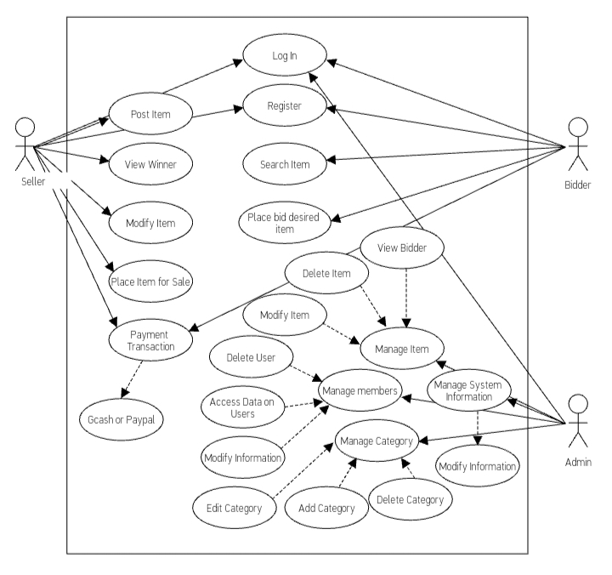

It is extremely significant to understand the needs of the user in a project. Use case diagram assists in defining the user requirements and needs. It also shows the interaction between the system users and the system itself which allows easier designing and development activities. The users for online auction management web site will be bidder, seller, and admin (Konia, 2007). The actors involved in the use case diagram will be the system, bidder, seller, and admin.

The system will be having three types of user; namely the seller, bidder, and admin.

The seller sells the product to the person who bids the highest price. For sellers, online auctions open up new sales channels for new products and offer buyers favorable purchasing conditions. The bidder, like an in-person auction room online auction allows interested buyers to bid against each other for a particular item. At the end of the auction window, the person with the highest bid receives the item. Online auctions often allow buyers to find expensive items at a reduced rate. Admin are able to manage the listings content in a way that they are able to edit or delete them if they are found to not follow the platform's rules and holds online auctions of various products on a website and serves sellers and bidders accordingly. The system is designed to allow users to set up their products for auctions and bidders to register and bid for various products available for bidding.

**ACTIVITY DIAGRAM**

**Figure 4.**

Digital and Handmade Artwork Online Auction System for Artist Students

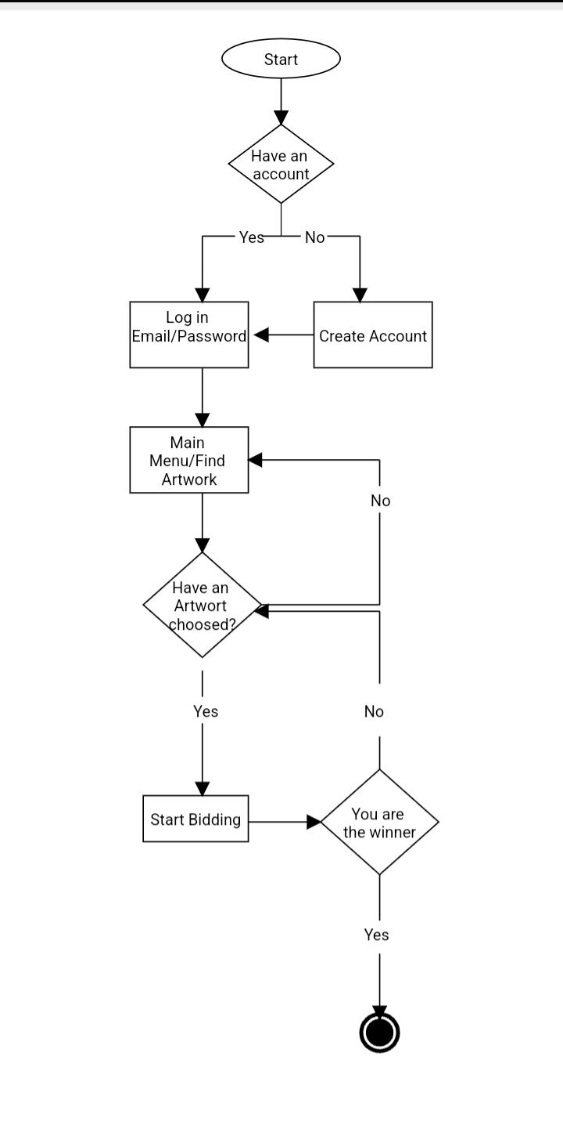

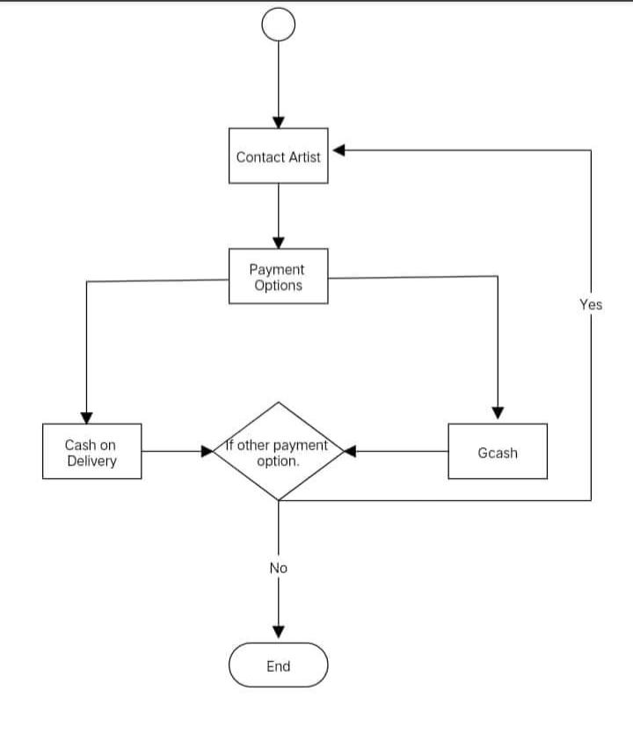

Activity diagram provides a graphical representation of various activities that are carried out in an application. A clear overview of the online auction management website will be provided from the beginning till the end (Maltzman, 2008). The workflow of the activities and their dependencies with each other during the execution of the tasks and processes is shown in the activity diagram. The major functionalities of the site have been depicted using the diagram as shown above

**Figure 5**

**Entity Diagram**

**Digital and Handmade Artwork Online Auction System for Artist Students**

|  |
| --- |
| USERS |
| user_id (PK)  firstname  middlename  lastname  suffix  dob  age  email  contact  birthplace  gender  civilstatus  occupation  religion  house_no  street_name  purok  zone  barangay  municipality  province  region  image  password  user_type  verification_code  failed_attemp  last_failed_attemp  date-registered |

|  |
| --- |
| CATEGORY |
| cat_id (PK)  cat_name  date_added |

|  |
| --- |
| PRODUCT |
| product_id (PK)  user_id (FK)  product_cat_id (FK)  product_name  product_desc  starting_price  bid_due_date  product_image  product_status  date_created |

|  |
| --- |
| BIDDING |
| bidding_id (PK)  user_id (FK)  product_id (FK)  bidding_price  bidding_status  payment  payment_proof  date_added |

|  |
| --- |
| BIDDING_WINNER |
| winner_id (PK)  user_id (FK)  product_id (FK)  date_won |

This means that every time a bidder submits a bid or requests a price quote, a script is run to check whether the auction has terminated accordingly.

**Data Structures with Sample Records**

**Table 3**

**Data Structure for User**

|  |  |  |
| --- | --- | --- |
| **Field Name** | **Data Type** | **Field Size** |
| user_id | int | 11 |
| first name | varchar | 255 |
| middle name | varchar | 255 |
| last name | varchar | 255 |
| suffix | varchar | 255 |
| dob | varchar | 255 |
| age | varchar | 100 |
| email | varchar | 100 |
| contact | varchar | 100 |
| birthplace | varchar | 255 |
| gender | varchar | 255 |
| civilstatus | varchar | 50 |
| occupation | varchar | 50 |
| religion | varchar | 100 |
| house_no | varchar | 255 |
| street_name | varchar | 255 |
| purok | varchar | 255 |
| zone | varchar | 255 |

|  |  |  |
| --- | --- | --- |
| barangay | varchar | 255 |
| municipality | varchar | 255 |
| province | varchar | 255 |
| region | varchar | 255 |
| image | varchar | 255 |
| password | varchar | 100 |
| user_type | varchar | 50 |
| verification_code | int | 11 |
| failed_attemp | int | 11 |
| last_failed_attemp | timestamp |  |
| date-registered | date |  |

**Table 3.a**

**Sample Record for User**

|  |  |  |  |  |  |
| --- | --- | --- | --- | --- | --- |
| **user_id** | **first name** | **middle name** | **last name** | **suffix** | **dob** |
| 1 | Cain | Paz | Rualizo | n/a | 06/23/2000 |
| *2* | Sherlyn | Garrote | Duldulao | n/a | 05/28/2000 |
| 3 | Josh | Dela | Cruz | n/a | 02/19/2001 |

***Continuation of Table 3.b …***

|  |  |  |  |  |  |
| --- | --- | --- | --- | --- | --- |
| **age** | **email** | **Contact** | **birthplace** | **gender** | **civilstatus** |
| 22 | cainrualizo@gmail.com | 09351676433 | Vacunero, Sto. Dominngo, Ilocos Sur | Male | single |
| 22 | sherlynduldulao@gmail.com | 09551645181 | Namalpalan, Magsingal, Ilocos Sur | Female | single |
| 21 | Juandelacruz@gmail.com | 09268165482 | Bantay, Vigan, Ilocos Sur | Male | single |

***Continuation of Table 3.c …***

|  |  |  |  |  |  |
| --- | --- | --- | --- | --- | --- |
| **occupation** | **religion** | **house_no** | **street_name** | **purok** | **zone** |
| Student | Catholic | 115 | Rualizo | n/a | 1 |
| Student | Catholic | n/a | Nagdarawan | n/a | 8 |
| Student | Catholic | 1727 | n/a | n/a | 4 |

***Continuation of Table 4.d …***

|  |  |  |  |  |  |
| --- | --- | --- | --- | --- | --- |
| **barangay** | **municipality** | **province** | **region** | **image** | **password** |
| Vacunero | Sto. dominggo | Ilocos Sur | 1 |  | ******** |
| Namalpalan | Magsingal | Ilocos Sur | 1 |  | ******** |
| Bantay | Vigan | Ilocos Sur | 1 |  | ******** |

***Continuation of Table 3.e …***

|  |  |  |  |  |
| --- | --- | --- | --- | --- |
| **user_type** | **Verification_code** | **failed_attempt** | **last_failed_attempt** | **date_registered** |
| Admin | 374025 | 1 | 2023-05-06 | 2023-11-25 |
| Seller | 267064 | 0 | 2023-05-08 | 2023-04-26 |

**Table 4**

**Data Structure for Category**

|  |  |  |
| --- | --- | --- |
| **Field Name** | **Data Type** | **Field Size** |
| cat_ id | Int | 11 |
| cat_name | varchar | 255 |
| date_added | timestamp |  |

**Table 4.a**

**Sample Record for Category**

|  |  |  |
| --- | --- | --- |
| **cat_id** | **cat_name** | **dated_added** |
| 17 | Handmade | 2023-04-25 |
| 18 | Digital | 2023-04-25 |
| 19 | Paintings | 2023-05-08 |

**Table 5**

**Data Structure for Product**

|  |  |  |
| --- | --- | --- |
| **Field Name** | **Data Type** | **Field Size** |
| product_id | int | 11 |
| user_id | int | 11 |
| product_cat_id | int | 11 |
| product_name | varchar | 255 |
| product_desc | text |  |
| starting_price | varchar | 150 |
| bid_due_date | datetime |  |
| product_image | varchar | 255 |
| product_status | int | 11 |
| date_created | timestamp |  |

**Table 5.a**

**Sample Records for Product**

|  |  |  |  |  |
| --- | --- | --- | --- | --- |
| **product_id** | **user_id** | **product_cat_id** | **product_name** | **product_desc** |
| 1 | 1 | 1 | Old Style of Jar | Made in Clay |
| 2 | 2 | 2 | Head of Poseidon | Made in Vector |
| 3 | 3 | 3 | Abstract Painting | Made in high quality canvas |

|  |  |  |  |  |
| --- | --- | --- | --- | --- |
| **starting_price** | **bid_due_date** | **product_image** | **product_status** | **date_created** |
| 1000 | 2023-05-25 | jarartwork.jpeg | 0 | 2023-05-06 |
| 2000 | 2023-05-05 | digitalartwork.jpeg | 1 | 2023-05-09 |
| 5000 | 2023-05-07 | image(3).jpeg | 1 | 2023-05-08 |

***Continuation of Table 5.a …***

**Table 6**

**Data Structure for Bidding**

|  |  |  |
| --- | --- | --- |
| **Field Name** | **Data Type** | **Field Size** |
| bidding_id | int | 11 |
| user_id | int | 11 |
| product_id | int | 11 |
| bidding_price | int | 11 |
| bidding_status | int | 11 |
| payment | int | 11 |
| payment_proof | varchar | 255 |
| date_added | timestamp |  |

**Table 6.a**

**Sample Records for Bidding**

|  |  |  |  |
| --- | --- | --- | --- |
| **bidding_id** | **user_id** | **product_id** | **bidding_price time** |
| 1 | 1 | 01 | 01:06:02 |
| 2 | 2 | 02 | 01:24:13 |
| 3 | 3 | 03 | 01:13:46 |

***Continuation of Table 6.a …***

|  |  |  |  |
| --- | --- | --- | --- |
| **bidding_status** | **Payment** | **payment_proof** | **date_added** |
| Win | Gcash | Image.jpg | 05/05/2023 |
| Win | Paypal | Image.jpg | 05/01/2023 |
| Loose | Gcash | Image.jpg | 05/08/2023 |

**Table 7**

**Data structure for Bidding Winner**

|  |  |  |
| --- | --- | --- |
| **Field Name** | **Data Type** | **Field Size** |
| winner_id | int | 11 |
| user_id | int | 11 |
| product_id | int | 11 |
| date_won | timestamp |  |

**Table 7.a**

**Sample Records for Bidding Winner**

|  |  |  |  |
| --- | --- | --- | --- |
| **winner_id** | **user_id** | **product_id** | **date_won** |
| 1 | 01 | 1 | 04/26/2023 |
| 2 | 02 | 2 | 04/06/2023 |
| 3 | 03 | 3 | 05/08/2023 |

**Table 8**

**Data Structure for Customization**

|  |  |  |
| --- | --- | --- |
| **Field Name** | **Data Type** | **Field Size** |
| custom_id | Int | 11 |
| logo | Varchar | 255 |
| logoStatus | Int | 11 |
| brandName | Varchar | 255 |
| about | Text |  |
| contact | Contact | 100 |
| email | Varchar | 100 |
| status | Int | 11 |
| date_added | timestamp |  |

**Table 8.a**

**Sample Record for Customization**

|  |  |  |  |  |
| --- | --- | --- | --- | --- |
| **custom_id** | **logo** | **logoStatus** | **brandName** | **about** |
| 1 | ArtBid | ArtBid | Headof Posaidon |  |
| 2 | ArtBid | ArtBid | Jar |  |
| 3 | ArtBid | ArtBid | Painting |  |

***Continuation of Table 3.a***

|  |  |  |  |
| --- | --- | --- | --- |
| **Contact** | **email** | **status** | **date_added** |
| 09551645181 | Cain@gmail.com | Win | 05/01/2023 |
| 09269854123 | Cain@gmail.com | Win | 05/08/2023 |
| 0996251487 | Cain@gmail.com | loose | 04/29/2023 |

**Data Dictionary**

A

address = province+town+barangay

age = 100{Legal_number}

B

barangay = 50{Legal_character}

birthplace = 255{Legal_number}

bidding = 11{Legal_number}

C

contact_no = 11{Legal_number}

category_id = 11{Legal_number}

D

date = MM + DD + YYY

E

email = 50{Legal_character}

F

firstname = 50{Legal_character}

G

gender = 20{Legal_character}

L

lastname = 50{Legal_character}

Legal_Character} = [a..z/A..Z/./.-]

M

MM = [1..12]

middlename = 50{Legal_character}

N

name = firstname+middlename+

lastnme

P

product = 11{Legal_character}

password = {Legal_character}+

{Legal_number}

province = {Legal_character}+

{Legal_number}

payment = 11{Legal_character}

S

suffix = 50{Legal_character}

streetname = 50{Legal_character}

T

town = 20{Legal_character}

U

user_ID = 50{Legal_character}

username = {Legal_character}

{Legal_number}

YYYY = 4{Legal_number}

**Figure 6**

**Input-Process-Output**

**INPUT PROCESS OUTPUT**

1. **Product Information**
2. **Add Product Information**

Added Product Information

Add Product Information

Product Information

1. **Update Product Details**

Updated Product Information

Edit Product Information

Product Id

1. **Search Product Details**

Searched Product

Search Product

Product Id

1. **View Product Details**

Viewed Product

View Product

Product Id

1. **Upload Product**

Uploaded Product

Upload Product

Product Id

**Figure 7**

**Hierarchical Input Process Output for Buyer**

Sign Out

Edit

View

Bid

View

Send

View

Bid

View

Dashboard

Transaction

Products

Profile

Main Menu

Log In

**Figure 8**

**Hierarchical Input Process Output for Seller**

Sign Out

Modify

View

Confirm

View

Modify

View

View

Dashboard

Manage Product

View Winner

Profile

Main Menu

Log In

**Figure 9**

**Hierarchical Input Process Output for Admin**

Main Menu

Log In

Modify

View

Setting

Modify

View

Sign Out

View

Modify

Modify

View

Modify

View

View

Users

Profile

Manage Product

Manage Category

Dashboard

**Evaluation of the Developed System**

The tabular form of the respondents are shown and correspond to the interpretation of the Digital and Handmade Artwork Online Auction System for Artist Students.

**Table 13**

**Evaluation of Digital and Handmade Artwork Online Auction System for Artist Students in terms of Functional Suitability**

|  |  |  |
| --- | --- | --- |
| Indicator | Mean | Descriptive Equivalent Rating |
| Functional Suitability |  |  |
| Functional Completeness | 4.65 | Excellent |
| Functional Correctness | 4.45 | Very Good |
| Functional Appropriateness | 4.35 | Very Good |
| **Sub Mean** | **4.48** | Very Good |

Table 13 shows the indicators for the evaluation of Digital and Handmade Artwork Online Auction System for Artist Students in terms of Functional Suitability with the following sub area: Functional Completeness with a mean of 4.65 and a descriptive equivalent rating of “Excellent”, Functional Correctness with a mean of 4.45 and a descriptive equivalent rating of “Very Good”, Functional Appropriateness with a mean of 4.35 and a descriptive equivalent rating of “Very Good”. It has a sub mean of 4.48 with a descriptive equivalent rating “Very Good”.

**Table 14**

**Evaluation of Digital and Handmade Artwork Online Auction System for Artist Students in terms of Performance Efficiency**

|  |  |  |
| --- | --- | --- |
| Indicator | Mean | Descriptive Equivalent Rating |
| Performance Efficiency |  |  |
| Time Behaviour | 5.00 | Excellent |
| Resource Utilization | 4.00 | Very Good |
| Capacity | 5.00 | Excellent |
| **Sub Mean** | **4.66** | Excellent |

Table 14 shows the indicators for the evaluation of Digital and Handmade Artwork Online Auction System for Artist Students in terms of Performance Efficiency with the following sub area: Time Behaviour with a mean of 5.00 and a descriptive equivalent rating of “Excellent”, Resource Utilization with a mean of 4.00 and a descriptive equivalent rating of “Very Good”, Capacity with a mean of 5.00 and a descriptive equivalent rating of “Excellent”. It has a sub mean of 4.66 with a descriptive equivalent rating “Excellent”.

**Table 15**

**Evaluation of Digital and Handmade Artwork Online Auction System for Artist Students in terms of Reliability**

|  |  |  |
| --- | --- | --- |
| Indicator | Mean | Descriptive Equivalent Rating |
| Reliability |  |  |
| Maturity | 4.20 | Very Good |
| Availability | 4.45 | Very Good |
| Fault Tolerance | 4.20 | Very Good |
| Recoverability | 4.05 | Very Good |
| **Sub Mean** | **4.22** | Very Good |

Table 15 shows the indicators for the evaluation of Digital and Handmade Artwork Online Auction System for Artist Students in terms of Reliability with the following sub area: Maturity with a mean of 4.20 and a descriptive equivalent rating of “Very Good”, Availability with a mean of 4.45 and a descriptive equivalent rating of “Very Good”, Fault Tolerance with a mean of 4.20 and a descriptive equivalent rating of “Very Good”, Recoverability with a mean of 4.05 and a descriptive equivalent rating of “Very Good”. It has a sub mean of 4.22 with a descriptive rating “Very Good”.

**Table 16**

**Evaluation of Digital and Handmade Artwork Online Auction System for Artist Students in terms of Security**

|  |  |  |
| --- | --- | --- |
| Indicator | Mean | Descriptive Equivalent Rating |
| Security |  |  |
| Confidentiality | 4.55 | Excellent |
| Integrity | 4.70 | Excellent |
| Non-Repudiation | 4.05 | Very Good |
| Accountability | 4.40 | Very Good |
| Authenticity | 4.35 | Very Good |
| Sub Mean | 4.41 | Very Good |

Table 16 shows the indicators for the evaluation of Digital and Handmade Artwork Online Auction System for Artist Studentsin terms of Security with the following sub area: Confidentiality with a mean of 4.55 and a descriptive equivalent rating of “Excellent”, Integrity with a mean of 4.70 and a descriptive equivalent rating of “Excellent”, Non-Repudiation with a mean of 4.05 and a descriptive equivalent rating of “Very Good”, Accountability with a mean of 4.40 and a descriptive equivalent rating of “Very Good”, Authenticity with a mean of 4.35 and a descriptive equivalent rating of “Very Good”. It has a sub mean of 4.41 with a descriptive equivalent rating “Very Good”.

**Chapter IV**

**FINDINGS, CONLUSIONS, AND RECOMMENDATIONS**

**Findings**

The researchers were able to develop a Digital and Handmade Online Auction System for Artist Students have come up with the following findings:

The researcher have encountered problems with the online auction payment.

Due to time constraints and lack of technical knowledge, we could not develop an administrative section of the online auction website and online payment system could not be achieved. However, the team is still researching on how to add all those features for user satisfaction.

1. The functional requirements of the system.

The developed system has functional requirements that the links to various pages of the system was tested and was successful.

2. The developed Digital and Handmade Online Auction System for Artist Students.

The researchers used the Agile Scrum model in developing the system. The system was organized by the researchers by using the requirement gathering, user design: planning, design, develop, test, release and feedback.

3. Evaluation/Level of Usability of the Proposed System

Using ISO 25010, the researchers were able to determine the quality of the proposed system in terms of the criteria Functional Sustainability, Performance Efficiency, Reliability and Security. The Digital and Handmade Online Auction System for Artist Students was evaluated by the students in the College of Arts and Science. The proposed system was evaluated in four criteria namely; Functional Sustainability, Performance Efficiency, Reliability and Security.

* 1. **Functional Suitability.** All indicators under Functional Suitability were rated as follows: Functional Completeness with a mean of 4.65, Functional Correctness with a mean of 4.45, Functional Appropriateness with a mean of 4.35. Overall, Functional Suitability was rated “Very Good” with a mean rating of “4.48” and interpreted to be “Highly Usable”.
  2. **Performance Efficiency.** All indicators under Performance Efficiency were rated as follows: Time with a mean of 5.00, Resource Utilization with a mean of 4.00, Capacity with a mean of 5.00. Overall, Performance Efficiency was rated “Excellent” with a mean rating of “4.66” and interpreted to be “Very Usable”.
  3. **Reliability.** All indicators under Reliability were rated as follows: Maturity with a mean of 4.20, Availability with a mean of 4.45, Fault Tolerance with a mean of 4.20, Recoverability with a mean of 4.05. Overall, Reliability was rated “Very Good” with a mean rating of “4.22” and interpreted to be “Highly Usable”.
  4. **Security.** All indicators under Security were rated as follows: Confidentiality with a mean of 4.55, Integrity with a mean of 4.70, Non-Repudiation with a mean of 4.05, Accountability with a mean of 4.40, Authenticity with a mean of 4.35. Overall, Security was rated “Very Good” with a mean rating of “4.11” and interpreted to be “Highly Acceptable”.

**Conclusion**

[An](https://www.lawinsider.com/clause/conclusion-of-online-auction-or-pass-in-sale) Online Auction, excluding a Live Auction, will close at the end of the time period specified for that Online Auction, provided there are no new successful bids during the 24 hours immediately preceding the end of the time period specified. If there are any successful bids on a particular lot or item within 24 hours of the time specified for the close of the Online Auction (the going, going, gone period), the auction will continue to be extended until there are no more within the Refresh Period. We accept no responsibility for any missed or unsuccessful bids resulting from any slight variations that may occur in the length of the Refresh Period.

Based on the findings of the developed system, the following conclusions were drawn:

1. The problems encountered in the manual system of Online Auction System will be addressed through the implementation of the developed system.
2. The functional requirements integrated in the online auction system met the expectation and needs of the clinic.
3. The Agile Scrum Development software process model is an efficient model in developing the system. It ensures the development of a high quality products faster by following its phases.
4. The developed system is functional, efficient, reliable, and secured as indicated by the grand mean of 4.44 and interpreted “Highly Usable”.

**Recommendation**

One thing which is not permanent in the business world is change. Therefore, the most successful companies are those that successfully harness and exploit innovation. The computer, when properly used, serves as the springboard for productivity and is a powerful instrument for effectiveness and efficiency.

We, therefore, recommend that the administrative section of this work would be looked at by interested researchers who have an interest in the field of study. Also, a payment system that will allow users to pay money online for their goods to be delivered to them could be enhanced.

REFERENCES

**REFERENCES**

Halton, C. (2018). An Empirical Analysis into the Determinants of eBay Auction Market

Closing Prices.

Chen, K., Ho, S., Liu, C., & Wang, C. (2017). THE OPTIMAL LISTING STRATEGIES IN

ONLINE AUCTIONS. *International Economic Review,* *58*(2), 421-437. Retrieved

September 11, 2021, from <http://www.jstor.org/stable/44280180>

Chen, K.-P., Lai, H.-pin, & Yu, Y.-T. (2017, November 24). The seller’s listing strategy in

online auctions: Evidence from eBay. International Journal of Industrial Organization. Retrieved September 11, 2021, from https://www.sciencedirect.com/science/article/abs/ pii/S0167718716303198%C2%A0

Kirkegaard, R., & Overgaard, P. (2008). Buy-Out Prices in Auctions: Seller Competition and

MultiUnit Demands. *The RAND Journal of Economics,* *39*(3), 770-789. Retrieved September 11, 2021, from <http://www.jstor.org/stable/25474396>

Gallien, J., & Gupta, S. (2007). Temporary and Permanent Buyout Prices in Online Auctions.

*Management Science,* *53*(5), 814- 833. Retrieved September 11, 2021, from <http://www.jstor.org/stable/20110742>

Decision making approaches for online auction with a permanent buyout option. IEEE

Xplore. (n.d.). Retrieved September 11, 2021, from https://ieeexplore.ieee.org/document/8407678%C2 %A0.

Chan, Tat & Lu, Kai & Wei, Zaiyan. (2019). Information Asymmetry and Strategic Early

Bidding in Peer-to-Peer Lending. SSRN Electronic Journal. 10.2139/ssrn.3403211.

Reza HABIBI. (2019). A NOTE ON STOPPING STRATEGY OF AUCTION:

MAXIMIZATION SELLER GAIN PERSPECTIVE. https://www.upicardie.fr/eastwest/fichiers/art241.pdf

Peters, E. & Aggrey K., (2020). Retrieved on May 12, 2022 from An ISO 25010

Based Quality Model for ERP Systems. Advances in Science, Technology and Engineering Systems Journal Vol. 5, No. 2, 578-583. Page

Sean Peak, (2022) Agile scrum methodology is a sprint-based project management system

APPENDICES

**Appendix A**

**Letter of Request**

***COLLEGE OF COMMUNICATION AND INFORMATION TECHNOLOGY***

January 13, 2023

**DR. ASHLEY S. MARTINEZ**

Dean, College of Fine Arts and Design

**Dear Sir,**

The Fourth Year BS Information Technology students of the University of Northern Philippines are currently developing systems as part of their requirements in their course, Capstone Project and Research 2. One group, composedof **Rualizo, Cain P., Duldulao, Sherlyn G., Belarde, Kobe Byein D., and Arruejo, Jan Paolo P.,** intends to develop a system for your college – the“Digital and Handmade Artwork Online Auction System for Artist Students”.

Rest assured that the data gathered will be used solely for research purposes and will be treated with utmost confidentiality. It is my hope that this humble request will be granted on a positive note.

Thank you for your unending support to the community’s development through Information Technology researches.

Very truly yours,

**RICHARD C. ARRUEJO, DIT**

*Capstone Project Adviser*

Noted:

**ROSANNE S. AGUP, MIS**

*Dean, CCIT*

Approved:

**ASHLEY S. MARTINEZ, PhD**

Dean, College of Fine Arts and Design

**Appendix B**

**Interview Guide**

Name: _________________________________________

Position: _______________________________________

Date of Interview: ________________________________

Questions:

1. What are the different processes of your online auction?

__________________________________________________________________

1. How is the process of your bidding session?

__________________________________________________________________

1. What features are important to you when choosing an auction platform?

__________________________________________________________________

1. If automated system will be developed, what features do you want to be integrated in the system?

__________________________________________________________________

__________________________________________________________________

**Appendix C**

**Evaluation Sheet**

E-Skedyul: Web-based Patient Appointment Information System of Tinaza Dental Center

Direction: Put check (√ ) the box that corresponds to your answer. Use the legend as your guide.

|  |  |
| --- | --- |
| Numerical Rating | Descriptive Rating |
| 5 | Very Usable |
| 4 | Highly Usable |
| 3 | Usable |
| 2 | Fairly Usable |
| 1 | Not Usable |

|  |  |  |  |  |  |
| --- | --- | --- | --- | --- | --- |
| A. Functional Suitability | 5 | 4 | 3 | 2 | 1 |
| 1. Functional Completeness - Degree to which the set of functions covers all the specified tasks and user objectives. |  |  |  |  |  |
| 2. Functional Correctness - Degree to which a product or system provides the correct results with the needed degree of precision. |  |  |  |  |  |
| 3. Functional Appropriateness - Degree to which the functions facilitate the accomplishment of specified tasks and objectives. |  |  |  |  |  |
| B. Performance Efficiency |  |  |  |  |  |
| 1. Time Behaviour - Degree to which the response and processing times and throughput rates of a product or system, when performing its functions, meet requirements. |  |  |  |  |  |
| 2. Resource Utilization - Degree to which the amounts and types of resources used by a product or system, when performing its functions, meet requirements |  |  |  |  |  |
| 3. Capacity - Degree to which the maximum limits of a product or system parameter meet requirements. |  |  |  |  |  |
| C. Reliability |  |  |  |  |  |
| 1. Maturity - Degree to which a system, product or component meets needs for reliability under normal operation. |  |  |  |  |  |

|  |  |  |  |  |  |
| --- | --- | --- | --- | --- | --- |
| 2. Availability - Degree to which a system, product or component is operational and accessible when required for use. |  |  |  |  |  |
| 3. Fault Tolerance - Degree to which a system, product or component operates as intended despite the presence of hardware or software faults. |  |  |  |  |  |
| 4. Recoverability - Degree to which, in the event of an interruption or a failure, a product or system can recover the data directly affected and re-establish the desired state of the system. |  |  |  |  |  |
| D. Security |  |  |  |  |  |
| 1. Confidentiality - Degree to which a product or system ensures that data are accessible only to those authorized to have access. |  |  |  |  |  |
| 2. Integrity - Degree to which a system, product or component prevents unauthorized access to, or modification of, computer programs or data. |  |  |  |  |  |
| 3. Non-Repudiation - Degree to which actions or events can be proven to have taken place so that the events or actions cannot be repudiated later. |  |  |  |  |  |
| 4. Accountability - Degree to which the actions of an entity can be traced uniquely to the entity. |  |  |  |  |  |
| 5. Authenticity - Degree to which the identity of a subject or resource can be proved to be the one claimed. |  |  |  |  |  |

Comments/Suggestions:

________________________________________________________________________ _______________________________________________________________________

Thank You Very Much!

___________________________________________ __________________ Signature Over Printed Name & Position of Evaluator Date of Evaluation Appendix D

**Appendix D**

**PROTOTYPES**

Various activity diagrams were used to illustrate the flow of activities of a given subsystem and the flow of activities of the entire application. Following are some prototypes of the Auction management system application.

**First Page**

The buyer homepage shows available products to bid but once you click the product you will redirect to the login page.

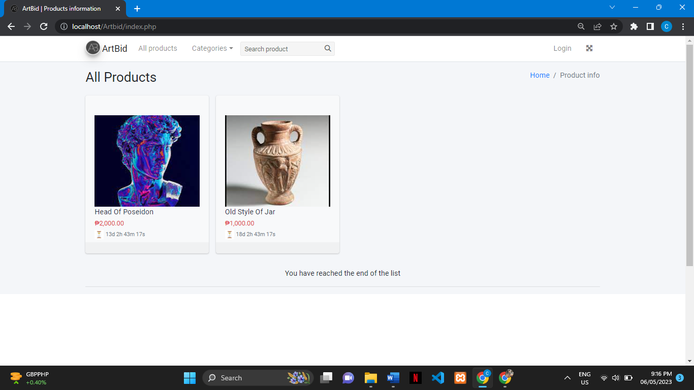

**Buyer and Seller Login and Registration Prototype.**

1. Here on the login page you can fill up your account or if you don’t have an account you can create one in the lower part of the sign-in button. Click whatever you desire to become in your account if it is a buyer or seller.

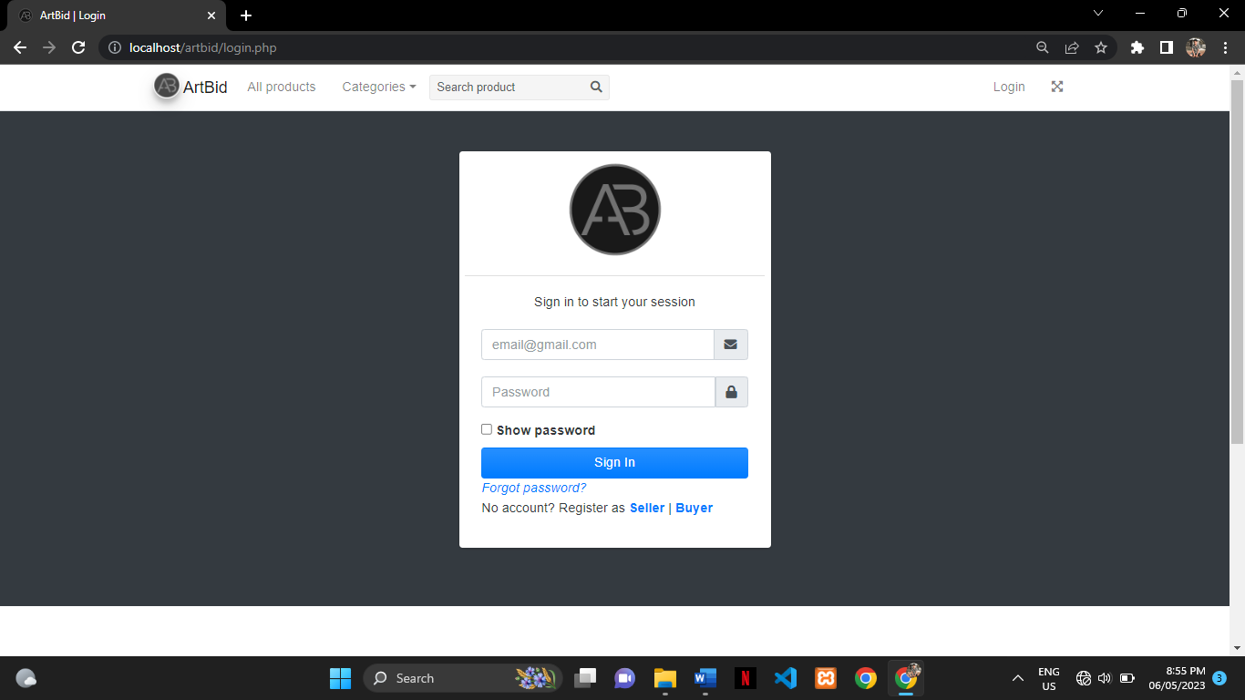

1. Buyer and Seller have the same format of registration.

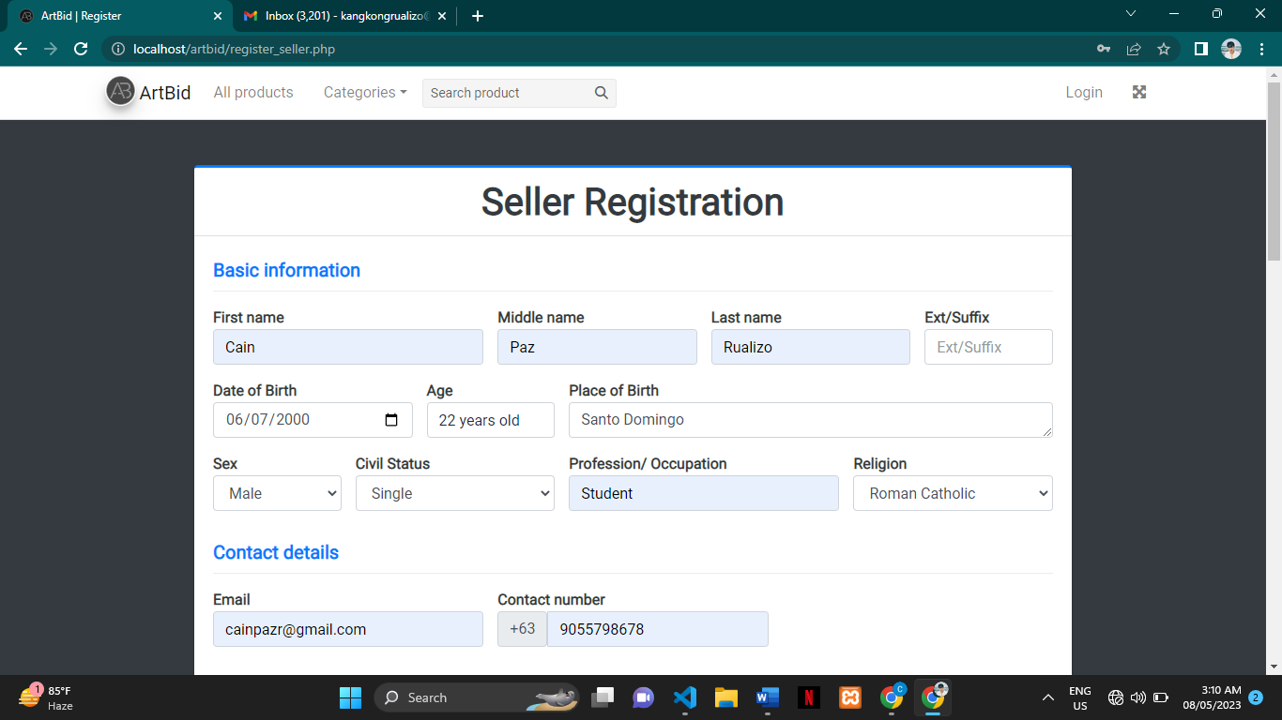

…Fill up the information needed.

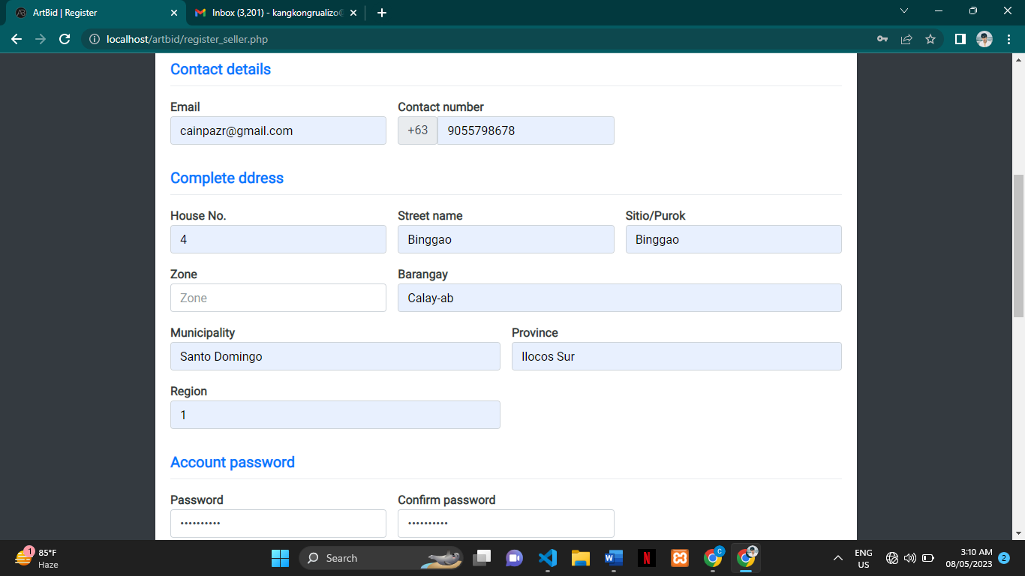

1. Password must meet the right inputs.

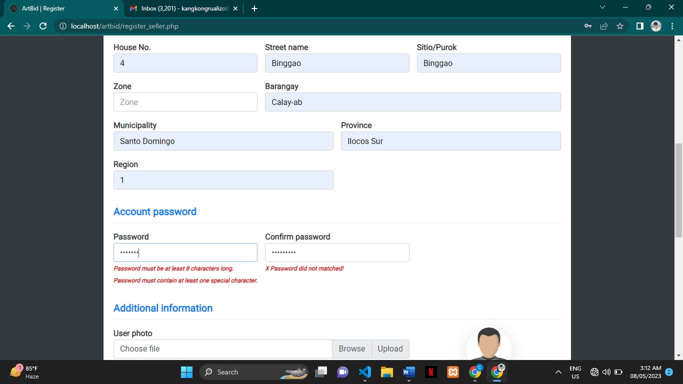

1. After filling up the information needed click submit to register and you will redirect to login.

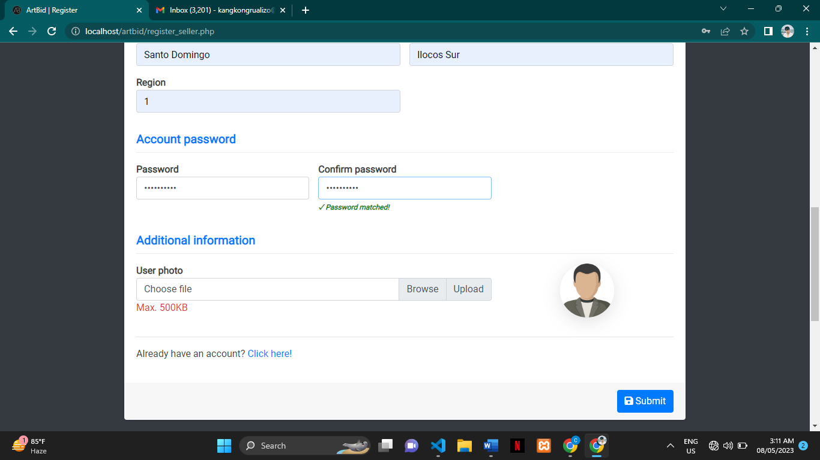

…

…If you typed your password wrong this will pop up.

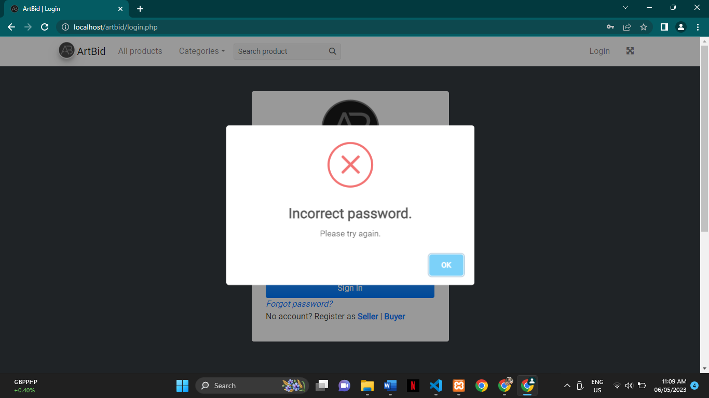

1. If you typed multiple wrong passwords you will be banned in 10 minutes.

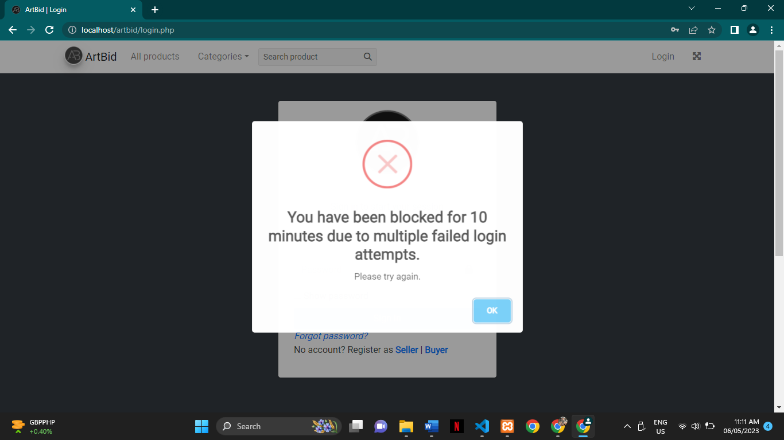

1. If you forget your password you can change it by clicking the forgot password in the login form.



1. Once you clicked the forgot button you will redirect to this page and find your account by pressing the search button to start finding your account.

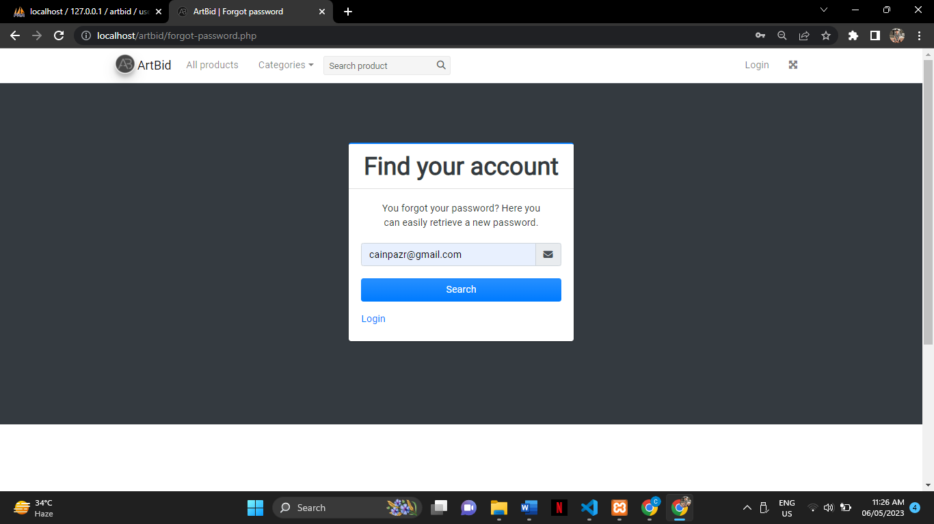

1. Once the System finds your account this page will show and ask you to send a verification code to your email to change your account password. By clicking the continue button a verification code will be sent to your email.

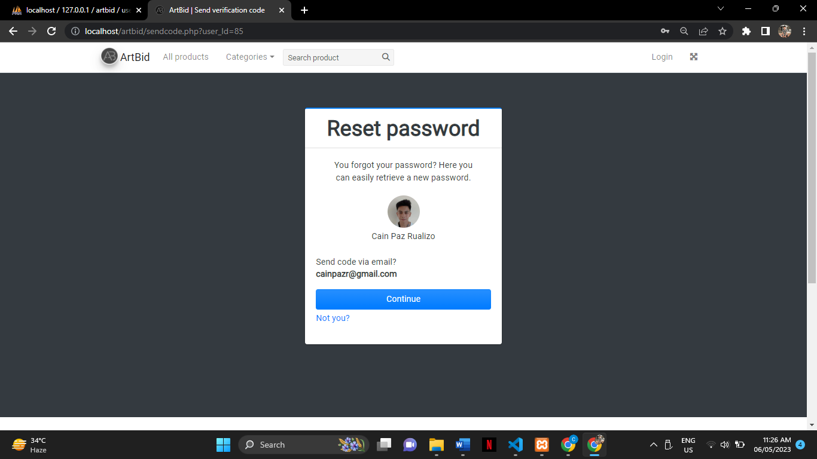

…This will pop up on your screen if the code was sent to your email.

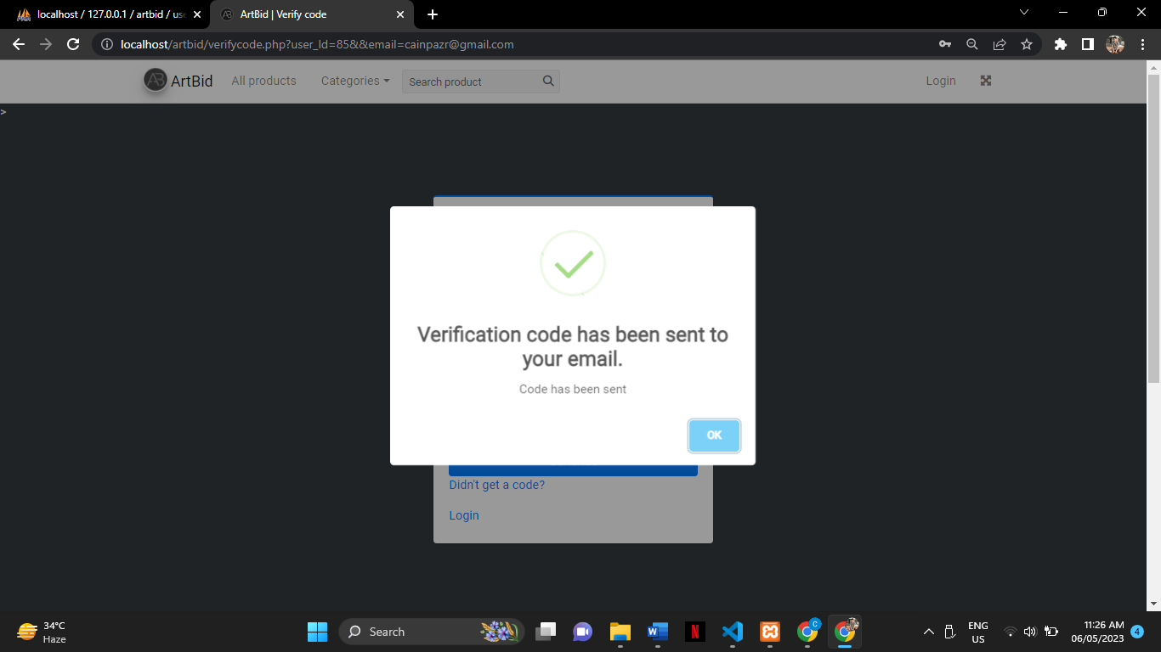

1. Copy the verification code that was sent to your email.

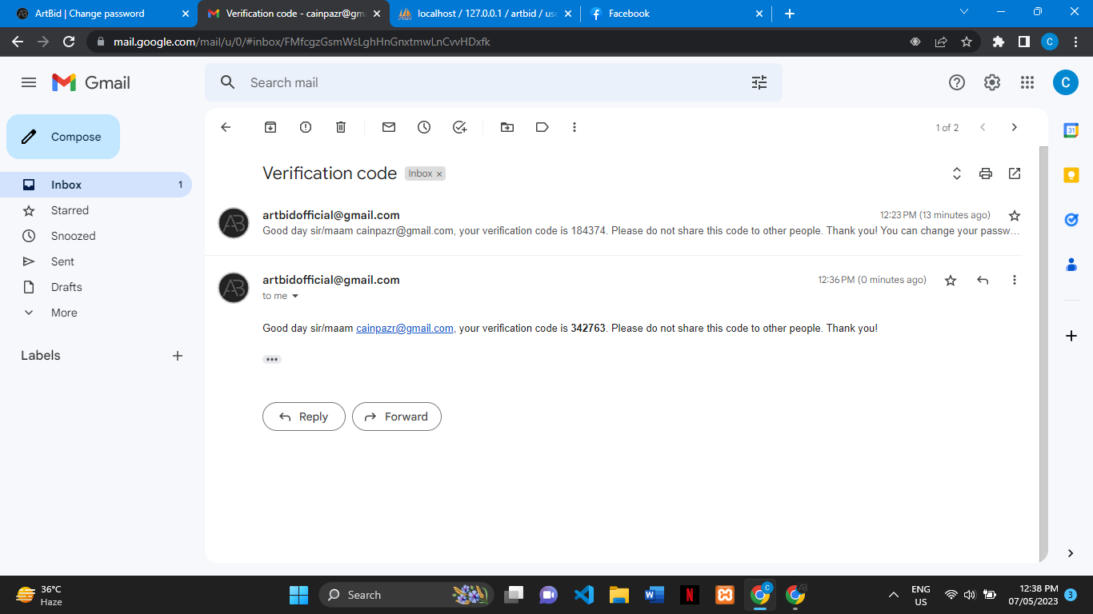

1. Paste the verification code here and click the continue button to verify the code.

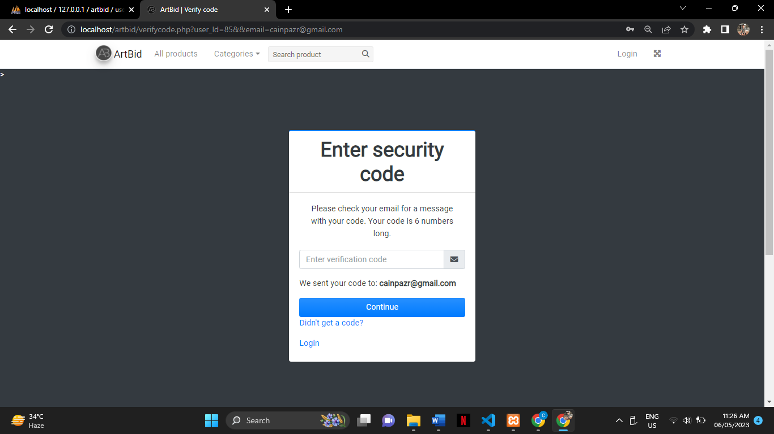

1. Once you submit the code you will redirect to this page to change your password. If you fulfill the information needed click the change password button to change your password.

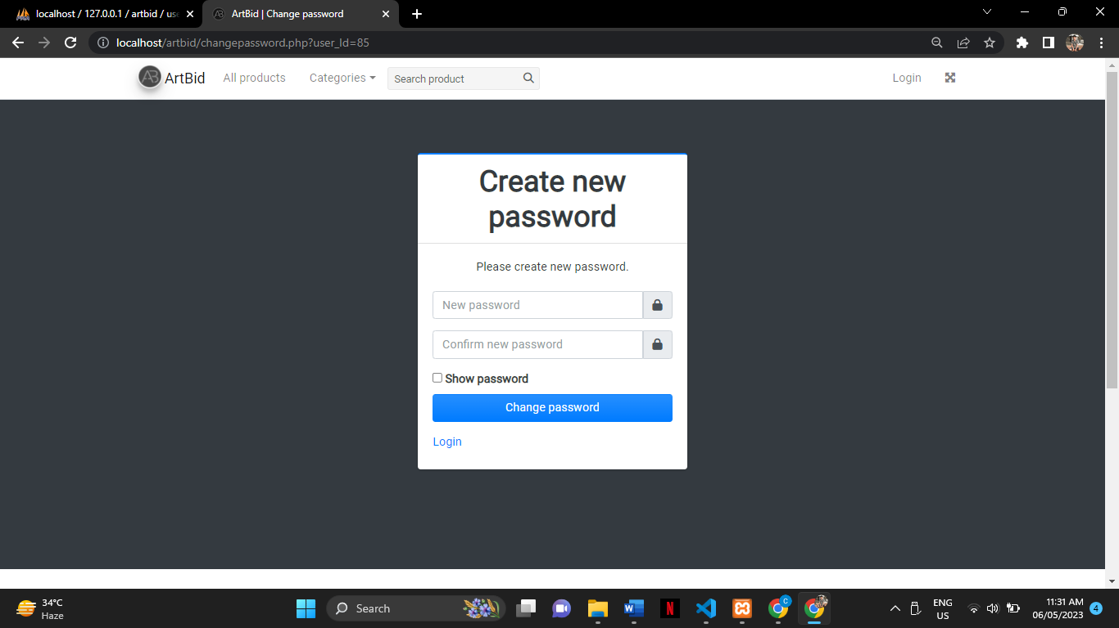

…This will pop up on your screen once the password is successfully changed and you will be redirected to the login page to log in to your account.



**Buyer’s Prototype**

1. Once the account has been login all available products will appear on the screen. Product details are shown in the product card (product image, title, starting price, and the bid due date). The navigation bar contents are Dashboard(On-going Bidding and Ended Bidding), Transaction, All Products, Categories, Search Bar, and Profile.

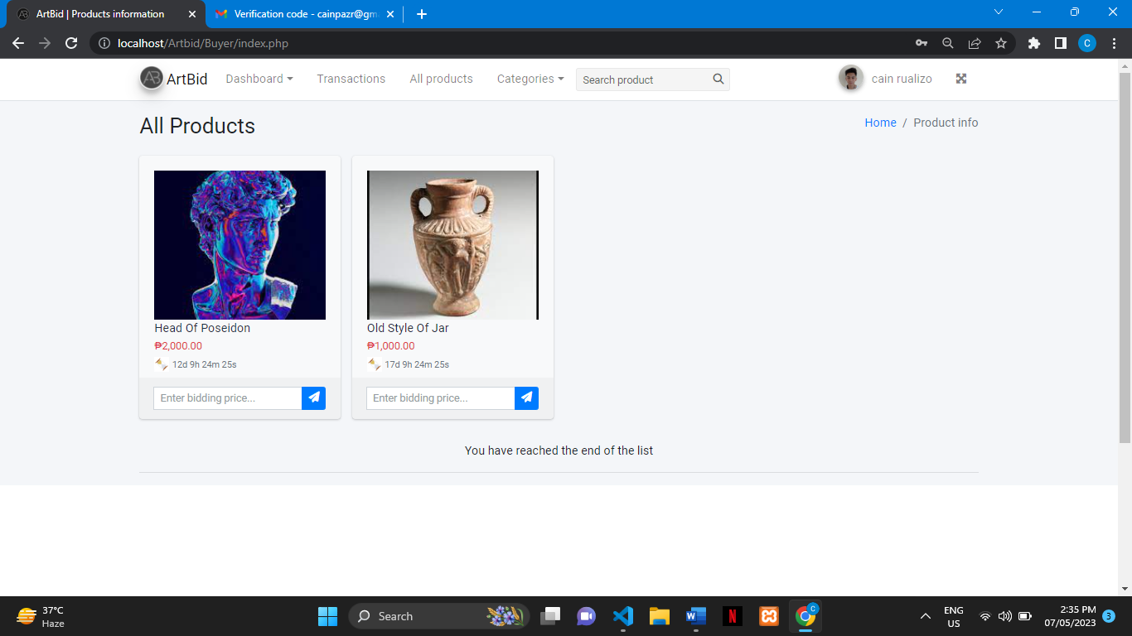

1. To view more details of the product just click the image.

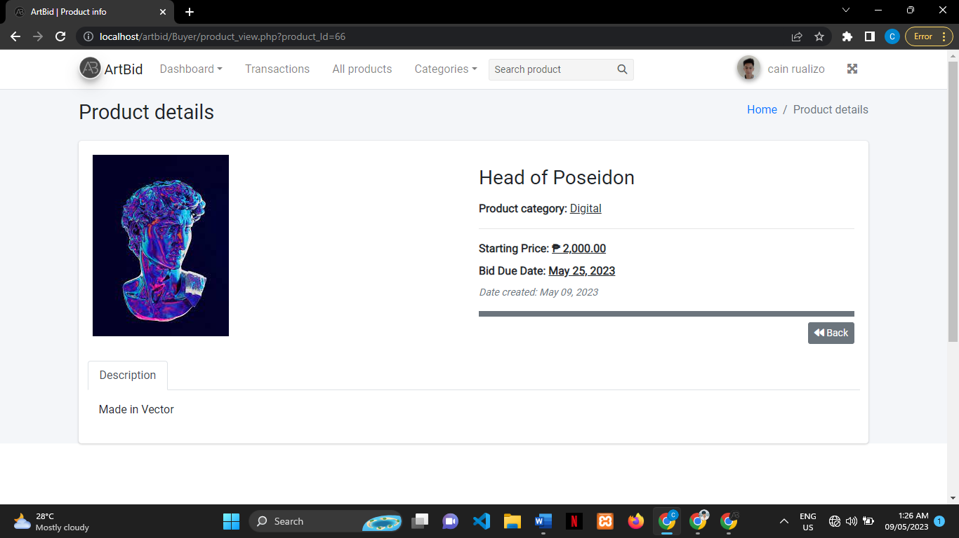

1. To access profile information click the avatar and click the profile.

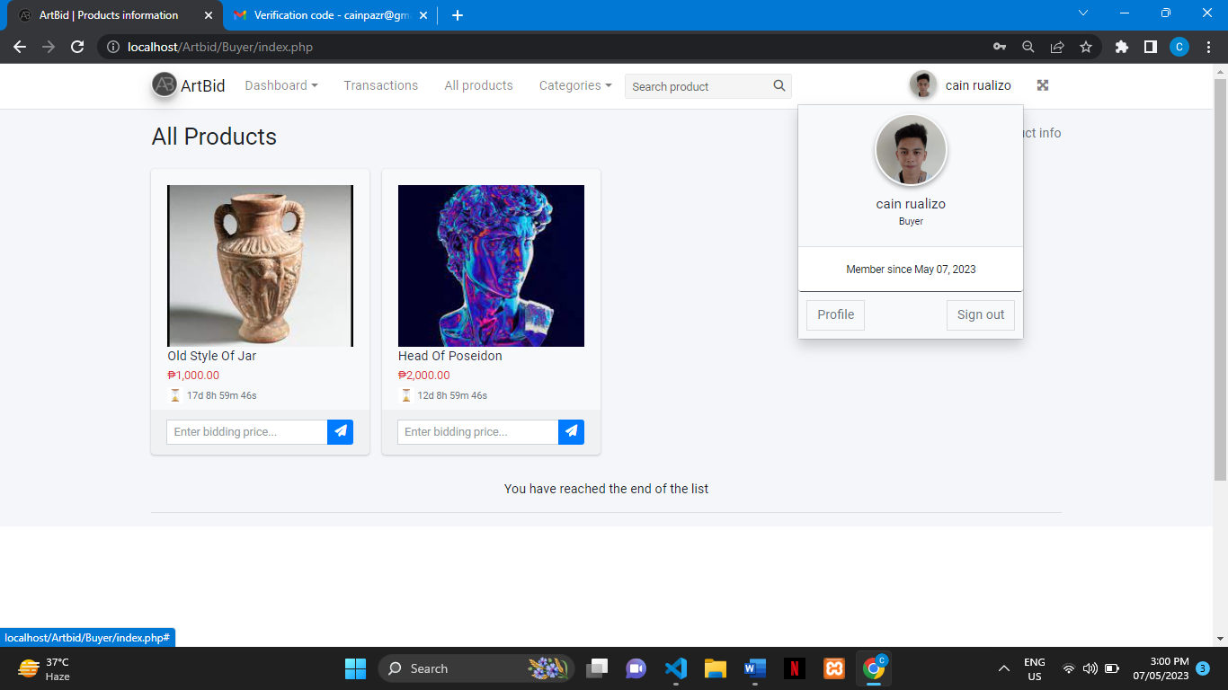

1. This is the profile page buyer, seller, and admin have the same format of profile.

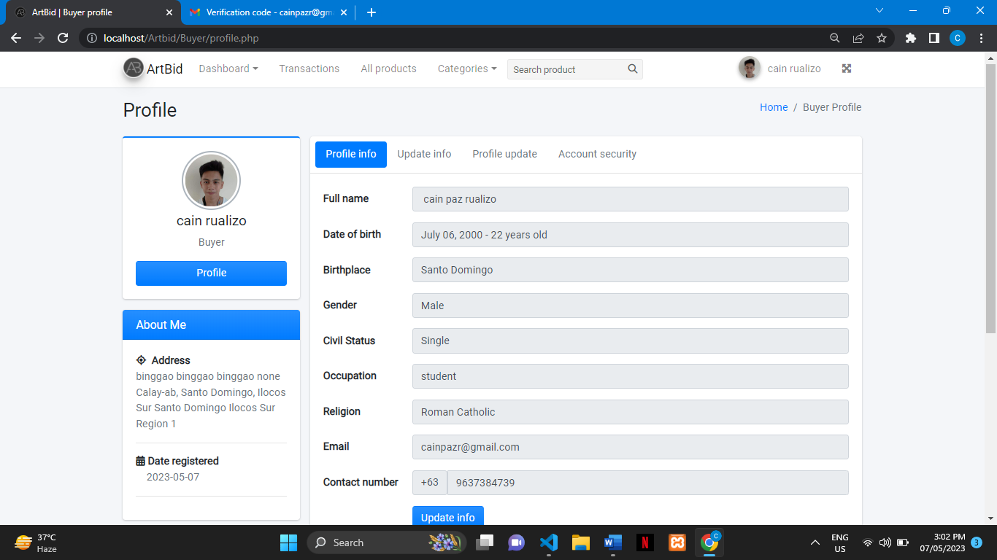

1. To change profile information click the update information just click the update info.

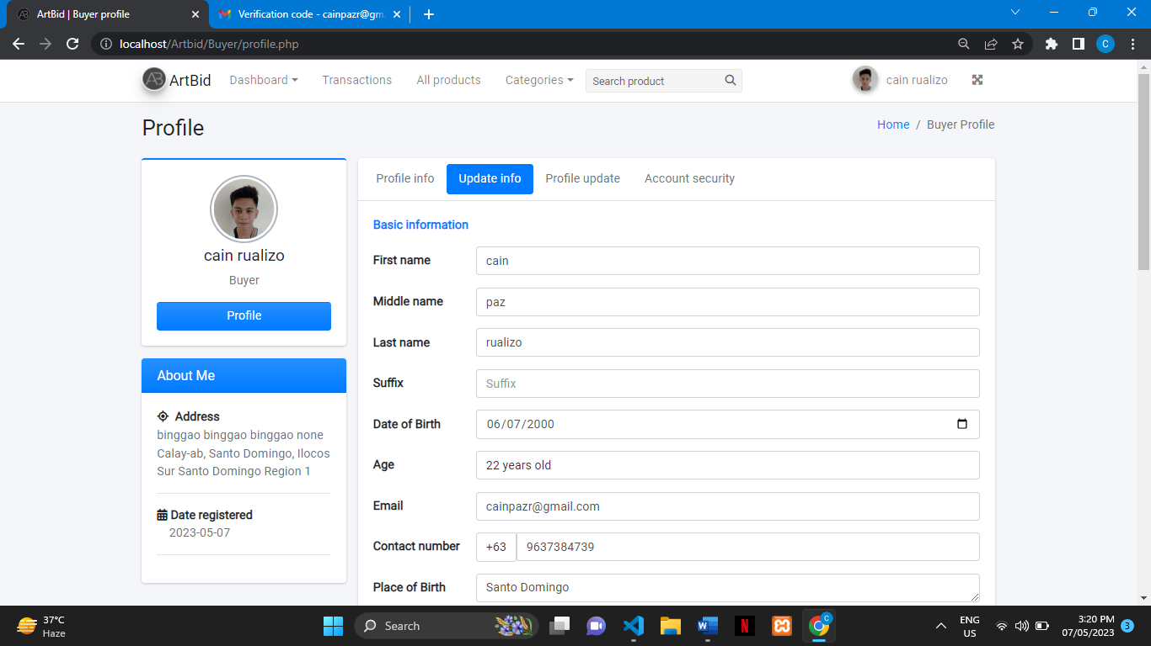

…once you change some information to submit just click submit button in the lower part.

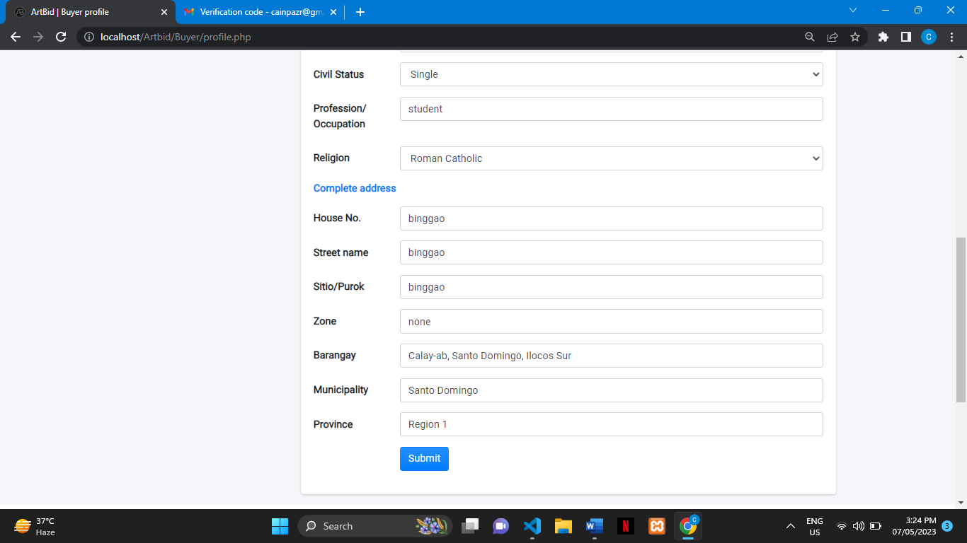

1. 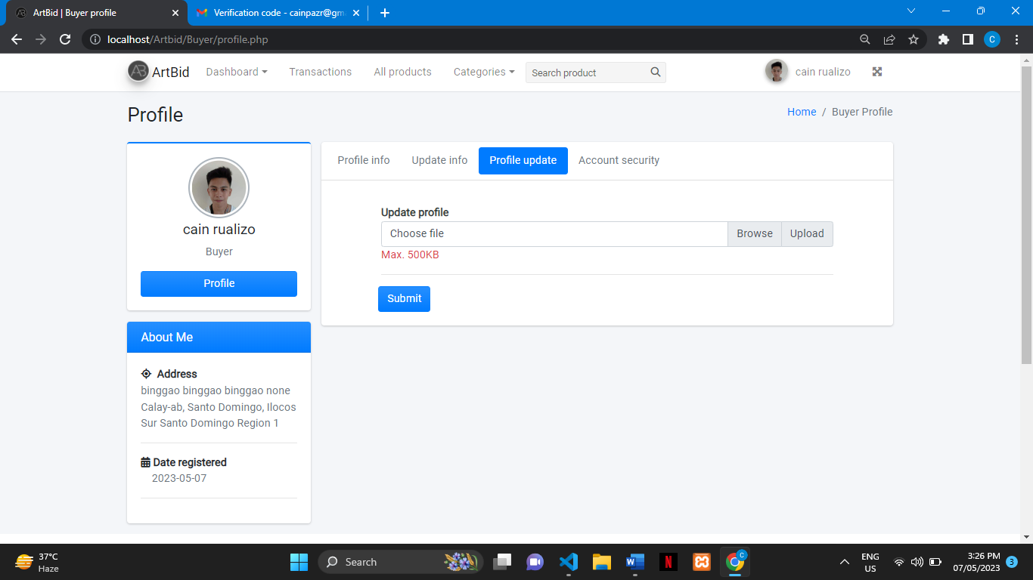To change your avatar click the profile update. Click the browse to search images on your pc/laptop. After choosing the right image for your avatar click submit to update your avatar.
2. To change your password click Account Security to change your password.Once you fill up the information needed click the submit button on the lower part.

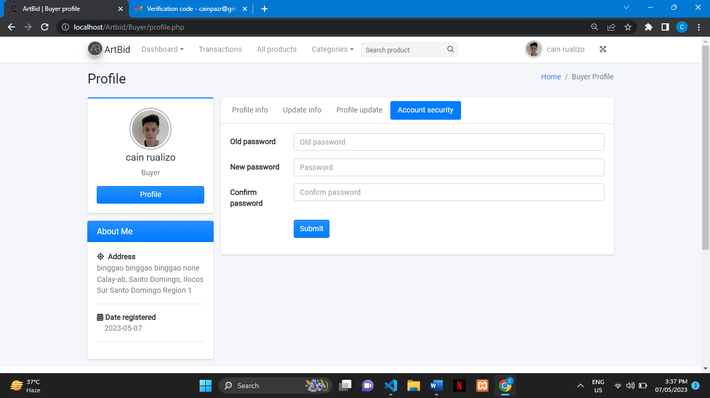

1. 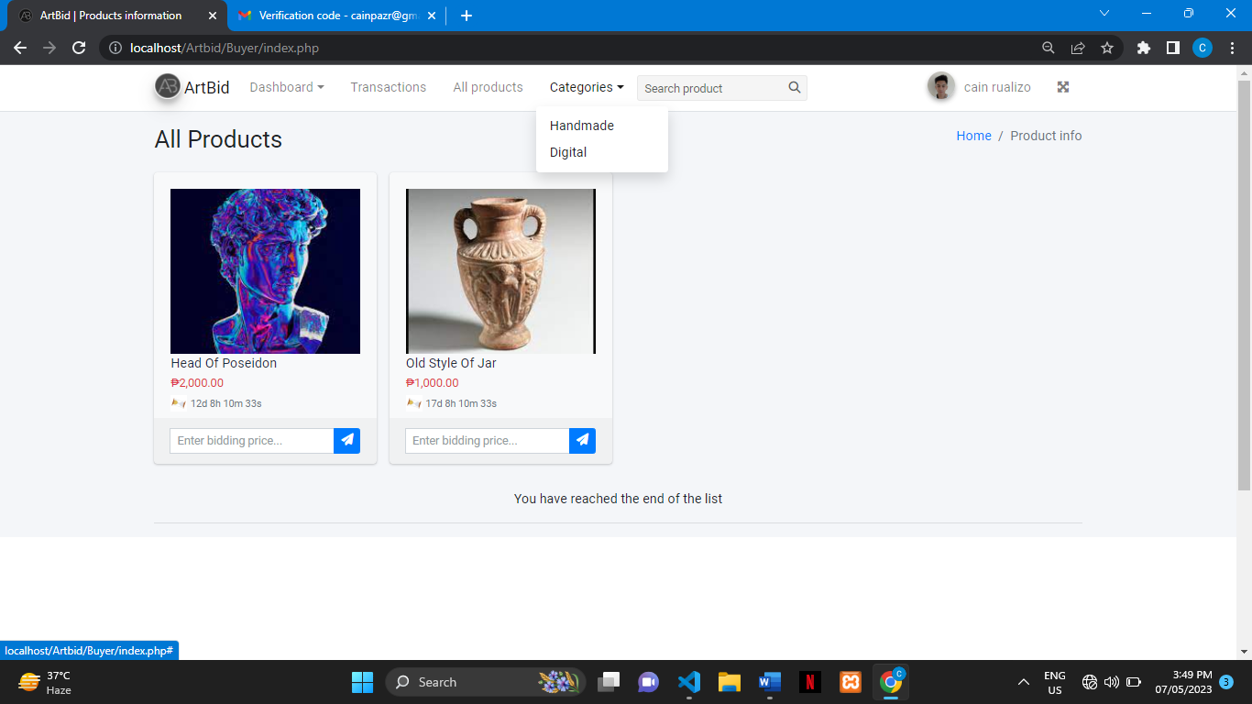 To see more products click Category to see more products.
2. To bid just enter the desired amount but not then lower the starting bid.

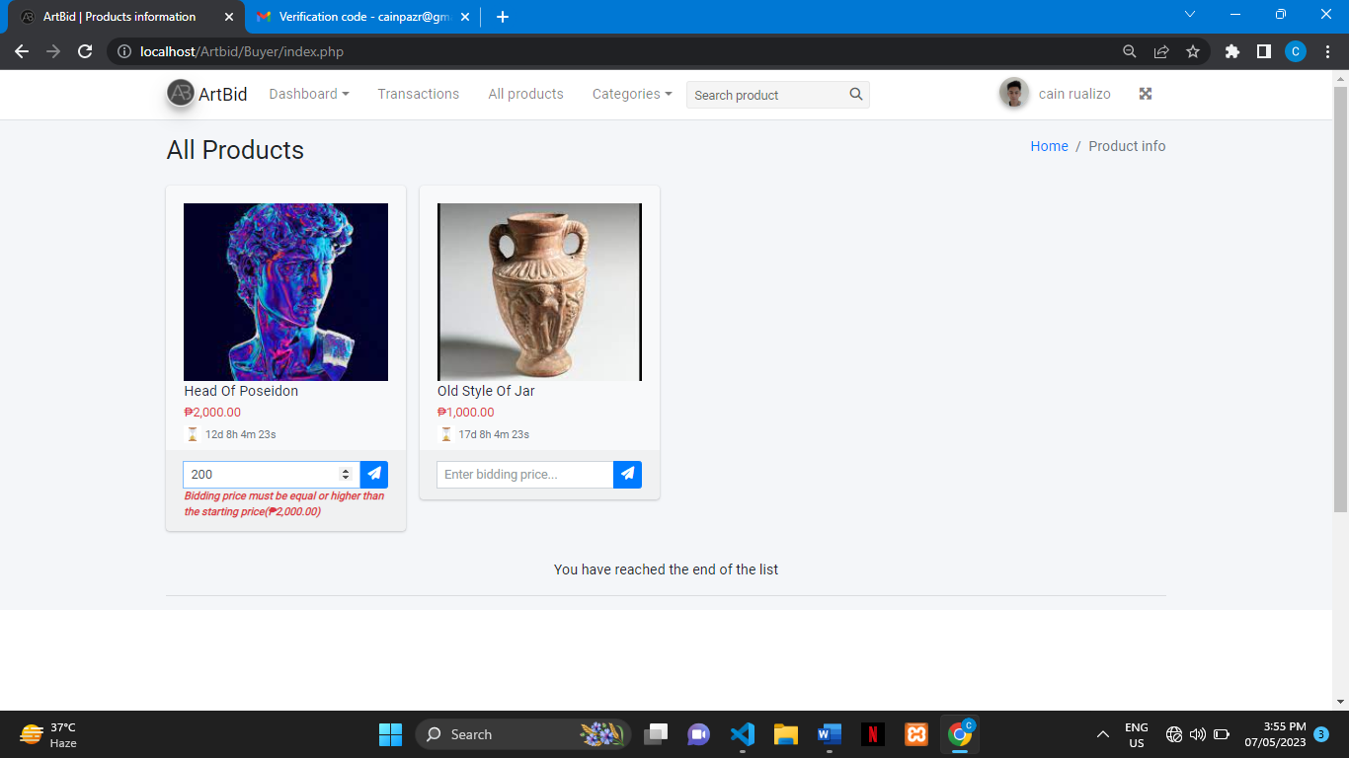

…This will pop up if you enter lower than the starting price.



…After you choose the desired amount that you want this will pop up on your screen

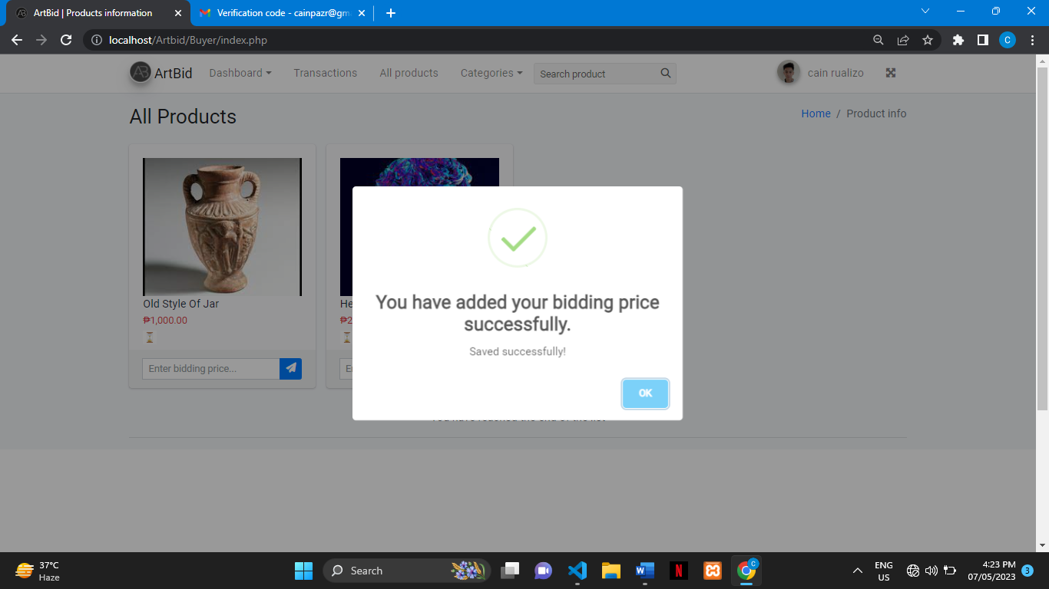

1. To access the item that you bid just click the dashboard and click the ongoing bidding.

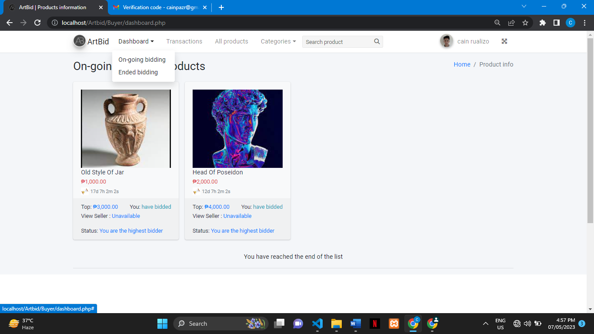

…here in the product card you can see the product name, starting price, and the bidding due date. In the lower part, you can see the top buyer bid, the text that you have bidded/lost/won, view seller information, and the status of your bid if it is you are the highest bidder/someone has a higher bidder/you are the lowest bidder.

**You are the highest bidder**

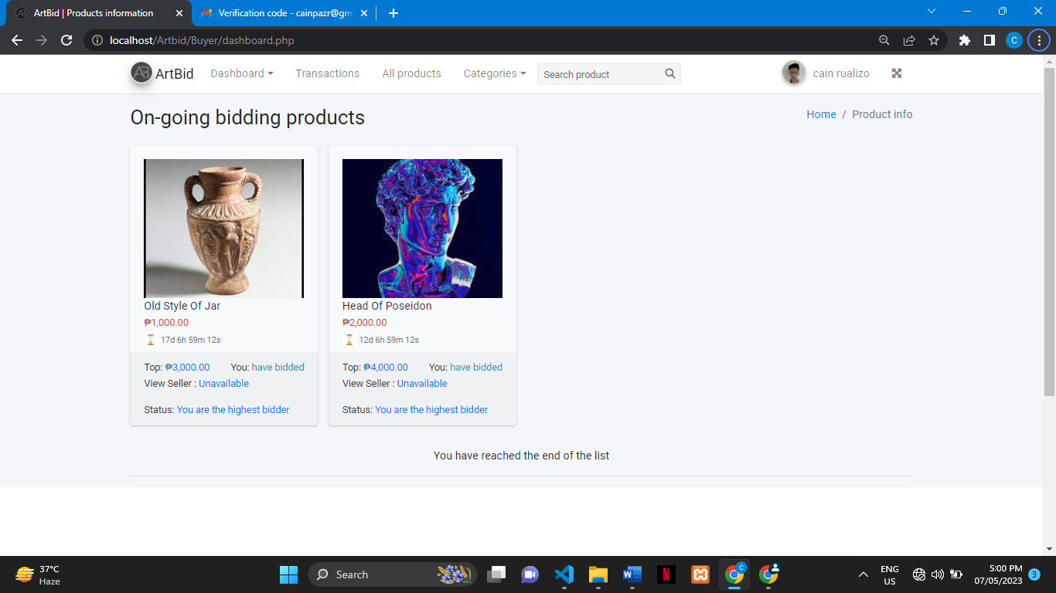

**…The bidding textbox will appear if someone has a higher bid.**

**Someone has the highest bidder**

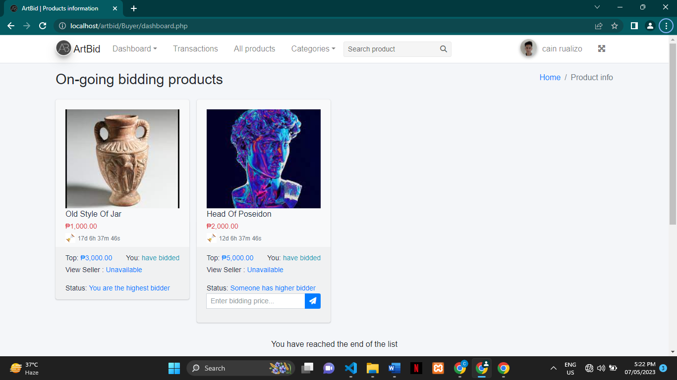

**You are the lowest bidder**

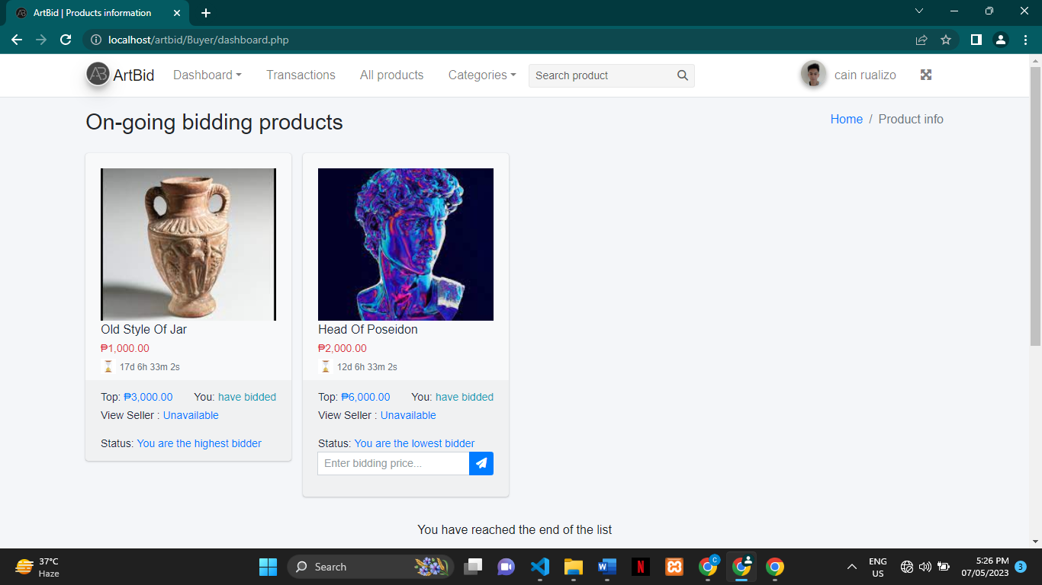

1. When the bidding ended winners will be notified in their registered email.

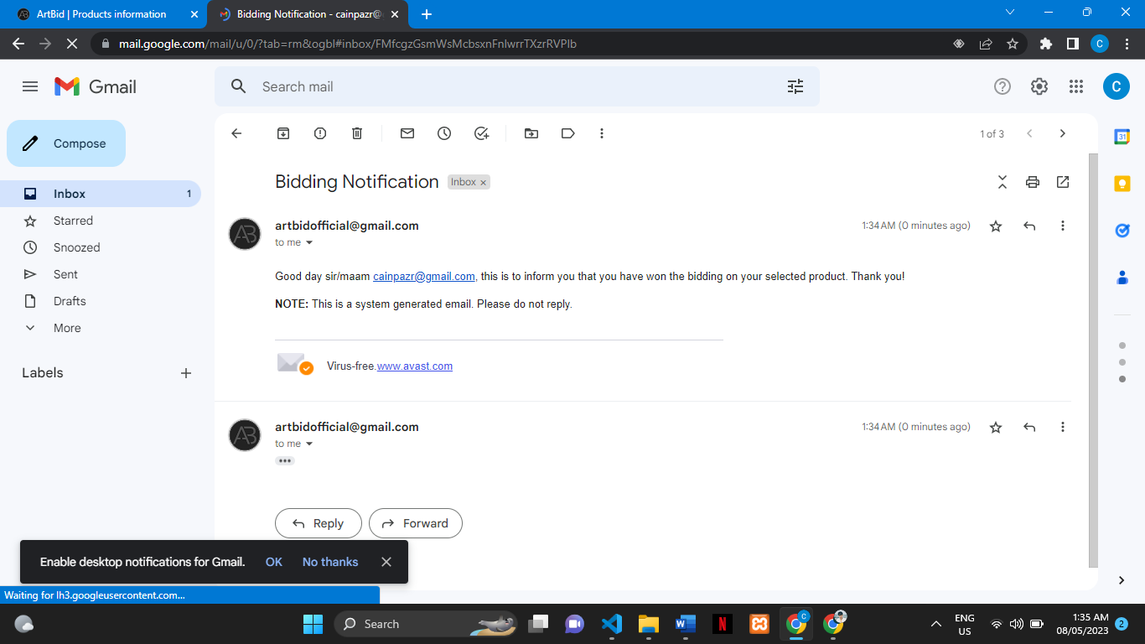

1. To see the product that ended click on ended bidding on the dashboard.

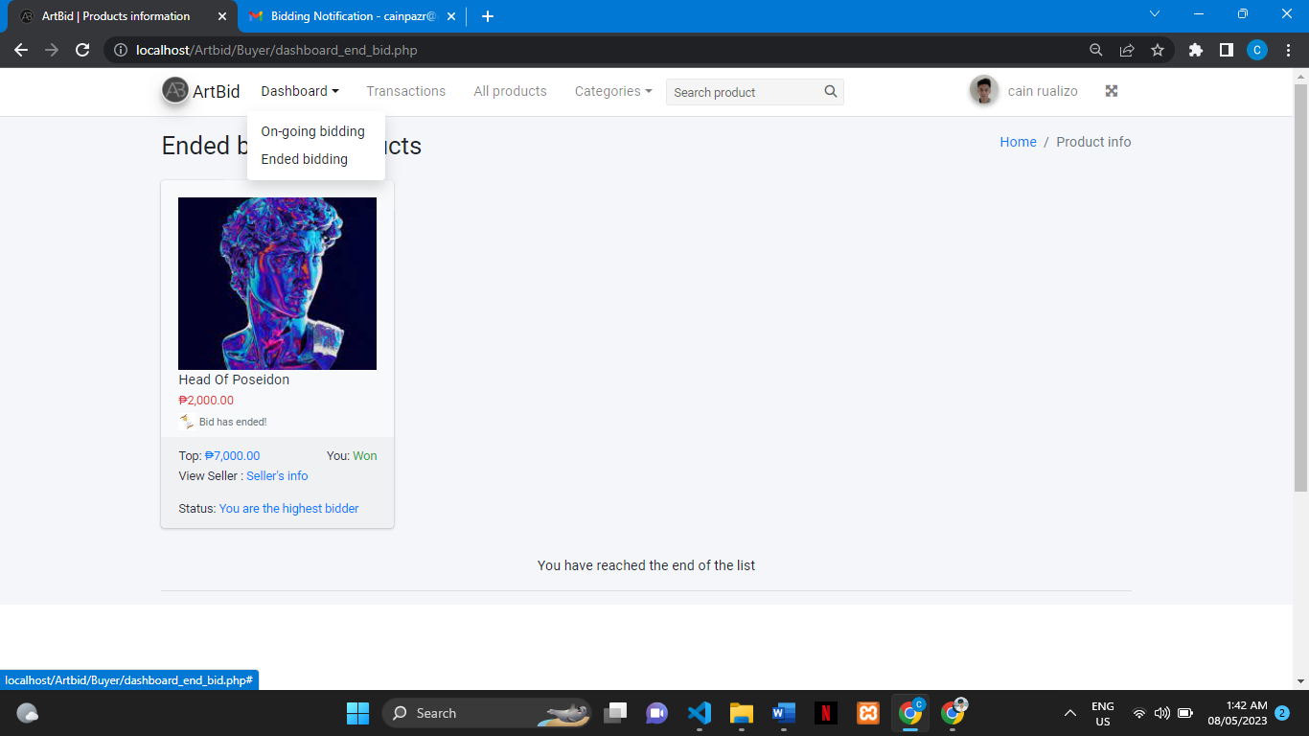

1. On The lower part of the product card you can see the sign that you won and to contact the seller for payment click the seller info. The seller info will only show if you won the product.

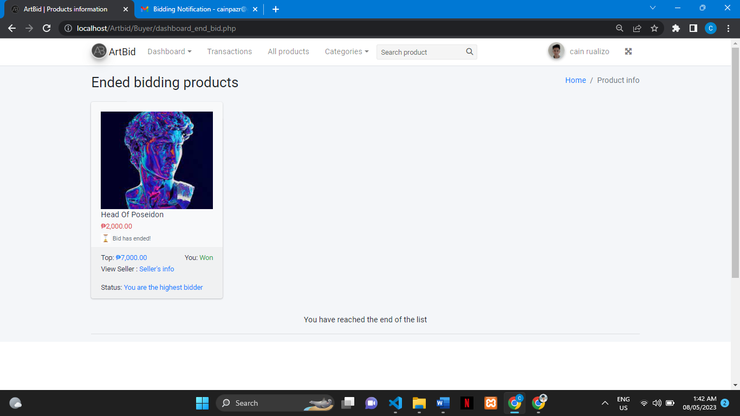

1. Contact the seller thru cellphone number, email, or personal visit it depends on you on how you want to reach the seller and talk about how you can pay him/her and how you can get the item that you bid on but in our system it is mandatory to pay Gcash or PayPal.

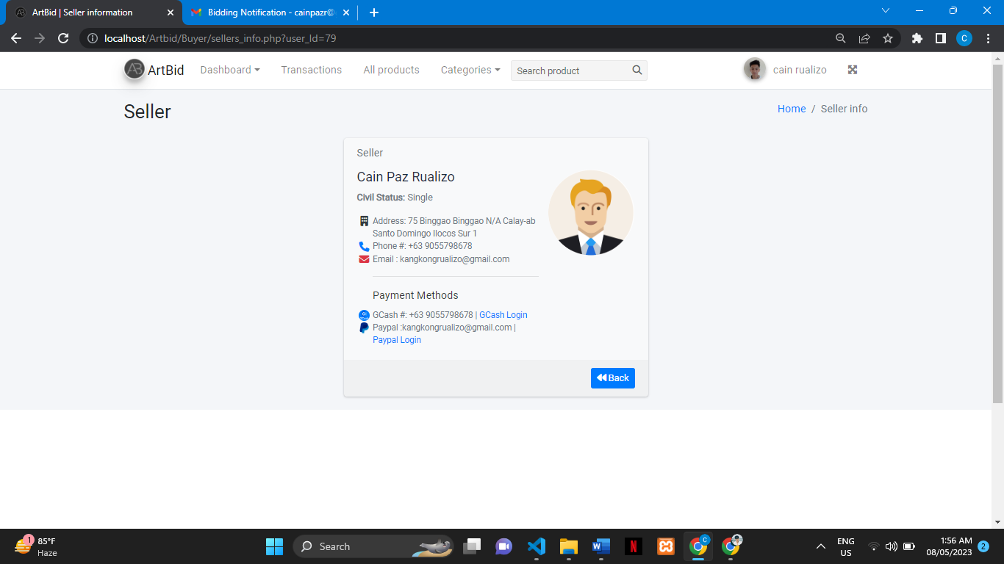

1. After that you are required to send a receipt to the seller for confirmation of payment in the transaction. Click the receipt sign to upload a picture of your receipt and sit send it t to the seller but it will be only clickable if you win the product. The status will stay pending/unpaid but after you upload a receipt the status will become payment unconfirmed.

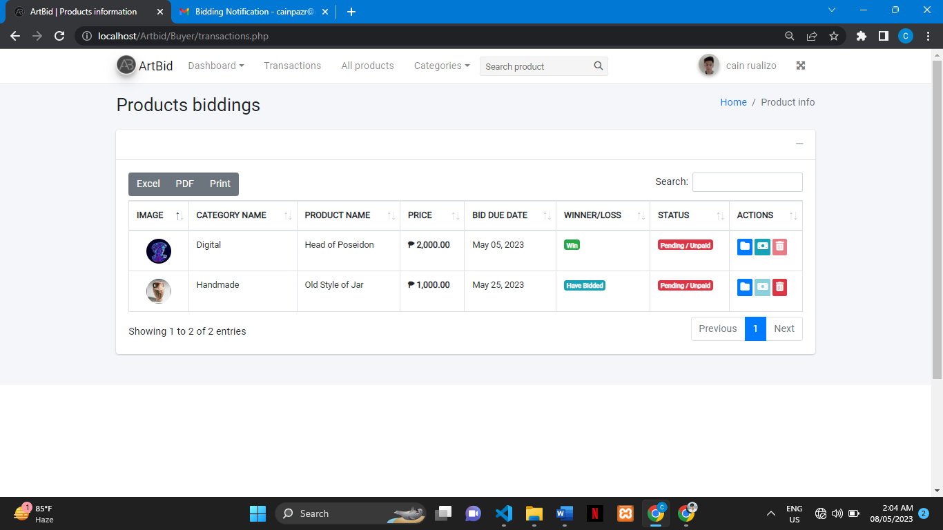

1. Click the browse to show your files in pc/laptop to upload a receipt of your payment. After you upload your receipt to submit just click the submit button.

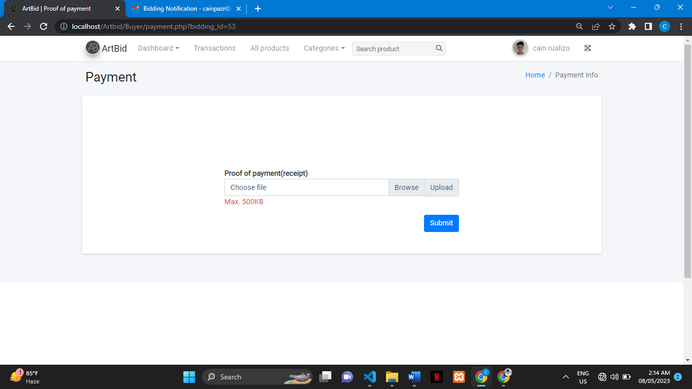

1. after you send a receipt the status will become payment unconfirmed and wait for them to confirm it.

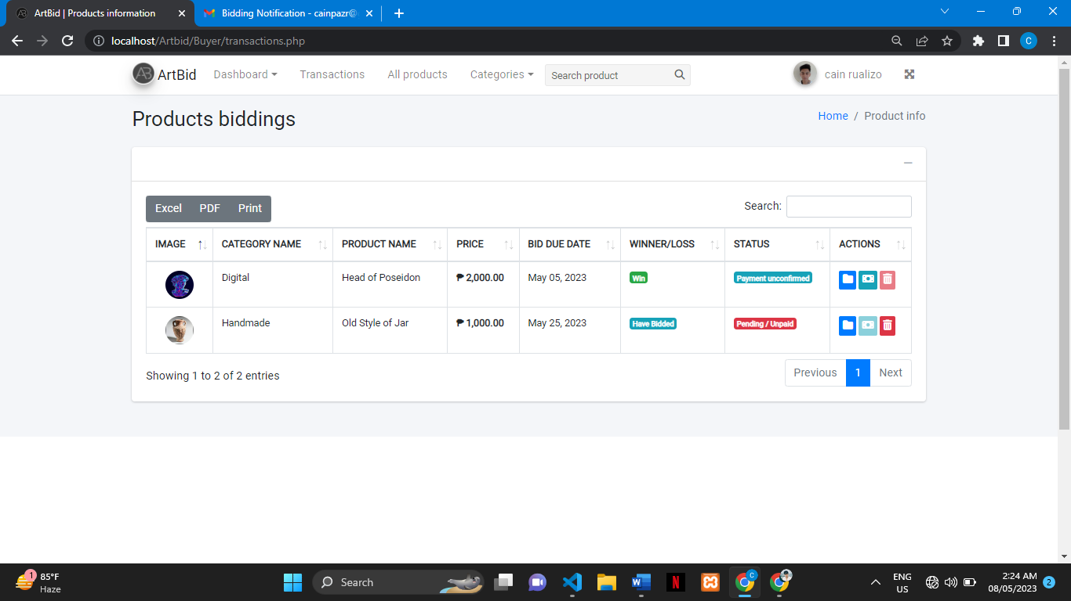

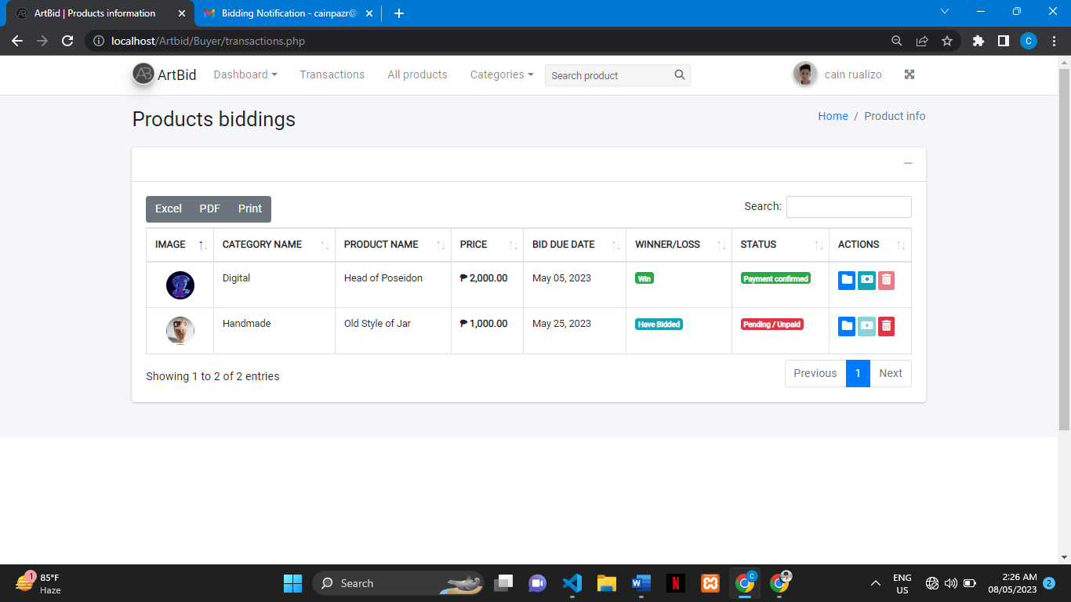… The status will become a payment confirmed once the seller confirms it.

**Seller’s Prototype**

Seller’s Dashboard you can see here the active products and sold products but it shows only when the buyer bids the product.

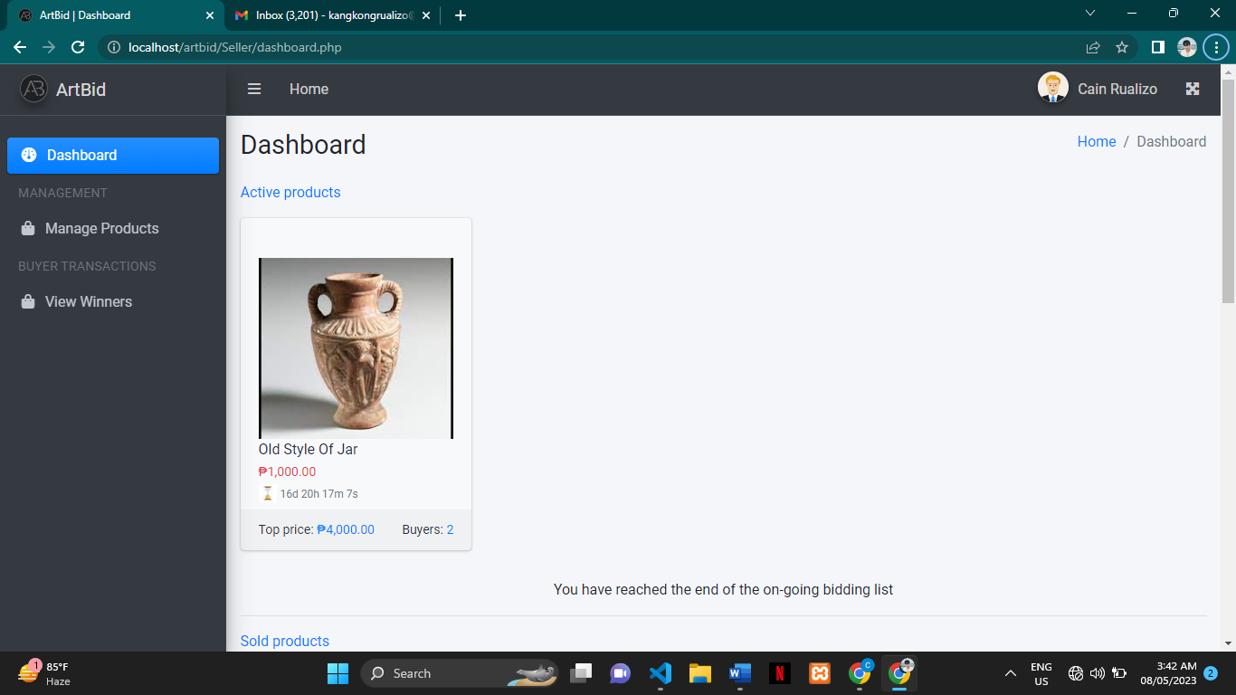

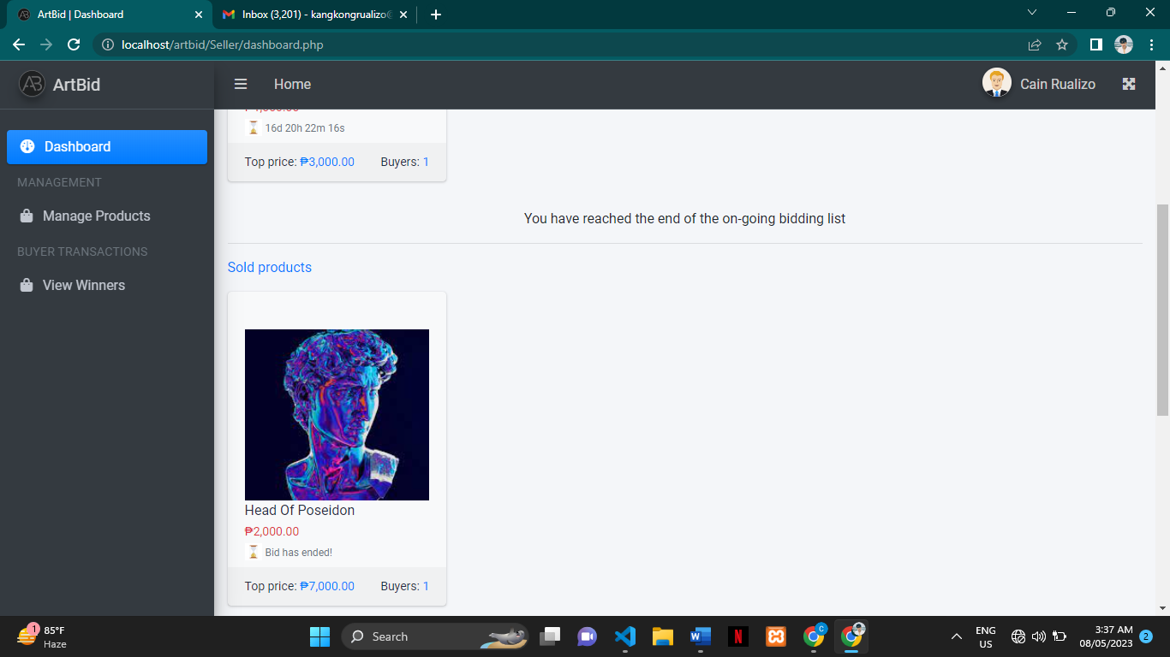

1. To see the bidders click the buyer number beside of top price.



1. You can see here the names of the bidders and their bids. To know about more the buyer click the buyer’s info.

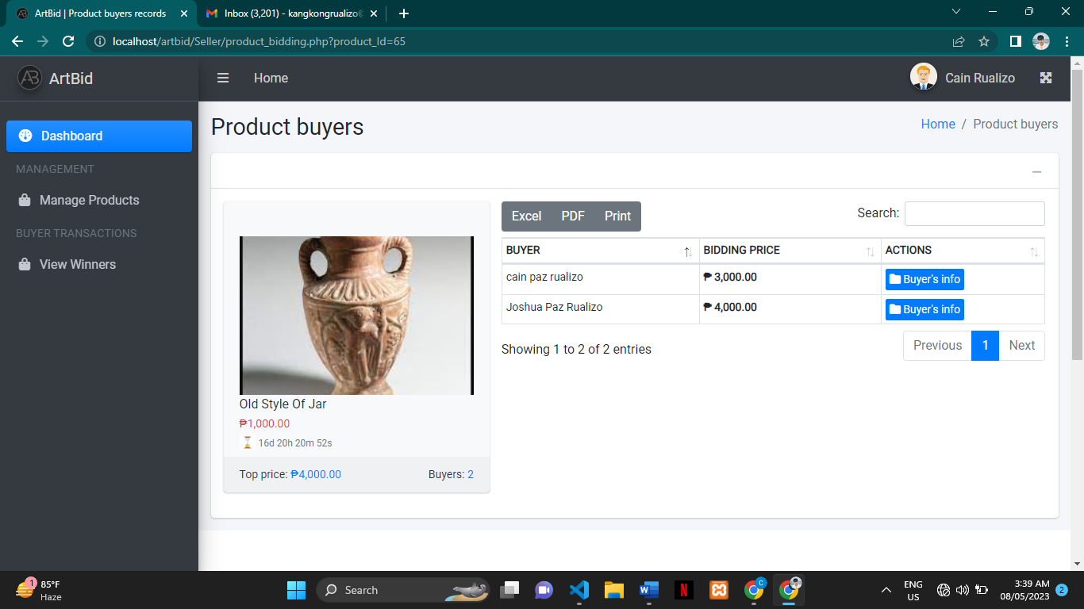

1. Here is the information about the buyer.

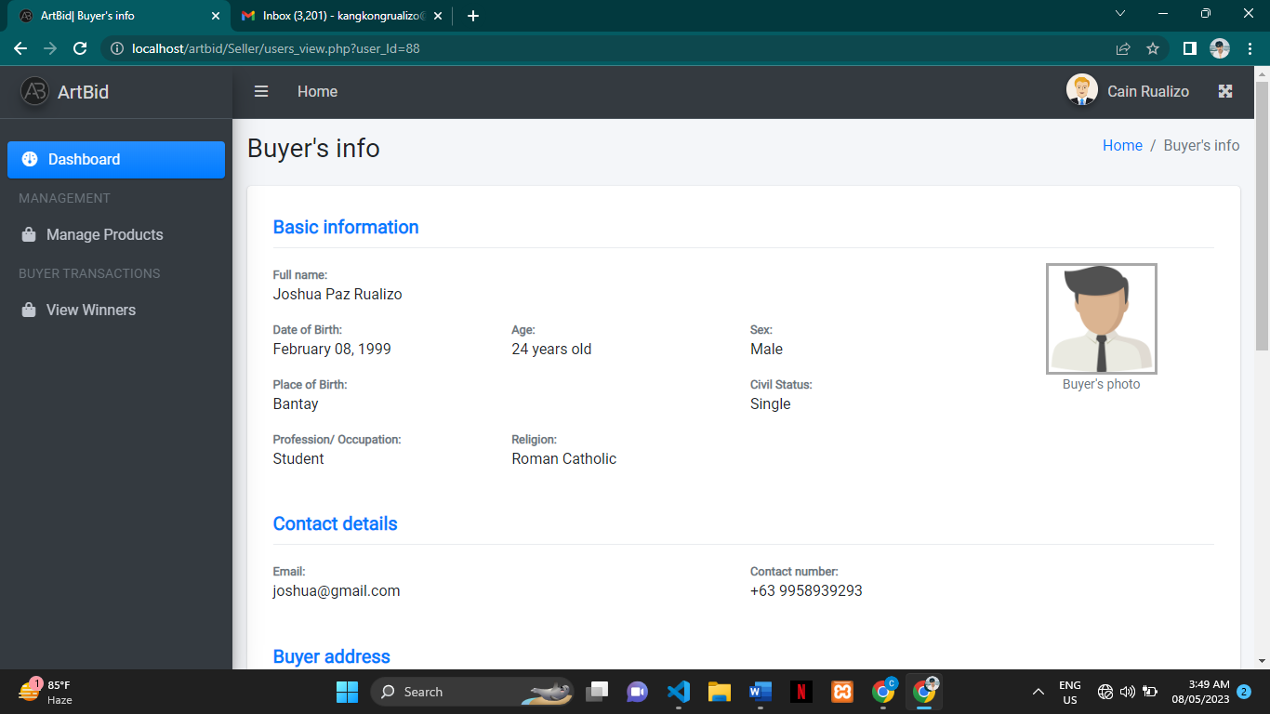

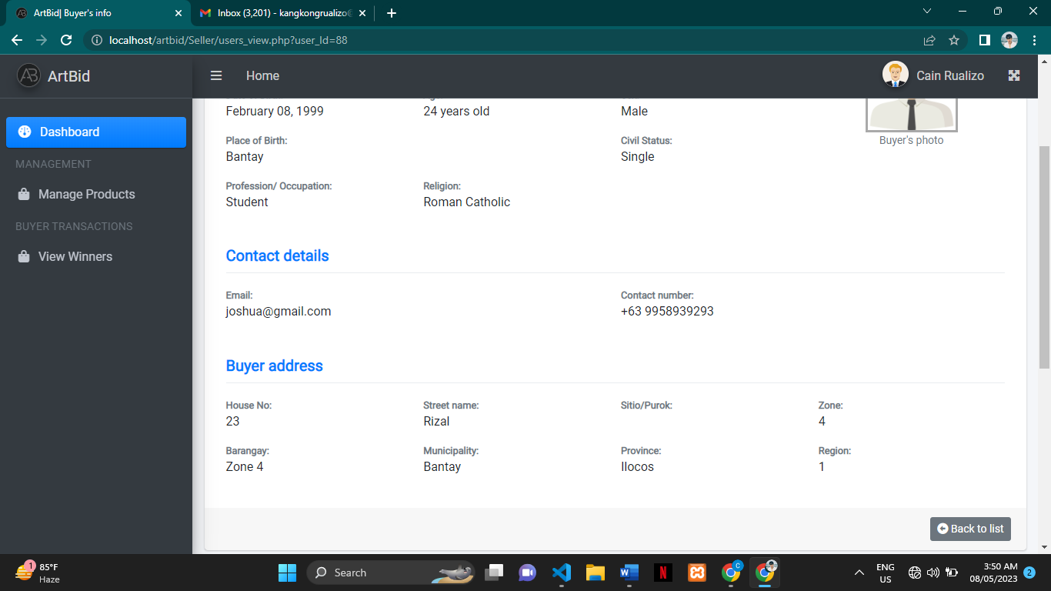

1. To add a product click the manage product in the sidebar and click the post product.

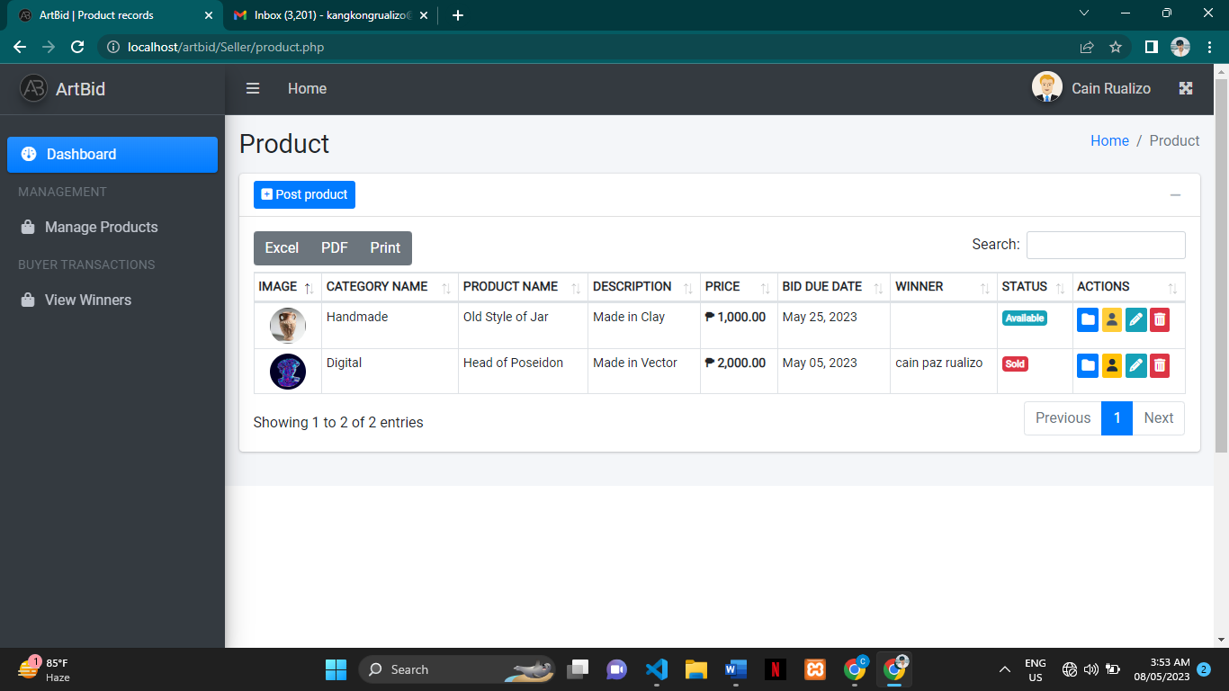

1. Fill up the all needed information and submit it or post it by clicking the submit button below.

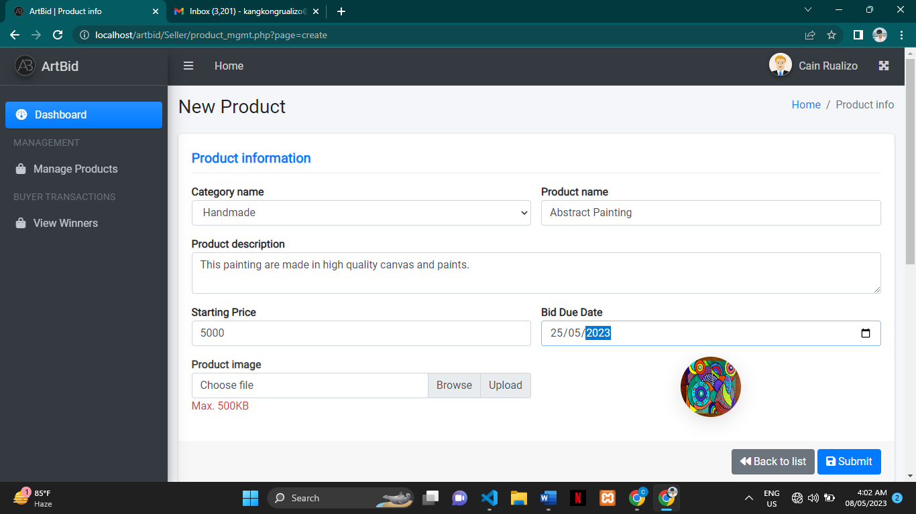

1. Once you submitted it will appear in the manage product table.

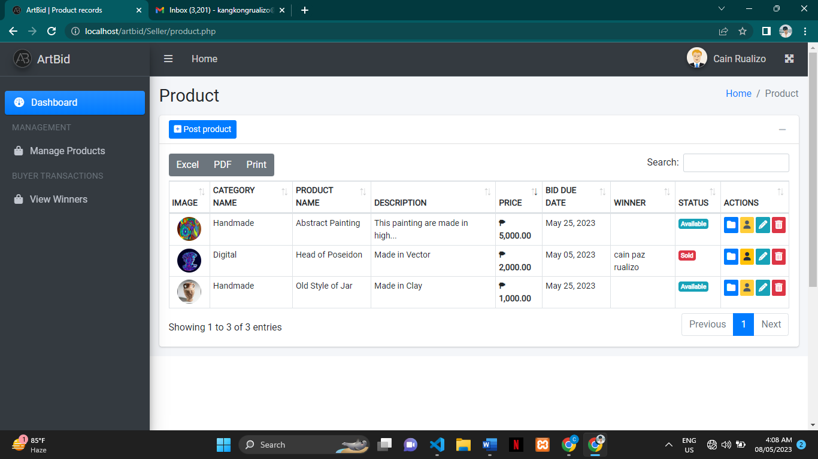

1. Click the icon folder will view the product information.

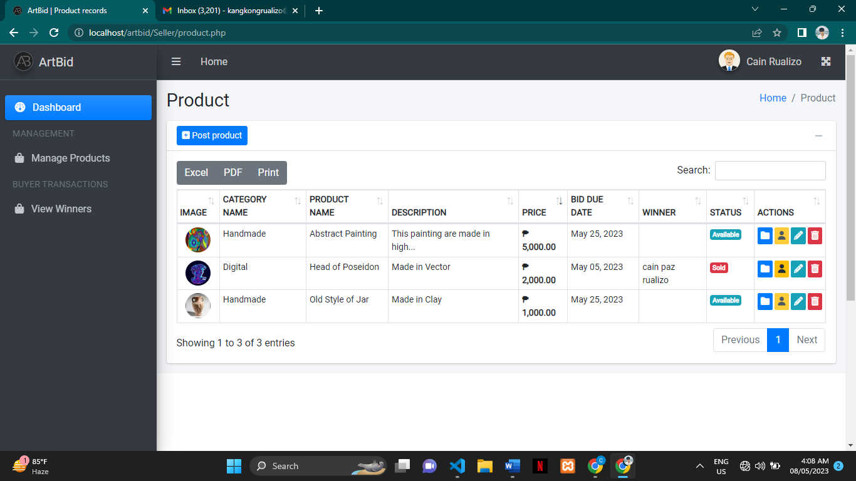

1. You can see here the product detail.



1. The icon person will view the winner’s information but It will be only active once the item was sold.



1. If you want to edit the product click the pencil icon.



…After you fill up or update something to submit or update click the submit button below.

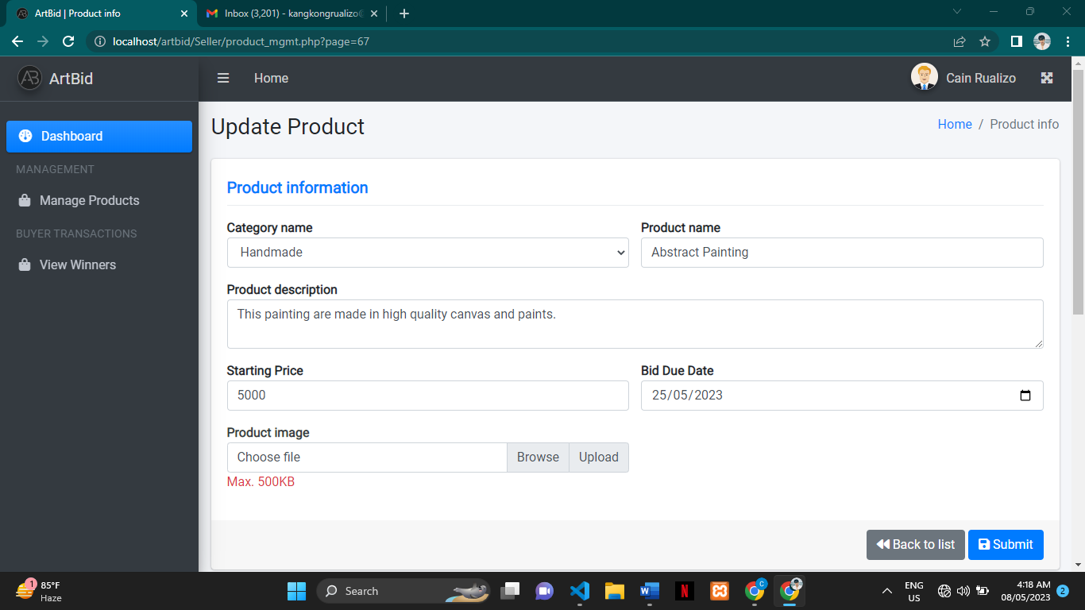

1. To delete a product click the trashcan icon.



…Click confirm to delete otherwise click cancel.

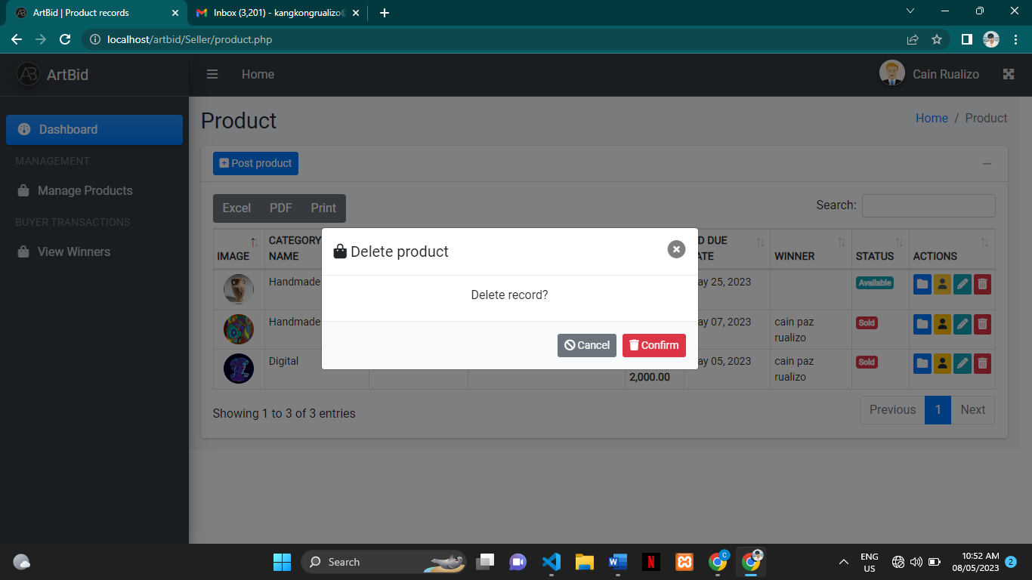

1. When one of the products has met the due date an automated mail will send to your account to notify you when the product was ended.

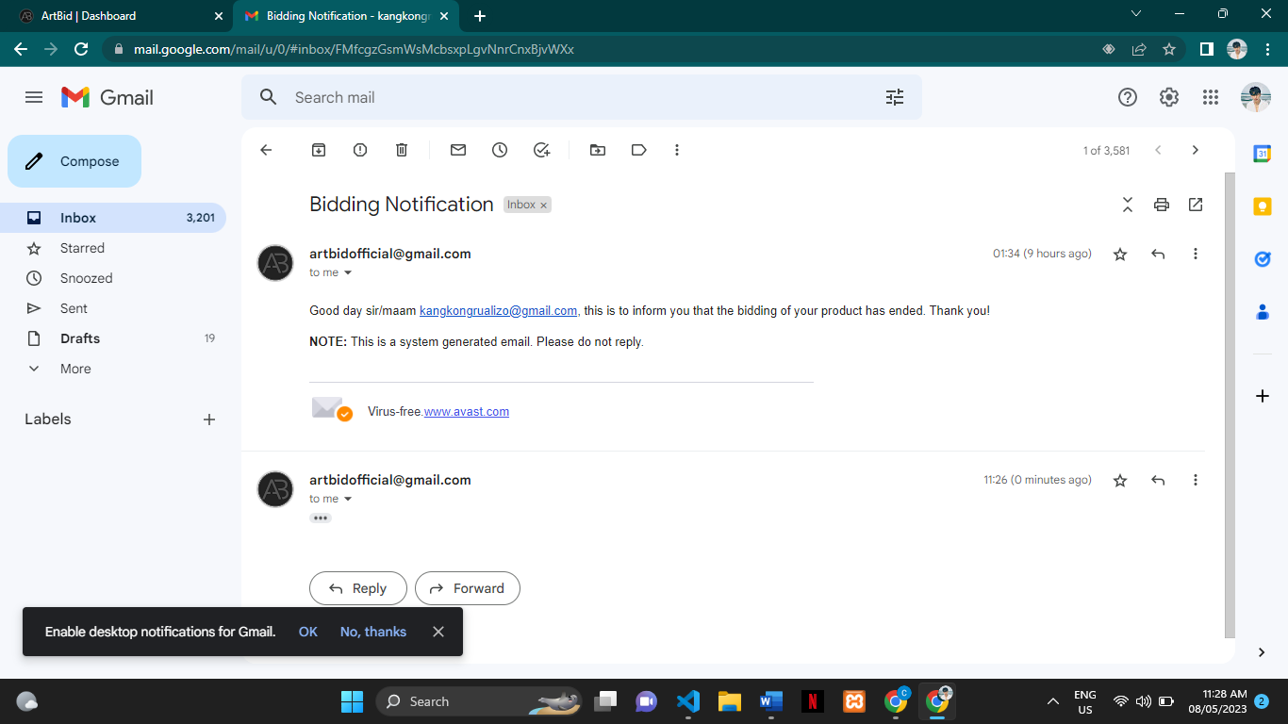

1. To view the winners of your product click view winners in the sidebar.

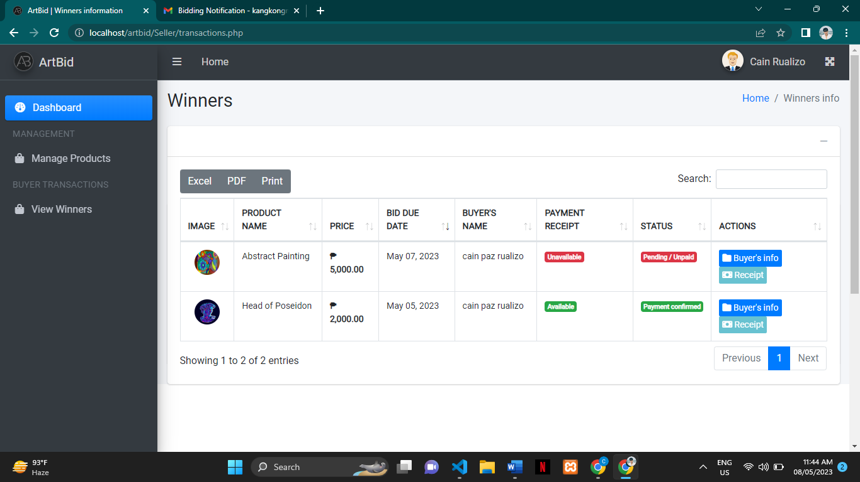

1. The table show’s the product image, product name, product price, bid due date, winner’s name, payment receipt, status, and actions (buyer’s info and receipt).



1. Payment receipt will be marked available if the buyer sends a picture of his/her receipt. The Status will be marked Payment Confirmed if the seller received the receipt from the winner.



1. To contact the winner click the icon folder to see the winner’s information. The receipt icon is not active because the winner must send a picture of his/her receipt to activate the receipt icon.
2. 

…This will be the output if the seller received a receipt from the winner. The icon will be activated once the winner sends his/her receipt.

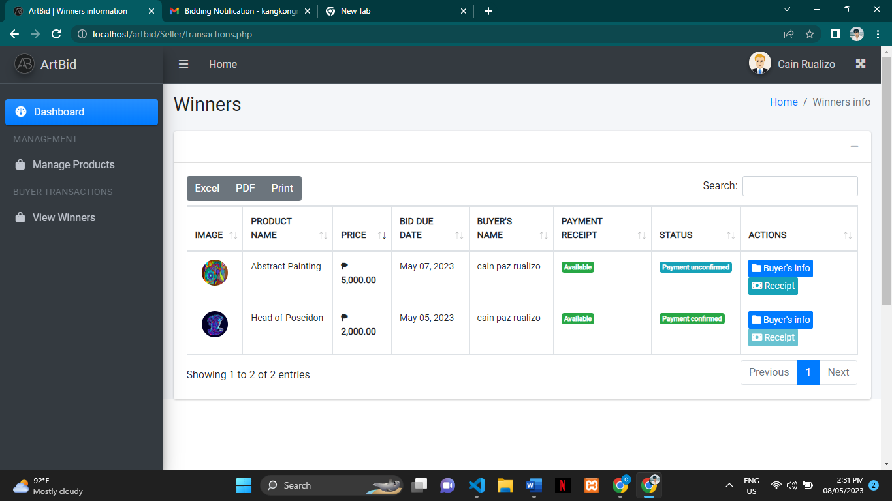

1. Click the receipt icon to view the receipt you can download it if you cannot see clearly the receipt.

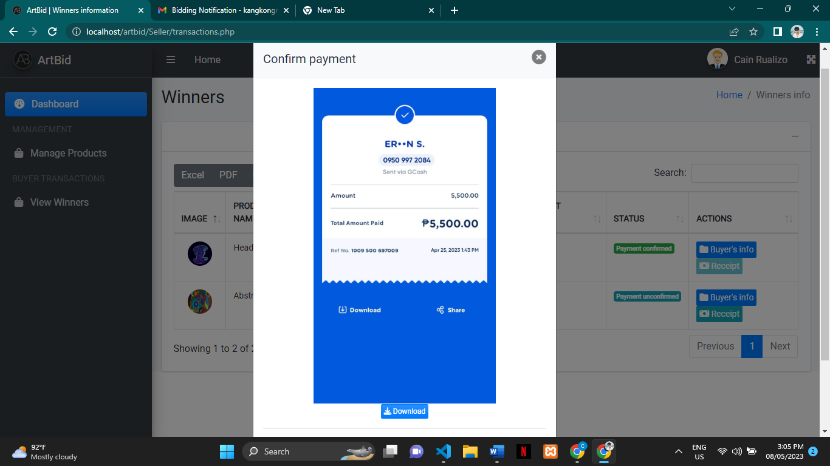

**…**Click confirm if the receipt was legit otherwise click cancel.

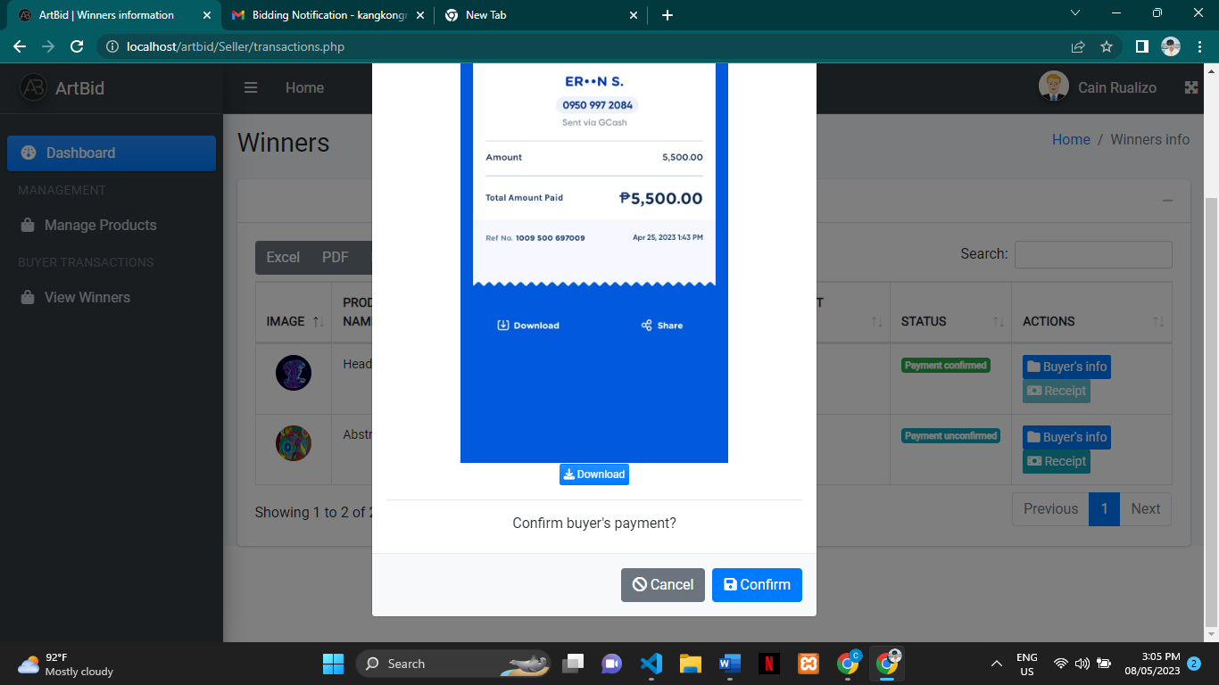

1. This will be the output if the seller confirms the receipt.

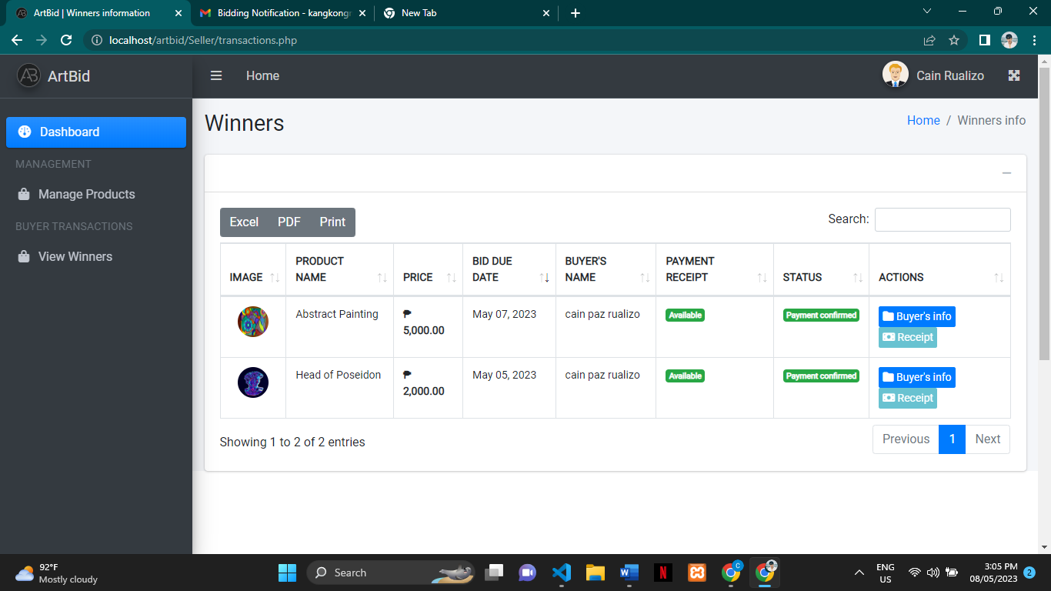

**Admin Prototype**

1. To login in admin the email and password is:

**Email:** artbid@gmail.com

**Password:** admin123

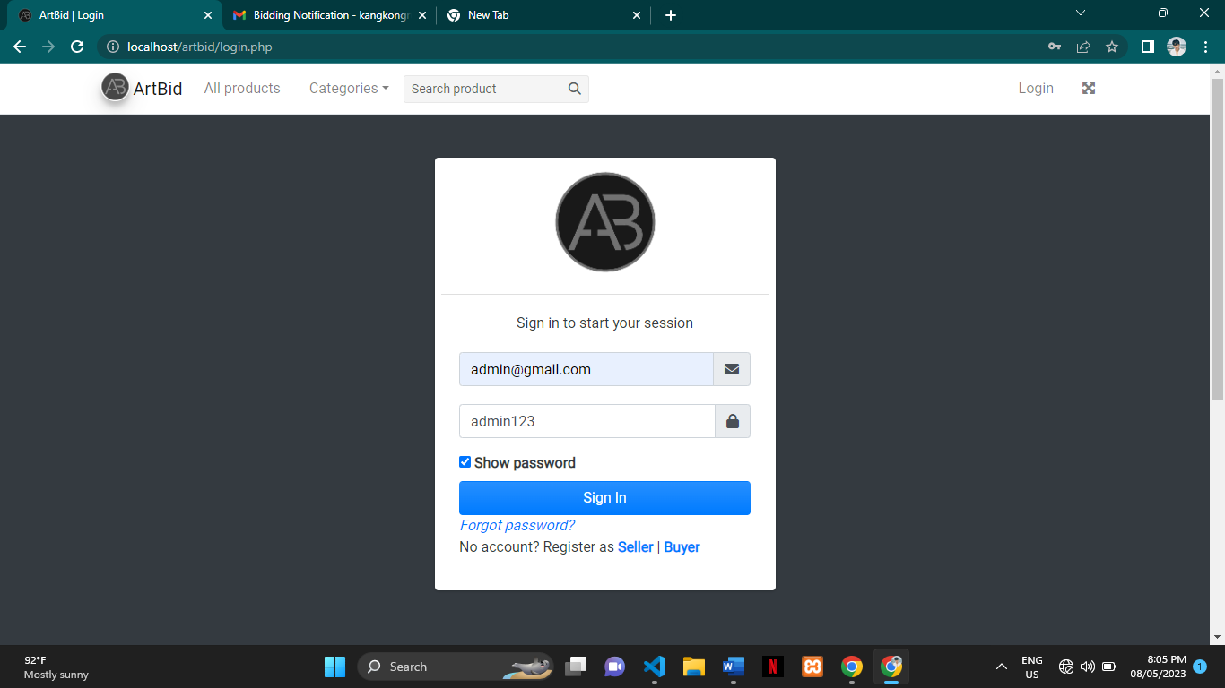

1. After login it will redirect to dashboard. Here in dashboard it show’s the registered administrator, seller, and buyer. If you click the more info you will redirect to tables of registered administrator, seller, and buyer.

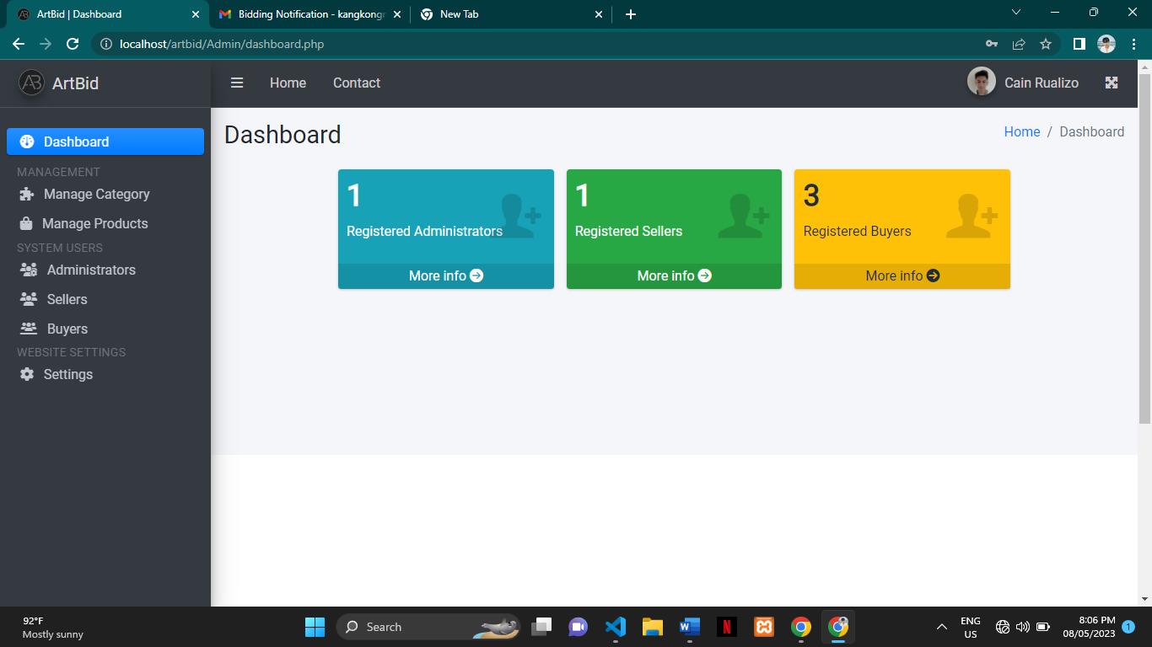

1. To go to management in the sidebar to create a category for products click manage category and click the new category.

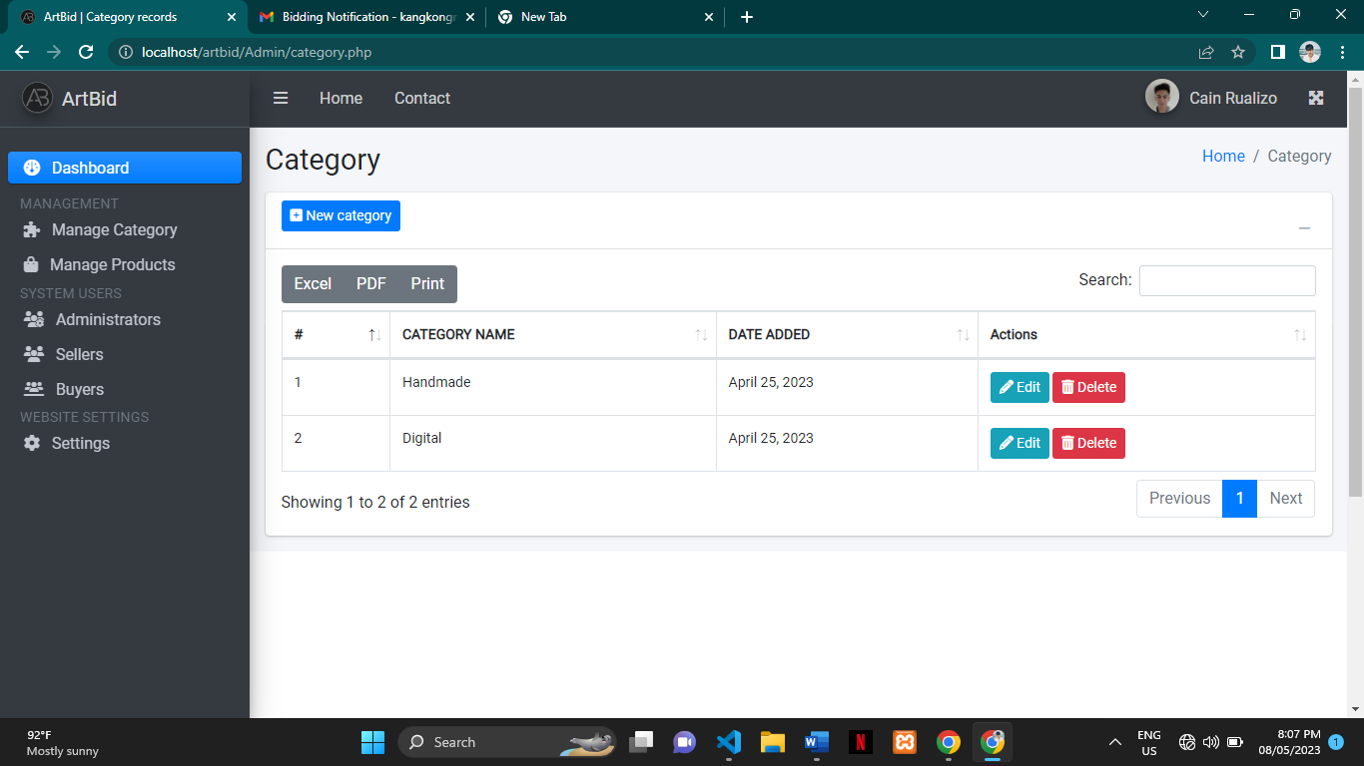

1. Insert any desired category in the textbox to upload the category click submit otherwise click cancel.

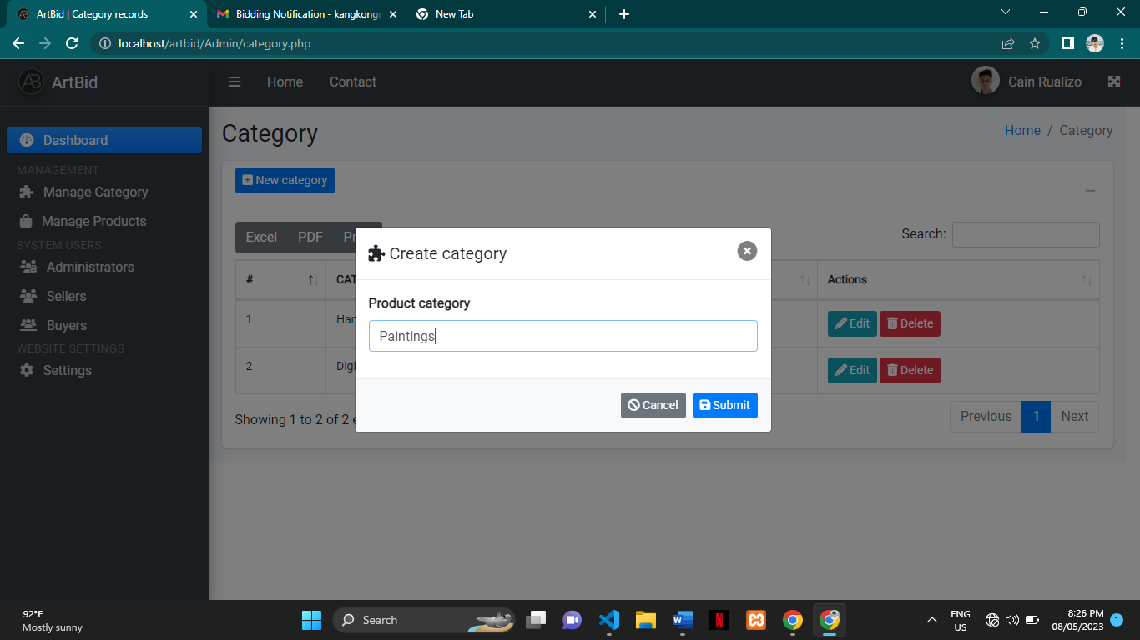

1. To edit the category click edit in the actions in the table.

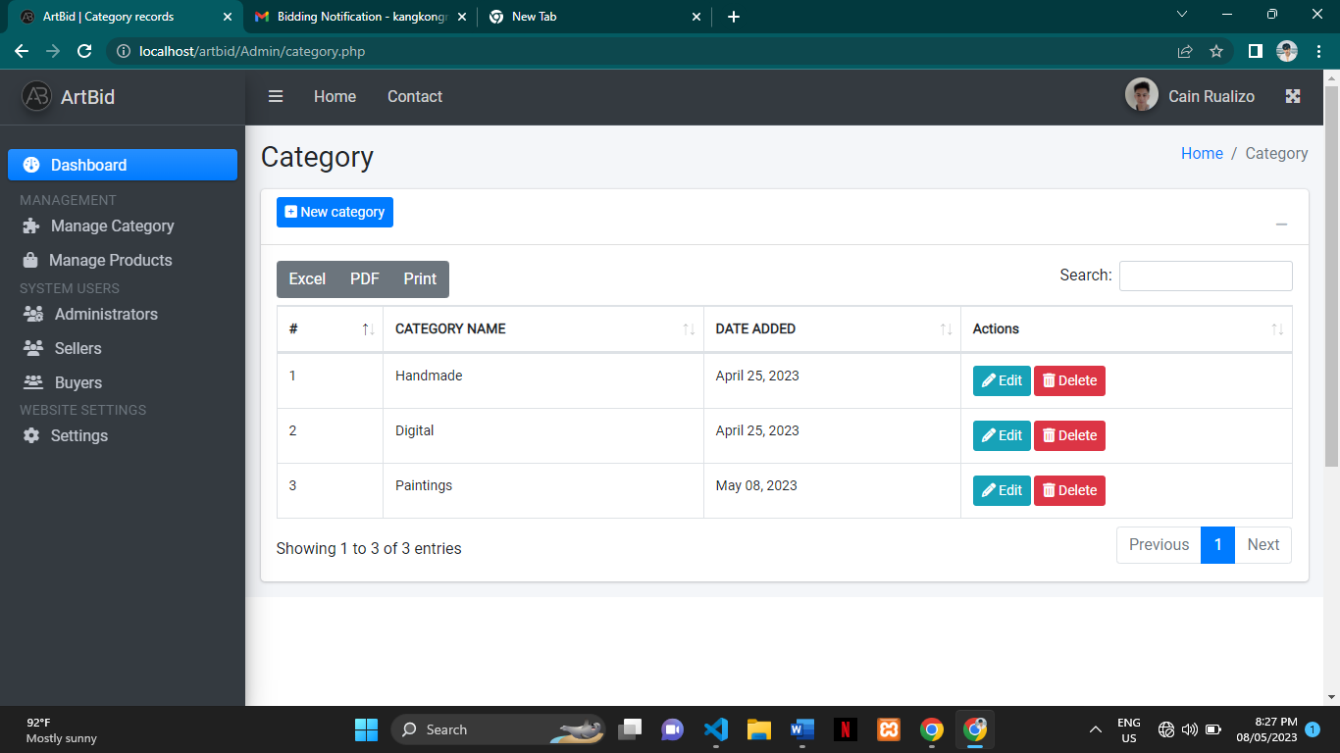

1. To delete category click delete.



1. To see or manage the products seller’s uploaded click manage product in the management.

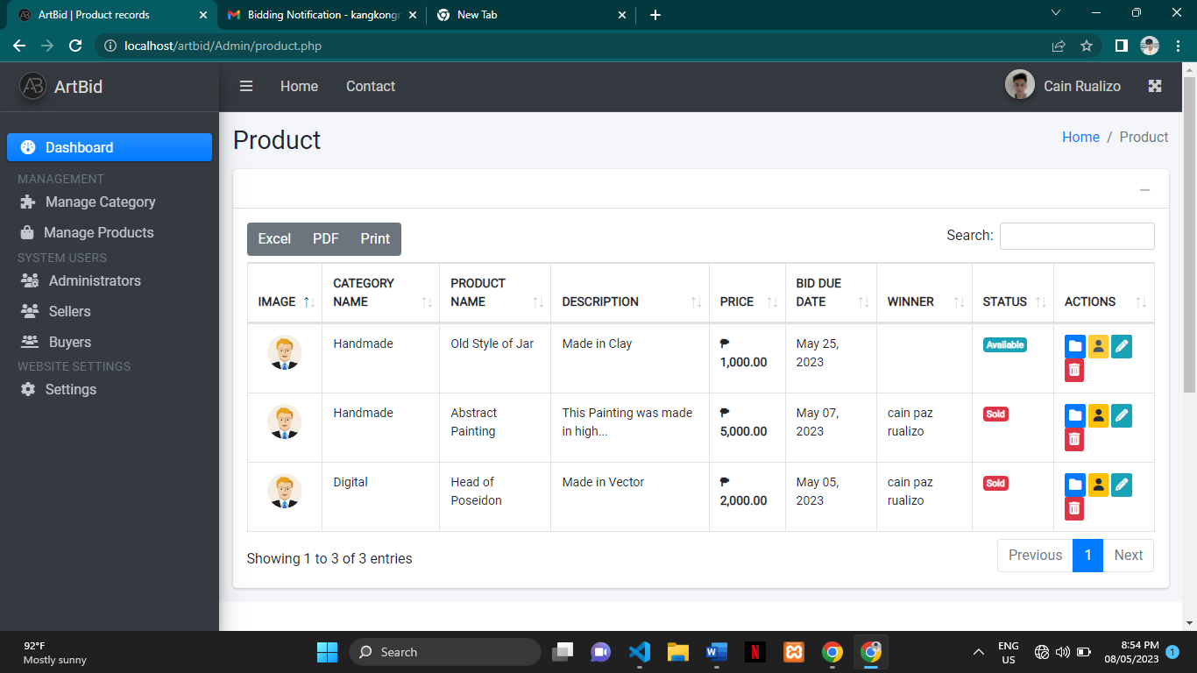

1. Contents of the table is the image of the seller’s, category of their product, product name, description, price, bid due date, winner of the product, the status of the product, and the actions.



1. The folder icon use to view product details.





1. The person icon use to view winner information’s but it will be only active if the product is sold.



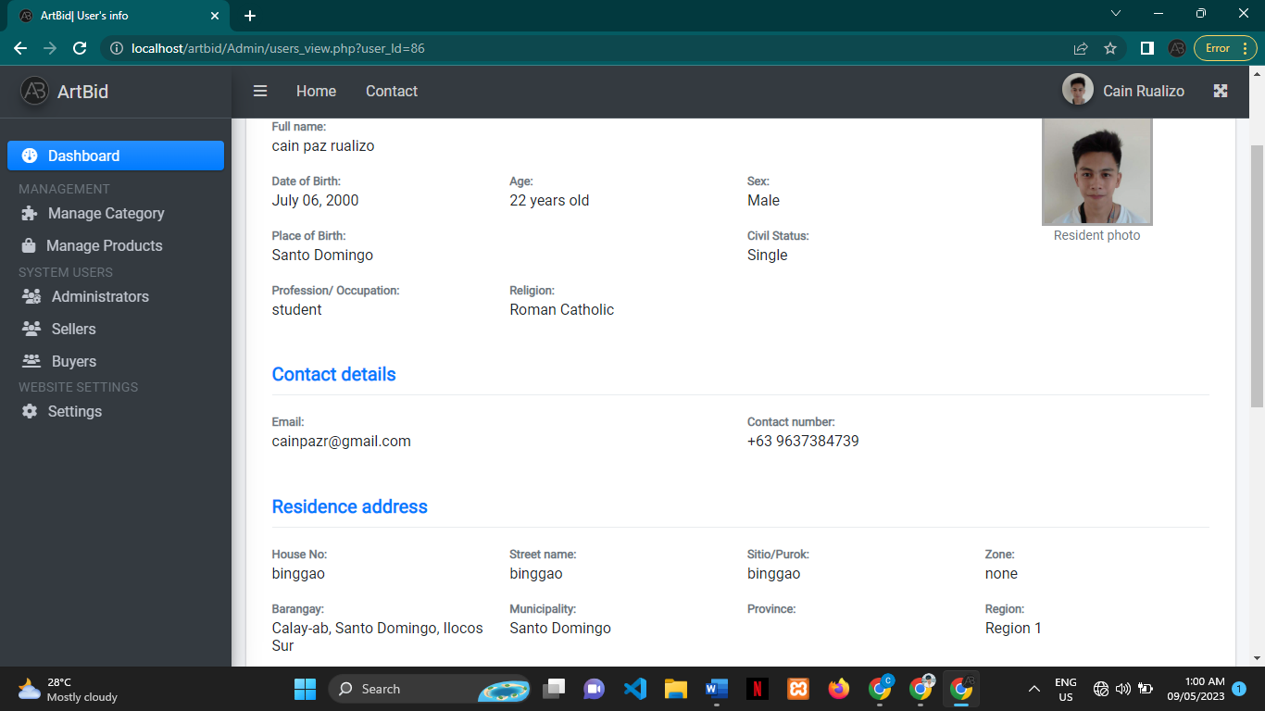

1. The pencil icon use to edit the product.



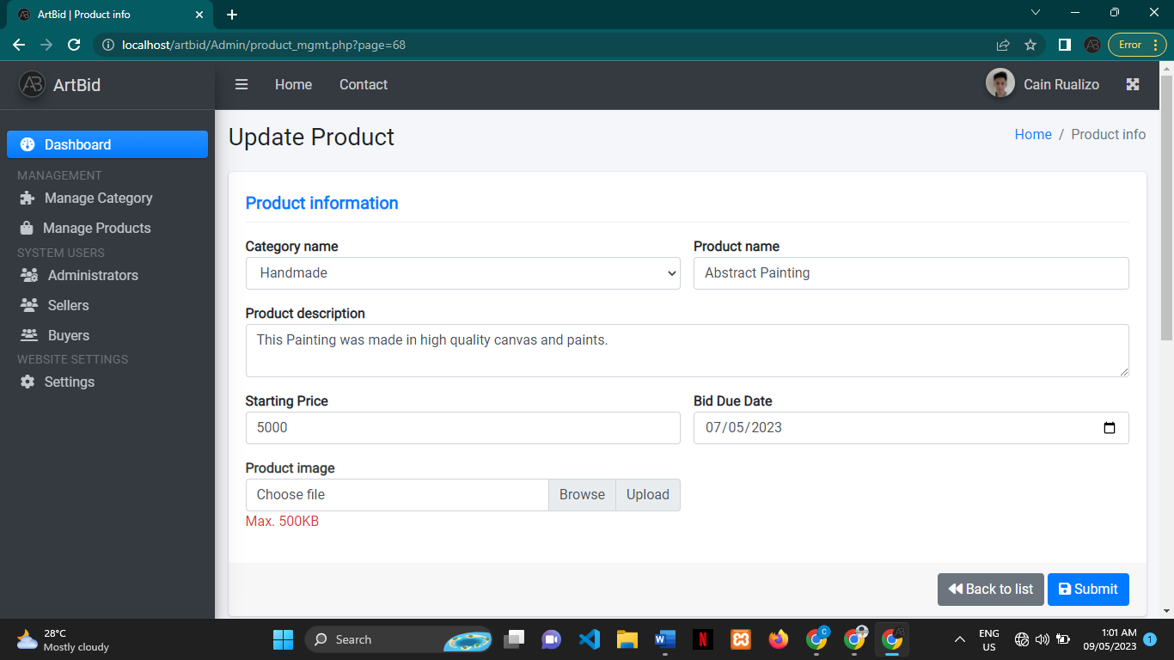

1. The trash icon use to delete the product.



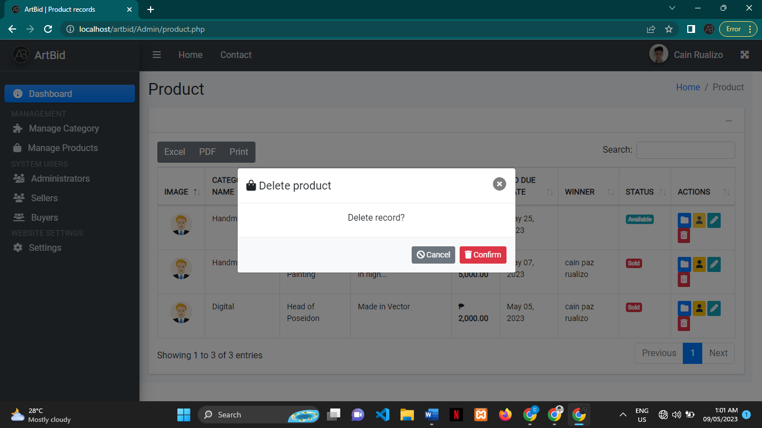

1. Click administration in the sidebar to view or add staff or admin. This account is the primary admin cannot be edited, delete, and change the security password.

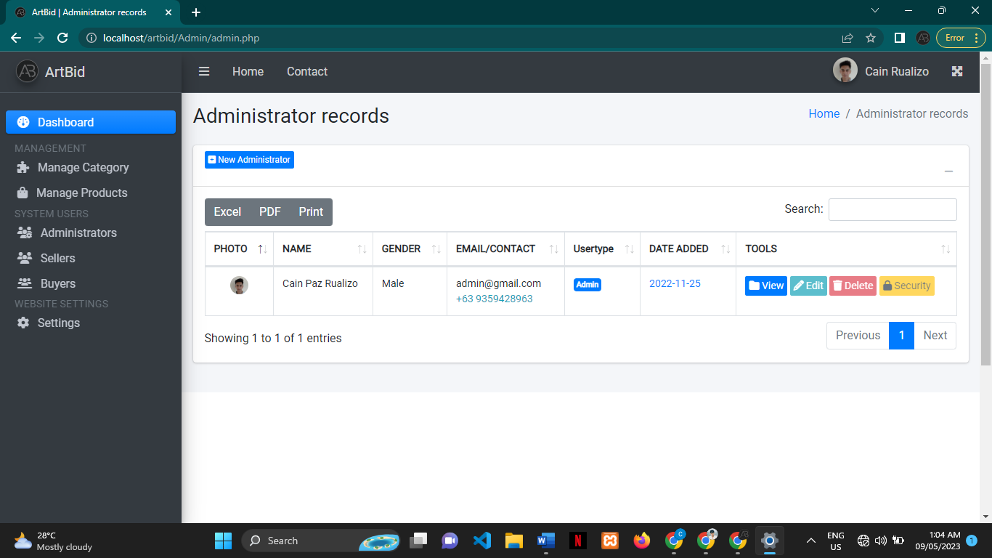

**The seller and Buyer have the same format.**

1. Click sellers to view seller information’s or click buyers to view buyer information’s.

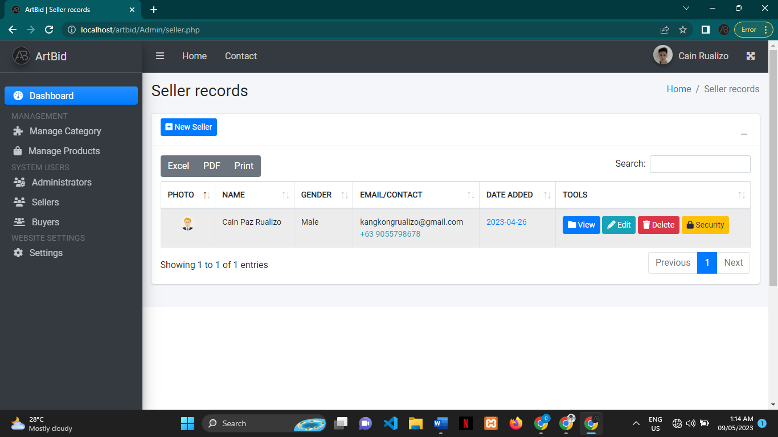

1. The folder icon use to see more information about the seller.

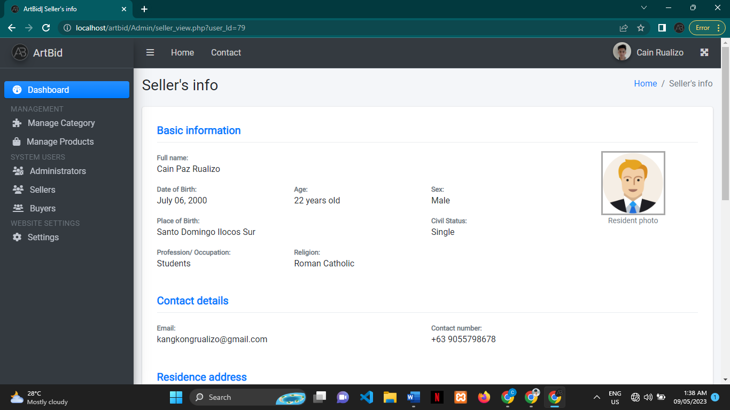

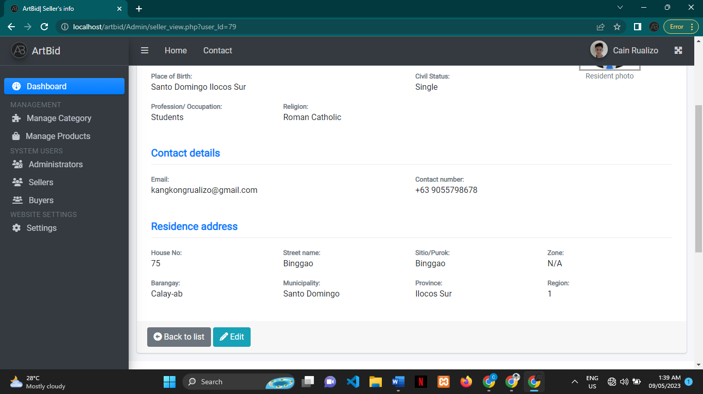

1. The pencil icon use to see edit information of the seller.

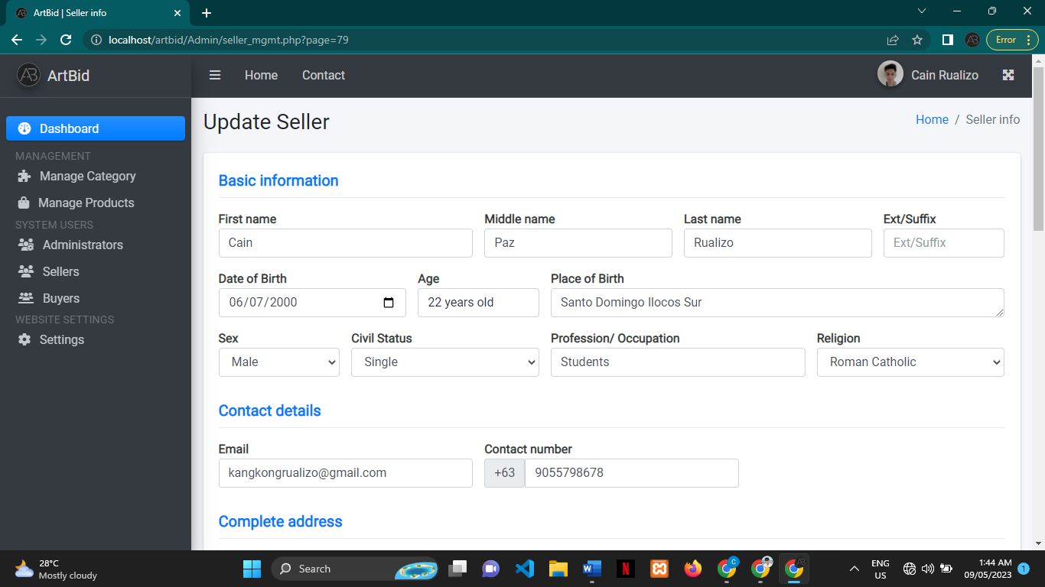

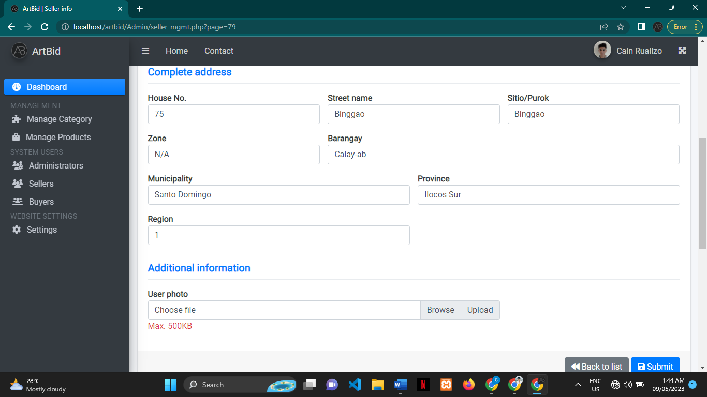

1. The trash icon use to delete account.

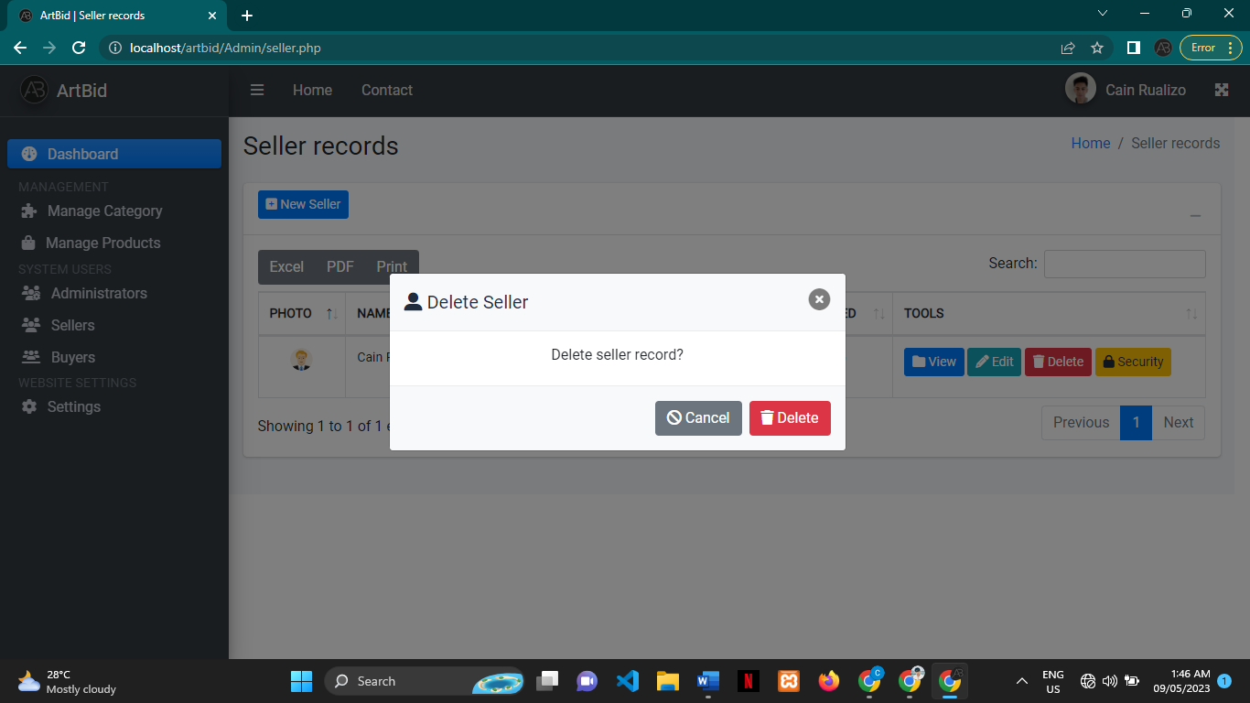

1. The lock icon use to change security password.

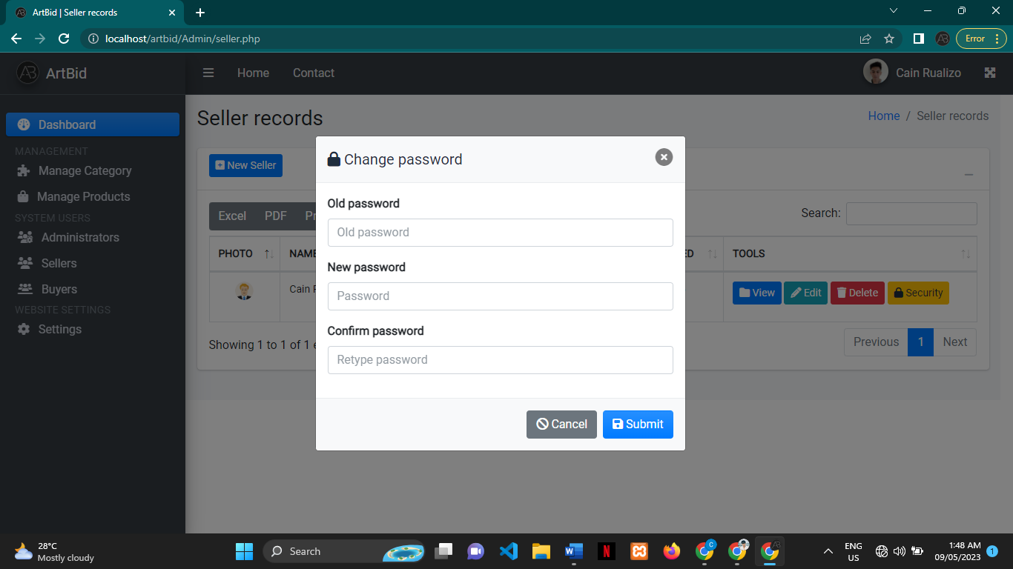

1. To change information’s of the website click settings in the website settings.

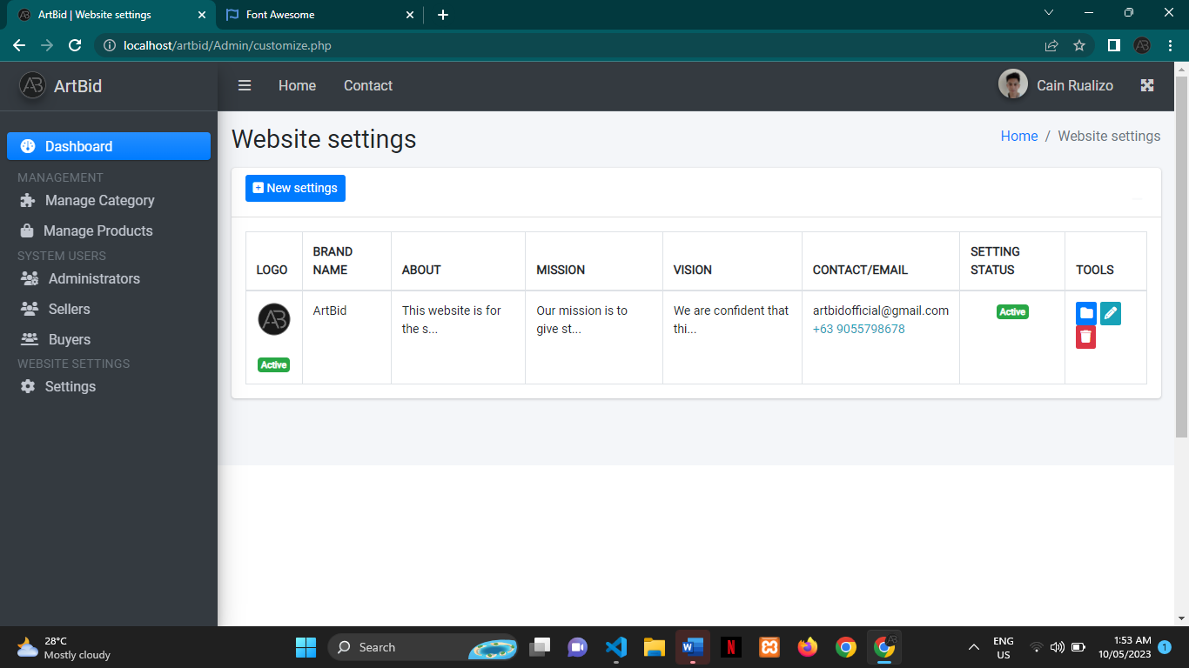

1. If you want to add additional information’s of the website click the new settings to add.



1. Fill up the information needed and click submit otherwise click cancel.

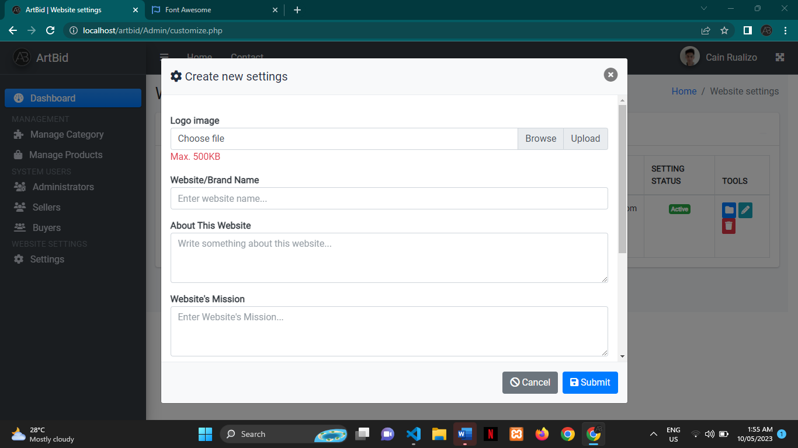

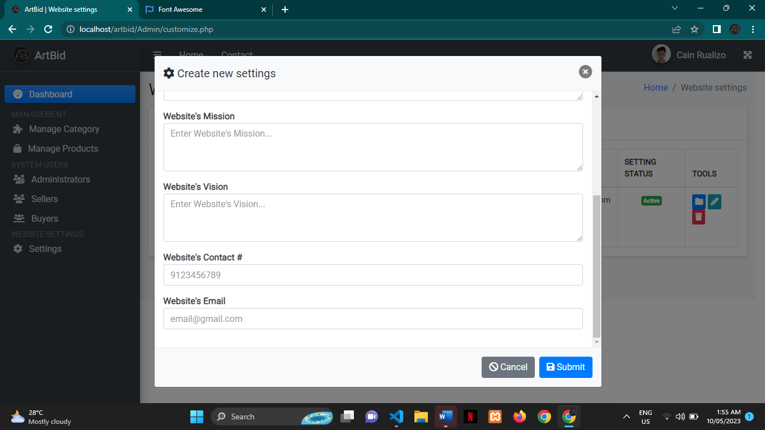

**CURRICULUM VITAE**

CAIN P. RUALIZO

Binggao, Calay-ab, Santo Domingo, Ilocos Sur 2729

09055798678 cprualizo.ccit@unp.edu.ph

|  |  |  |  |
| --- | --- | --- | --- |
| PERSONAL PROFILE | |  |  |
| Nickname |  | : | Cain |
| Birthday |  | : | June 27, 2000 |
| Birthplace |  | : | Calay-ab, Santo Domingo |
| Status |  | : | Single |
| Citizenship |  | : | Filipino |
| Father |  | : | Carlito T. Rualizo |
| Mother |  | : | Marijo P. Rualizo |

EDUCATIONAL BACKGROUND

|  |  |
| --- | --- |
| Elementary: | Bayubay Sur Elementary School |
|  | Bayubay Sto. Domingo, Ilocos Sur |
|  | 2013 |
| Junior High School: | Ilocos Sur National High School |
|  | Bantay, Ilocos Sur |
|  | 2017 |
| Senior High School: | Ilocos Sur National High School |
|  | Bantay, Vigan, Ilocos Sur |
|  | 2019 |
| Tertiary: | University of Northern Philippines |
|  | Tamag, Vigan City, Ilocos Sur |
|  | 2023 |

SEMINARS / WEBINARS ATTENDED

March 18, 2022 Breaking the Barriers: Webinar Workshop on Online

Job Opportunities, Digital Resume Writing, and

Android App Development

Via Google Meet

|  |  |  |
| --- | --- | --- |
| March 25, 2022 |  | Breaking the Barriers: A Webinar on Big Data Analytics |
|  |  | and Personality Development |
|  |  | Via Microsoft Team |
| April 7, 2022 |  | Harnessing the Potential of Microsoft: A Webinar on |
|  |  | Power App and Power Automate |
|  |  | Via Microsoft Team |
| April 22, 2022 |  | A Webinar on Financial Literacy and Digital Graphics |
|  |  | Via Microsoft Team |
| May 11, 2022 |  | Basic Motion Graphics using Adobe After Effects |
|  |  | Via Zoom Video Communication and Facebook Live |
| May 12-13, 2022 |  | 2022 ICT Training cum Research Presentation and |
|  |  | UMAK Virtual Tour |
|  |  | Via Zoom |
| May 17, 2022 |  | Machine Vision: The Ability of Computer to See |
|  |  | Via Zoom Video Communication and Facebook Live |
| May 24, 2022 |  | Tech Trends: Data Analytics (Basic Session) |
|  |  | Via Facebook Live |
| May 25, 2022 |  | Basic Video Editing using Premiere Pro and Graphic |
|  |  | Design using other Adobe Products |
|  |  | Via Zoom and Facebook Live Platform |
| June 8, 2022 |  | Webinar-Workshop on Communication Skills, Basic |
|  |  | Technical Writing. and Blockchain Technology |
|  |  | Via Microsoft Team |
| June 17, 2022 |  | FLEX IT UP! A WEBINAR ON THE DIGITAL |
|  |  | TRANSFORMATION OF CAREER COACHING |
|  |  | Via Microsoft Team |

JAN PAOLO P. ARRUEJO

Busiing Norte, San Ildefonso, Ilocos Sur. 3010

09052758334 jpparruejo.ccit@unp.edu.ph

PERSONAL PROFILE

Nickname : paolo

|  |  |  |  |
| --- | --- | --- | --- |
| Birthday |  | : | June 27, 2001 |
| Birthplace |  | : | Busiing Norte, San Ildefonso, Ilocos Sur. |
| Status |  | : | Single |
| Citizenship |  | : | Filipino |
| Father |  | : | Rey Arruejo |
| Mother |  | : | Ma.Teresa Arruejo |

EDUCATIONAL BACKGROUND

|  |  |
| --- | --- |
| Elementary: | Busiing Elementary School |
|  | Busiing Norte, San Ildefonso Ilocos Sur |
|  | 2013 |
| Junior High School: | Divine Word College of Vigan |
|  | Vigan, Ilocos Sur |
|  | 2017 |
| Senior High School: | Divine Word College of Vigan |
|  | Vigan, Ilocos Sur |
|  | 2019 |
| Tertiary: | University of Northern Philippines |
|  | Tamag, Vigan City, Ilocos Sur |
|  | 2023 |

SEMINARS / WEBINARS ATTENDED

May 6, 2022 Game Development Backend Database using AWS

Via Google Meet

May 8, 2022 Mustering up Courage and Confidence: Public Speaking in

Theory Praxis

Via Microsoft Team

May 11, 2022 Basic Motion Graphics using Adobe After Effects

Via Microsoft Team

May 11, 2022 Understanding the Skills Required for Career

Advancement

Via Microsoft Team

May 12-13, 2022 2022 ICT Training cum Research Presentation and

UMAK Virtual Tour

Via Zoom

May 12, 2022 Software Development Life Cycle

Via Zoom Video Communication and Facebook Live

May 21, 2022 Exploring Microsoft and Its Competitive Advantage

Via Facebook Live

May 17, 2022 Human Resource: Information System and

Technological Advancement

Via Zoom and Facebook Live Platform

May 17, 2022 Digital Workforce: The role of Gen Z Towards

Technological Trends

Via Microsoft Team

May 28, 2022 Introduction of Ruby Programming

Via Microsoft Team

June 17, 2022 FLEX IT UP! A WEBINAR ON THE DIGITAL

TRANSFORMATION OF CAREER COACHING

Via Microsoft Team

KOBE BYEIN BELARDE

Bulbulala Santiago, Ilocos Sur 2707

09495967127 kbbelarde.ccit@unp.edu.ph

PERSONAL PROFILE

|  |  |  |  |
| --- | --- | --- | --- |
| Nickname |  | : | Kobe |
| Birthday |  | : | July 15, 2001 |
| Birthplace |  | : | Bulbulala, Santiago, Ilocos Sur |
| Status |  | : | Single |
| Citizenship |  | : | Filipino |
| Father |  | : | Primo Belarde |
| Mother |  | : | Evelyn Belarde |

EDUCATIONAL BACKGROUND

|  |  |
| --- | --- |
| Elementary: | Olo-Olo Elementary School |
|  | Santiago, Ilocos Sur |
|  | 2013 |
| Junior High School: | Santiago Catholic School |
|  | Santiago, Ilocos Sur |
|  | 2017 |
| Senior High School: | Santiago Catholic School |
|  | Santiago, Ilocos Sur |
|  | 2019 |
| Tertiary: | University of Northern Philippines |
|  | Tamag, Vigan City, Ilocos Sur |
|  | 2023 |

SEMINARS / WEBINARS ATTENDED

March 18, 2022 Breaking the Barriers: Webinar Workshop on Online

Job Opportunities, Digital Resume Writing, and

Android App Development

Via Google Meet

j Valley

Via Zoom Video Communication and Facebook Live

May 24, 2022 Tech Trends: Data Analytics (Basic Session)

Via Facebook Live

May 26, 2022 Fundamentals of UI/UX Design

Via Zoom and Facebook Live Platform

|  |  |  |
| --- | --- | --- |
| March 25, 2022 |  | Breaking the Barriers: A Webinar on Big Data Analytics |
|  |  | and Personality Development |
|  |  | Via Microsoft Team |
| April 7, 2022 |  | Harnessing the Potential of Microsoft: A Webinar on |
|  |  | Power App and Power Automate |
|  |  | Via Microsoft Team |
| April 22, 2022 |  | A Webinar on Financial Literacy and Digital Graphics |
|  |  | Via Microsoft Team |
| May 11, 2022 |  | Basic Motion Graphics using Adobe After Effects |
|  |  | Via Zoom Video Communication and Facebook Live |
| May 12-13, 2022 |  | 2022 ICT Training cum Research Presentation and |
|  |  | UMAK Virtual Tour |
|  |  | Via Zoom |
| May 23, 2022 |  | Cybersecurity Aware HEI: Cyber Secured Cagayan |

June 7, 2022. Advanced Use of MS OFFICE APPLICATION

June 8, 2022 Webinar-Workshop on Communication Skills, Basic

Technical Writing. and Blockchain Technology

Via Microsoft Team

SHERLYN G. DULDULAO

Banguian, Abulug, Cagayan 3517

09551645181 sgduldulao.ccit@unp.edu.ph

PERSONAL PROFILE

Nickname : Chit

Birthday : May 28, 2000

Birthplace : Barbarit, Magsingal, Ilocos Sur

Status : Single

Citizenship : Filipino

Father : Semion O. Duldulao

Mother : Emelyn G. Duldulao

EDUCATIONAL BACKGROUND

|  |  |
| --- | --- |
| Elementary: | Barbarit, Magsingal, Elementary School |
|  | Barbarit Magsingal, Ilocos Sur |
|  | 2013 |
| Junior High School: | Abulug National Rural and Vocational High School |
|  | Langay, Abulug, Ilocos Sur |
|  | 2017 |
| Senior High School: | Abulug National Rural and Vocational High School |
|  | Langay, Abulug, Ilocos Sur |
|  | 2019 |
| Tertiary: | University of Northern Philippines |
|  | Tamag, Vigan City, Ilocos Sur |
|  | 2023 |

SEMINARS / WEBINARS ATTENDED

March 18, 2022 Breaking the Barriers: Webinar Workshop on Online

Job Opportunities, Digital Resume Writing, and

Android App Development

Via Google Meet

|  |  |  |
| --- | --- | --- |
| March 25, 2022 |  | Breaking the Barriers: A Webinar on Big Data Analytics |
|  |  | and Personality Development |
|  |  | Via Microsoft Team |
| April 7, 2022 |  | Harnessing the Potential of Microsoft: A Webinar on |
|  |  | Power App and Power Automate |
|  |  | Via Microsoft Team |
| April 22, 2022 |  | A Webinar on Financial Literacy and Digital Graphics |
|  |  | Via Microsoft Team |
| May 11, 2022 |  | Basic Motion Graphics using Adobe After Effects |
|  |  | Via Zoom Video Communication and Facebook Live |
| May 12-13, 2022 |  | 2022 ICT Training cum Research Presentation and |
|  |  | UMAK Virtual Tour |
|  |  | Via Zoom |
| May 17, 2022 |  | Machine Vision: The Ability of Computer to See |
|  |  | Via Zoom Video Communication and Facebook Live |
| May 24, 2022 |  | Tech Trends: Data Analytics (Basic Session) |
|  |  | Via Facebook Live |
| May 25, 2022 |  | Basic Video Editing using Premiere Pro and Graphic |
|  |  | Design using other Adobe Products |
|  |  | Via Zoom and Facebook Live Platform |
| June 8, 2022 |  | Webinar-Workshop on Communication Skills, Basic |
|  |  | Technical Writing. and Blockchain Technology |
|  |  | Via Microsoft Team |
| June 17, 2022 |  | FLEX IT UP! A WEBINAR ON THE DIGITAL |
|  |  | TRANSFORMATION OF CAREER COACHING |
|  |  | Via Microsoft Team |